INDEX

|  |  |  |  |  |
| --- | --- | --- | --- | --- |
| Sr.no | Aim | Date | Page No | Sign |
| 1.1A | Analyze Lab01-01.exe and Lab01-01.dll for signatures, packing, imports, indicators, and purpose. |  | 3 |  |
| 1B | Analyze Lab01-02.exe for antivirus detection, packing, functionality hints, indicators. |  |  |  |
| 1C | Analyze Lab01-03.exe for detection, packing, functionality hints, indicators. |  |  |  |
| 1D | Analyze Lab01-04.exe for detection, packing, imports, compilation time, resource analysis. |  |  |  |
| 1E | Analyze Lab03-01.exe using dynamic tools for strings, indicators, and signatures. |  |  |  |
| 1F | Analyze Lab03-02.dll for installation, persistence, filters, indicators. |  |  |  |
| 1G | Execute and monitor Lab03-03.exe to observe behavior and host indicators. |  |  |  |
| 1H | Analyze Lab03-04.exe for dynamic roadblocks, execution behavior. |  |  |  |
| 2.2A | Analyze Lab05-01.dll with IDA Pro, investigate imports, variables, strings, functions. |  | 16 |  |
| 2B | Analyze Lab06-01.exe for code construct and program purpose. |  |  |  |
| 2C | Analyze Lab06-02.exe for functionality, network indicators, and purpose. |  |  |  |
| 2D | Analyze Lab06-03.exe for new function behavior and indicators. |  |  |  |
| 2E | Analyze Lab06-04.exe and identify changes in main and HTML parsing. |  |  |  |
| 3.3A | Analyze Lab07-01.exe for persistence, mutex use, signatures, purpose. |  | 33 |  |
| 3B | Analyze Lab07-02.exe for persistence, purpose, execution behavior. |  |  |  |
| 3C | Analyze Lab07-03.exe and DLLs for persistence, removal, purpose. |  |  |  |
| 3D | Use OllyDbg and IDA Pro to analyze Lab09-01.exe, commands, indicators. |  |  |  |
| 3E | Use OllyDbg to analyze Lab09-02.exe for static strings and obfuscation. |  |  |  |
| 3F | Analyze Lab09-03.exe and its DLLs for memory loading and behavior. |  |  |  |
| 4.4A | Analyze Lab10-01.exe and .sys driver for service and kernel behavior. |  | 69 |  |
| 4B | Analyze Lab10-02.exe for created files and actions. |  |  |  |
| 4C | Analyze Lab10-03.exe and driver for execution and kernel behavior. |  |  |  |
| 5.5A | Analyze Lab11-01.exe for persistence and credential theft. |  | 79 |  |
| 5B | Analyze Lab11-02.dll and .ini file for installation and hooking. |  |  |  |
| 5C | Analyze Lab11-03.exe and .dll for persistence and infection behavior. |  |  |  |
| 6.6A | Analyze Lab12-01.exe and .dll for injected processes and behavior. |  | 118 |  |
| 6B | Analyze Lab12-02.exe for hidden execution and protection. |  |  |  |
| 6C | Analyze Lab12-03.exe for payload injection and file residue. |  |  |  |
| 6D | Analyze Lab12-04.exe for code injection and dropped malware. |  |  |  |
| 7.7A | Analyze Lab13-01.exe for encoding, Base64 behavior, and actions. |  | 134 |  |
| 7B | Analyze Lab13-02.exe for encoding routines and function tracing. |  |  |  |
| 7C | Analyze Lab13-03.exe for dual encoding techniques and decryption. |  |  |  |
| 8.8A | Analyze Lab14-01.exe for networking beacons, purpose, detection. |  | 152 |  |
| 8B | Analyze Lab14-02.exe for IP communication and HTTP usage. |  |  |  |
| 8C | Analyze Lab14-03.exe for command input, encoding, and signature design. |  |  |  |
| 8D | Analyze Lab15-01.exe for anti-disassembly and correct input. |  |  |  |
| 8E | Analyze Lab15-02.exe for URL requests, page parsing, and usage. |  |  |  |
| 8F | Analyze Lab15-03.exe for hidden malicious behavior and execution. |  |  |  |

**Practical No 1**

**Virustotal.com**

**PeID**

**Process Explorer**

Q1. (a) Files: Lab01-01.exe and Lab01-01.dll.

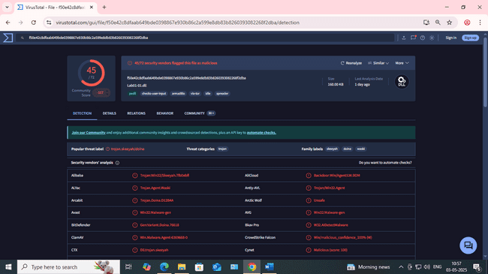 1**. Upload the files to http://www.VirusTotal.com/ and view the reports. Does either file match any existing antivirus signatures?**

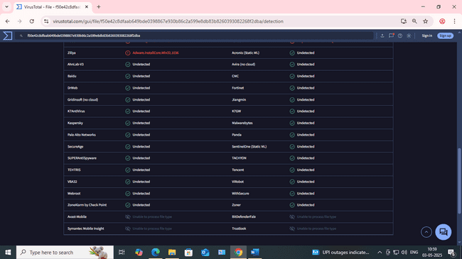

We can clearly see that these files have been matched with the previously known signatures and have also been detected as malicious

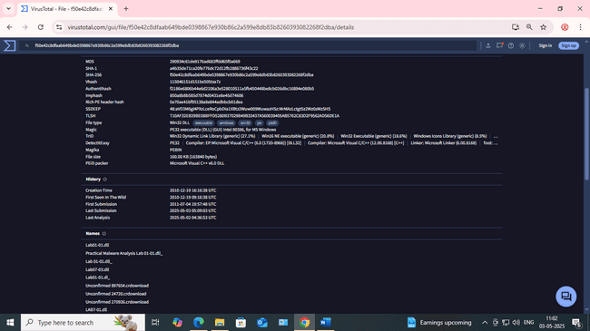

**2. When were these files compiled?**

The compilation time of both file as per the report of VirusTotal is

Lab01–01.exe → 2010–12–19 16:16:19

Lab01–01.dll → 2010–12–19 16:16:38

**3. Are there any indications that either of these files is packed or obfuscated? If so, what are these indicators**

PEiD can be used to find the packed or obfuscated file although we were able to find all the necessary details and the strings. So we conclude that both of these files were not been packed or obfuscated

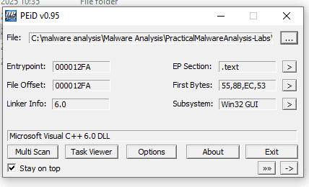

**4. Do any imports hint at what this malware does? If so, which imports are they**

Both, the executable and DLL file do imports. Lab01–01.exe does the following imports

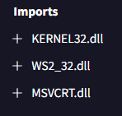

**KERNEL32.dll** → Kernel32.dll is the 32-bit dynamic link library found in the

Windows operating system kernel. It handles memory management, input/output

operations, and interrupts. When Windows boots up, kernel32.dll is loaded into a

protected memory space so other applications do not take that space over.

**MSVCRT** → A module containing standard C library functions such as printf,

memcpy, and cos. It is a part of the Microsoft C Runtime Library. Non-system

processes like msvcrt.dll originate from software you installed on your system.

**WS2_32.dll** → The Windows Sockets Library ws2_32.dll, is required by windows and

applications to handle network connections.

**5. Are there any other files or host-based indicators that you could look for on infected systems?**

While finding the strings we found that there is another file named as “Kerne132.dll” which is supposed to be disguised as the “Kernel32.dll”. Also there is another “Lab01–01.DLL” which is not a common OS DLL. So we can look for these files on the system.

**6. What network-based indicators could be used to find this malware on infected machines?**

We found an IP address when we checked the string. So we capture all the network traffic from all the systems and can look for the communication that is being done over this IP address.

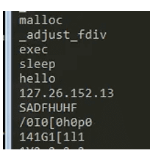

**7. What would you guess is the purpose of these files?**

On bringing up all the pieces together we can assume that Lab01–01.exe along with the extension Lab01–01.dll is a malware which creates a backdoor and connects to a C&C server and transfer the critical information. Secondly both of the files are not packed and Lab01–01.exe searches in and from directories and look for a particular files and replaces them with disguised files. Also it imports functions from core KERNEL32.DLL and network based imports to establish the connections. Also uses the exec function which means that it would be executing some other programs/files along with sleep function which waits until a particular statement or piece of code gets executed. This is mostly used in backdoors.

**b. Analyze the file Lab01-02.exe**.

**1. Upload the Lab01-02.exe file to http://www.VirusTotal.com/. Does it match any existing antivirus definitions?**

We have uploaded the file and have found that it matched the existing antivirus definitions.

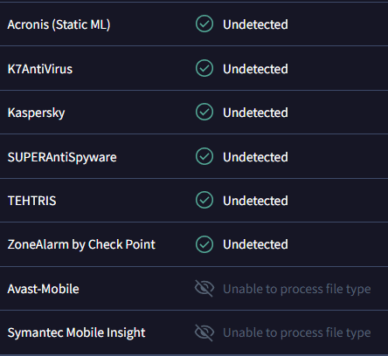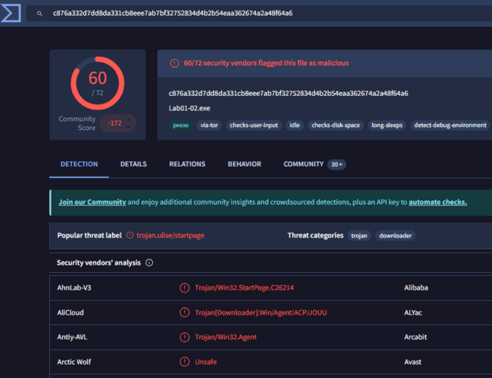

**2. Are there any indications that this file is packed or obfuscated? If so, what are these indicators? If the file is packed, unpack it if possible?**

We found out that this executable was packed and we were also able to unpack it using the UPX tool.

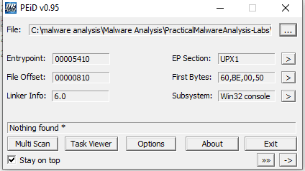

**3. Do any imports hint at this program’s functionality? If so, which imports are they and what do they tell you?**

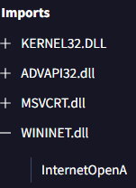

InternetOpenA → Initializes an application’s use of the WinINet functions we can see what user agent is used to initiate the connection.

**4. What host- or network-based indicators could be used to identify this malware on infected machines?**

We can look for the service named MalService via services.msc also we can check for the dnslookups for http://malwareanalysisbook.com/ via a specific Internet Explorer string which will be passed via the browser user-agent FIELD. Moreover we can create a firewall rule to block such traffic

**c. Analyze the file Lab01-03.exe.**

**1. Upload the Lab01-03.exe file to http://www.VirusTotal.com/. Does it match any existing antivirus definitions?**

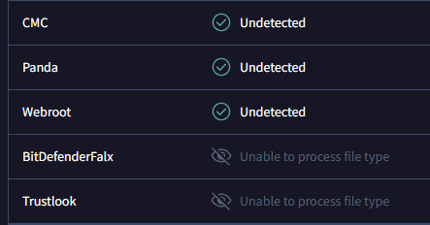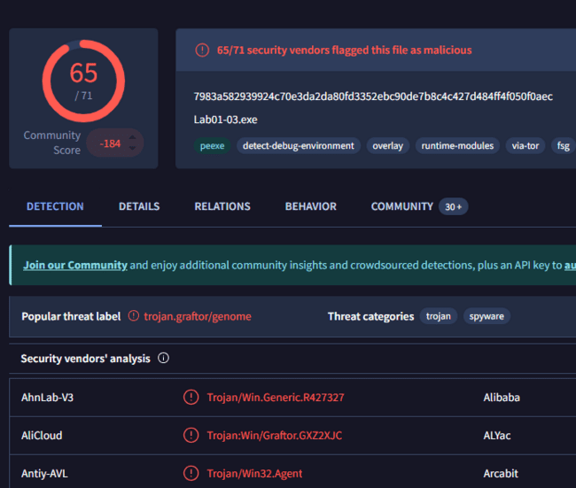  
The file is malicious.

**2. Are there any indications that this file is packed or obfuscated? If so, what are these indicators? If the file is packed, unpack it if possible.**

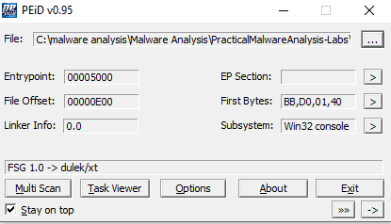

The executable is packed using FSG 1.0, lets try to run strings on the executable and check if we are able to find any clue about this executable

**3.Do any imports hint at this program’s functionality? If so, which imports are they and what do they tell you?**

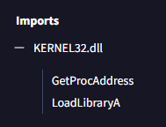

We can see the function ‘LoadLibraryA, GetProcAddress” this proves that this file is packed. We also found the KERNEL32.DLL also MSVCRT.DLL as well

**4. What host- or network-based indicators could be used to identify this malware on infected machines?**

**d. Analyze the file Lab01-04.exe.**

**1. Upload the Lab01-04.exe file to http://www.VirusTotal.com/. Does it match any existing antivirus definitions?**

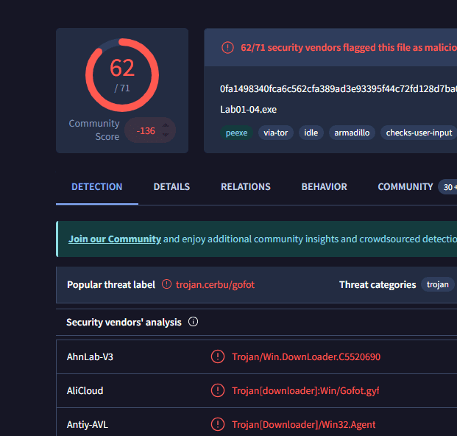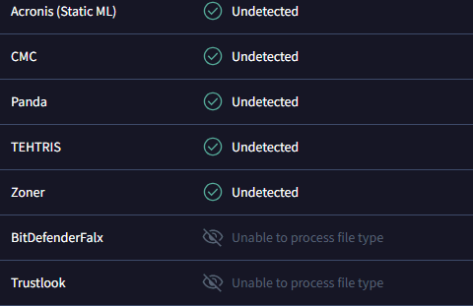The file is malicious.

**2. Are there any indications that this file is packed or obfuscated? If so, what are these indicators? If the file is packed, unpack it if possible.**

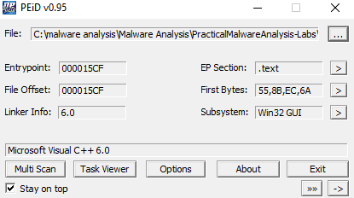

This executable does not seems to be packed.

**3. When was this program compiled?**

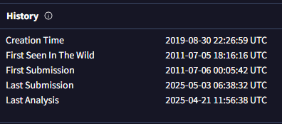

This program was compiled on 30/08/2019 but it doesn’t seems to be correct!

**4. Do any imports hint at this program’s functionality? If so, which imports are they and what do they tell you?**

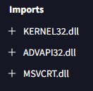

Files are being created and written to. Also some other executable’s are being executed and updater is being download from the URL.

**5. What host- or network-based indicators could be used to identify this malware on infected machines?**

Host-Based \winup.exe \system32\wupdmgrd.exe Network-Based <http://www.practicalmalwareanalysis.com/updater.exe>

**6. This file has one resource in the resource section. Use Resource Hacker to examine that resource, and then use it to extract the resource. What can you learn from the resource?**

The part d and e are the answers of this part. But let’s use Resource Hacker as we haven’t tried it yet and try to extract the resource!

**e. Analyze the malware found in the file Lab03-01.exe using basic dynamic analysis tools.**

**i. What are this malware’s imports and strings?**

On analyzing the malware we can only see one DLL file and one function import

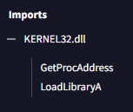

**ii. What are the malware’s host-based indicators?**

While finding the strings we found that there is another file named as “Kerne132.dll” which is supposed to be disguised as the “Kernel32.dll”. Also there is another “Lab01–01.DLL” which is not a common OS DLL. So we can look for these files on the system.

**iii. Are there any useful network-based signatures for this malware? If so, what are they?**

The malware is trying to connect to the URL www.practicalmalwareanalysis.com So that the filter can be added for the malicious activity

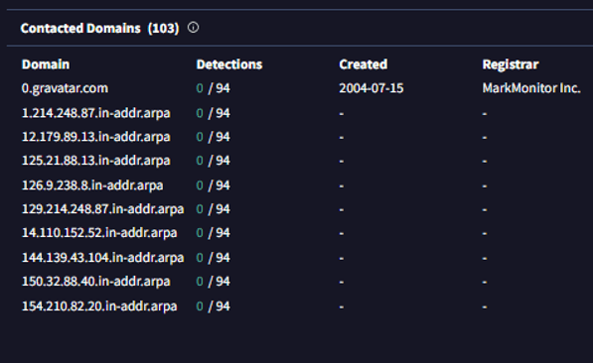

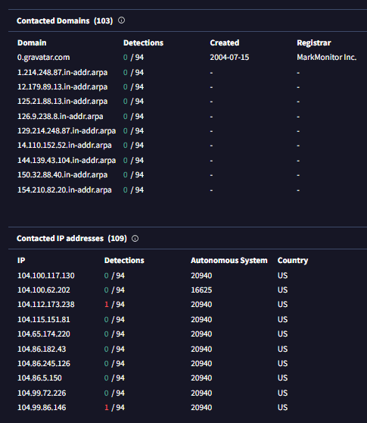

**f. Analyze the malware found in the file Lab03-02.dll using basic dynamic analysis tools.**

**i. How can you get this malware to install itself?**

We can get this malware installed using the rundll32.exe and by knowing the first argument to install i.e installA in this case.

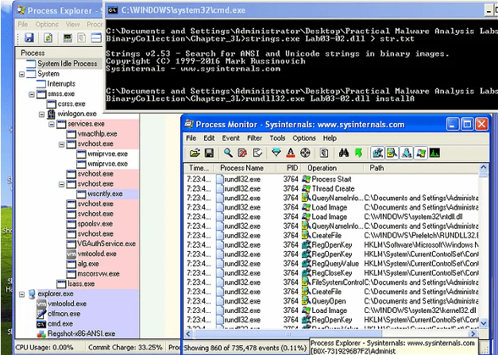

**ii. How would you get this malware to run after installation?**

Once we are done with installing the malware we can see a new service named IPRIP registry added. We can run it by using the network command in windows

**iii. How can you find the process under which this malware is running?**

In Process Explorer we can click in Find and the provide the name of the DLL and so we get the details under which the malware is running

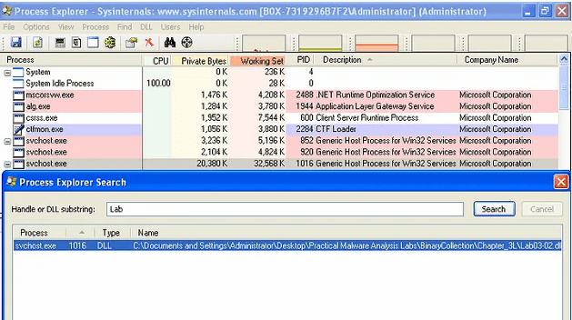

**iv. Which filters could you set in order to use procmon to glean information?**

We can use the pid in this case “1016” to filter everything

**v. What are the malware’s host-based indicators?**

The malware installs a service called IPRIP, displays name of Intranet Network Awareness (INA+) along with the description “Depends INA+, Collects and stores network configuration and location information , and notifies applications when this information changes.”



It writes to HKLM\SYSTEM\ControlSet001\Services\IPRIP\Parameters\ServiceDll: %CurrentDirectory%\Lab03–02.dll in the registry for persistence.

**vi. Are there any useful network-based signatures for this malware?**

It tries to connect to “practicalmalwareanalysis.com”

**g. Execute the malware found in the file Lab03-03.exe while monitoring it using basic dynamic analysis tools in a safe environment**

**i. What do you notice when monitoring this malware with Process Explorer?**

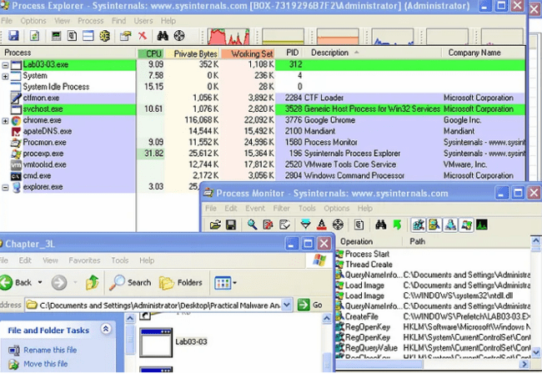

We notice that when the malware is run. The actual process is shown which then creates the child process and then removes itself leaving an orphan process.

**ii. Can you identify any live memory modifications?** 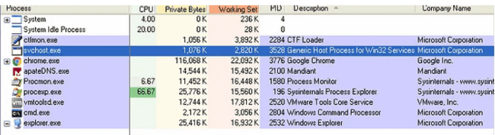

We can identify the live memory modifications by looking onto the memory strings as they reveal the strings after the malware is run in the memory. In those strings we can actually see the HOOK and log file from which we concluded that this executable is a Keylogger

**iii. What are the malware’s host-based indicators?** 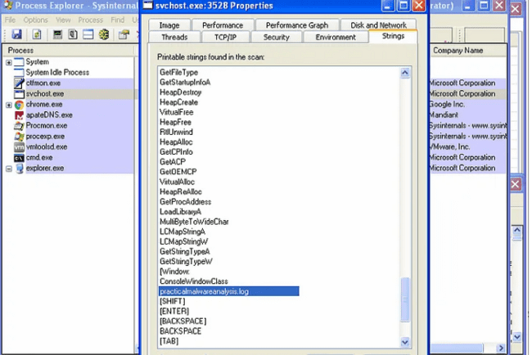

The host-based indicators for this malware is the file “practicalmalwareanalysis.log” presence on the system.

**iv. What is the purpose of this program?**

The purpose of this program is to log all of the keystrokes from the keyboard and then save them into the log file

**h. Analyze the malware found in the file Lab03-04.exe using basic dynamic analysis tools.**

**i. What happens when you run this file?** 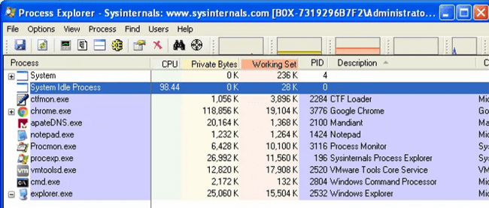

When we run the file. Process is created which opens up the CMD and then deleted the original executable after making it execute and hide itself somewhere else

**ii. What is causing the roadblock in dynamic analysis?** 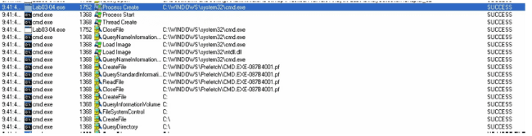

The executable is evasive and trying to evade itself by checking whether the system is VM or not. AV-Detection etc. Obviously this will make it difficult to observer the file via dynamic analysis

**iii. Are there other ways to run this program?** 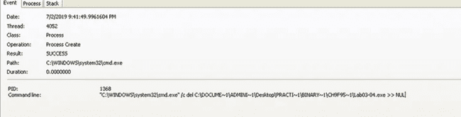

The other ways can be to open this executable using Ollydbg or IDA pro where we can analyze it in a more efficient way.

**Practical 2**

**IDA Freeware**

In this practical we used IDA Software.

# Analyze the malware found in the file Lab05-01.dll using only IDA Pro. The goal of this lab is to give you hands-on experience with IDA Pro. If you’ve already worked with IDA Pro, you may choose to ignore these questions and focus on reverse engineering the malware.

* 1. **What is the address of DllMain?**

The address off DllMain is 0x1000D02E. This can be found within the graph mode, or within the Functions window (figure 2).

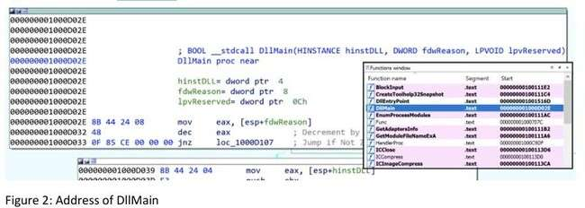

# Where is the import gethostbyname located?

gethostbyname is located at 0x100163CC within .idata (figure 3).This is found through the Imports window and double-clicking the function. Here we can also see gethostbyname also takes a single parameter — something like a string.

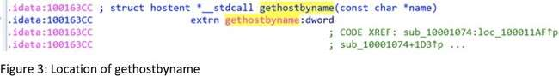

# How many functions call gethostbyname?

Searching the xrefs (ctrl+x) on gethostbyname shows it is referenced 18 times, 9 of which are type (p) for the near calll, and the other 9 are read (r) (figure 4). Of these, there are 5 unique calling functions.

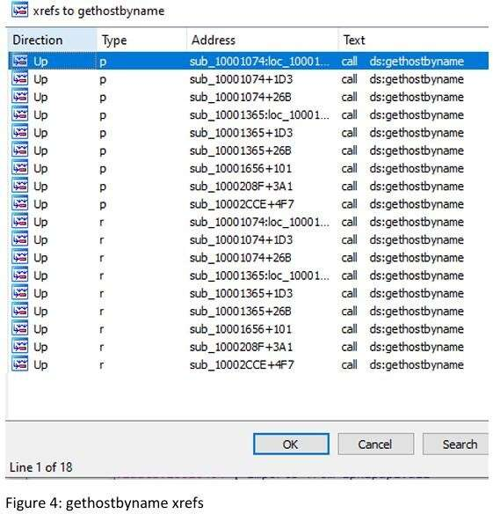

# For gethostbyname at 0x10001757, which DNS request is made?

Pressing G and navigating to 0x10001757, we see a call to thegethostbyname function, which we know takes one parameter; in this case, whatever is in eax — the contents of off_10019040 (figure 5)

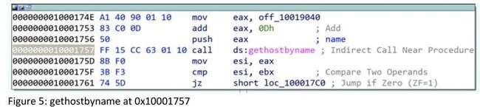

The contents of off_10019040 points to a variable aThisIsRdoPicsP which contains the string [This is RDO]pics.practicalmalwareanalysis.com. This is moved into eax (figure 6).

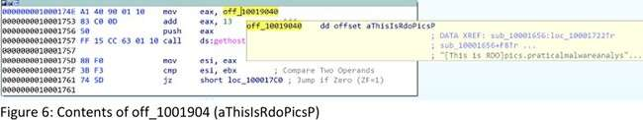

Importantly, 0Dh is added to eax, which moves the pointer along the current contents. 0Dh can be converted in IDA by pressing H, to 13. This means the eax now points to 13 characters inside of its current contents, skipping past the prefix [This is RDO] and resulting in the DNS request being made for pics.practicalmalwareanalysis.com.

# v & vi. How many parameters and local variables are recognized for the subroutine at 0x10001656?

There are a total of 24 variables and parameters for sub_10001656 (figure 7).

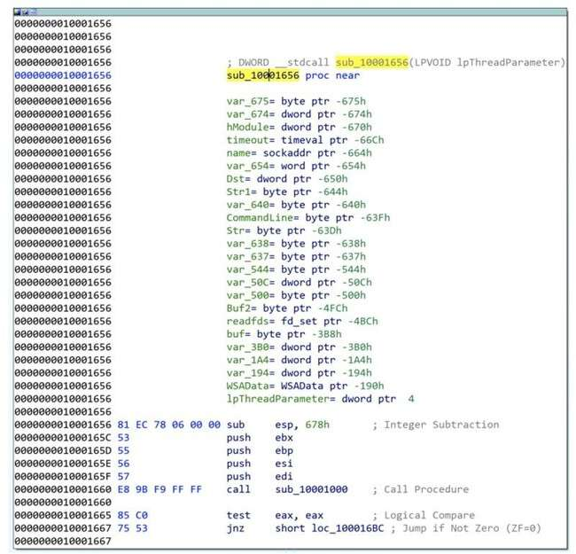

Figure 7: sub_10001656 parameters and varliables

Local variables correspond to negative offsets, where there are 23. Many are generated by IDA and prepended with var_ however there are some which have been resolved, such as name or commandline. As we work through, we generally rename any of the important ones.

Parameters have positive offsets. Here there is one, currently lpThreadParameter. This may also be seen as arg_0 if not automagically resolved

# vii. Where is the string \cmd.exe /c located in the disassembly?

Press Alt+T to perform a string search for \cmd.exe /c, which is stored as aCmdExeC, found within sub_1000FF58 at offset 0x100101D0 (figure 8).

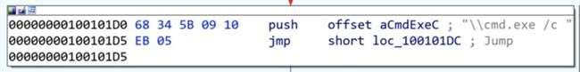

Figure 8: Location of ‘\cmd.exe /c’

# analyze the malware found in the file Lab06-01.exe.

* 1. **What is the major code construct found in the only subroutine called by main?**

Before we start, it is worth noting that sometimes IDA does not recognise the main subroutine. We can find this quite quickly by traversing from the start function and finding sub_401040. This is main as it contains the required parameters (argc and **argv). I

renamed the subroutine to main (figure 1).

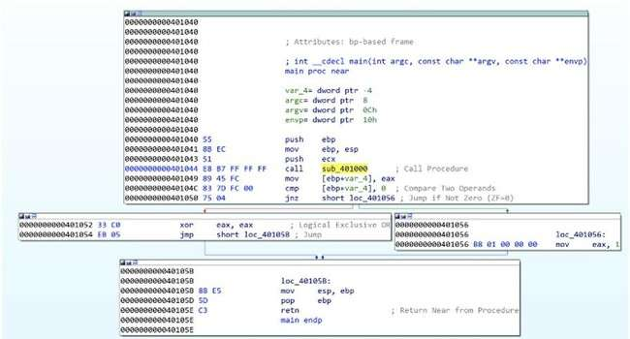

Figure 1: Lab06–01 | main subroutine

Navigating into the first subroutine called in main (sub_401000) (figure 2), we see it executes an external API call InternetGetConnectedState, which returns a TRUE if the system has an internet connection, and FALSE otherwise. This is followed by a comparison against 0 (FALSE) and then a JZ (Jump If Zero). This means the jump will be successful if

InternetGetConnectedState returns FALSE (0) (There is no internet connection).

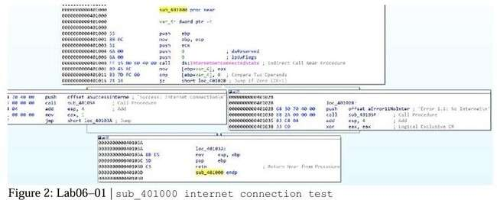

Therefore, the jump path (short loc_40102B) is taken and the string returned will be ‘Error

1.1: No Internet\n’.

InternetGetConnectedState returns TRUE, then the jump is not successful, and the returned string is ‘Success: Internet Connection\n’.

Based upon this, it can be determined that the major code construct is a basic If Statement.

# What is the subroutine located at 0x40105F?

Given the proximity to the strings at the offset addresses in each path, it can be assumed that sub_40105F is printf, a function used to print text with formatting (supported by the \n for newline in the strings).

IDA didn’t automatically pick this up for me, but with some cross-referencing and looking into what we would expect as parameters, we can be safe in the assumption.

# What is the purpose of this program?

Lab06–01.exe is a simple program to test for internet connection. It utilises API call

InternetGetConnectedState to determine whether there is internet, and prints an advisory string accordingly.

# Analyze the malware found in the file Lab06–02.exe.

**i & ii. What operation does the first subroutine called by main perform? What is the subroutine located at 0x40117F?**

This is very similar to Lab06–01.exe. We can easily find the main subroutine again (this time sub_401130), and again we see the first subroutine called is sub_401000. This is very similar

as it calls InternetGetConnectedState and prints the appropriate message (figure 3). We also can verify that 0x40117F is still the printf function, which I’ve renamed.

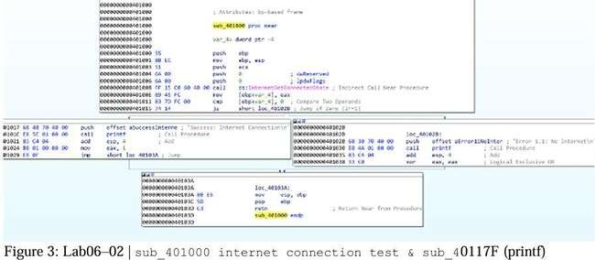

# What does the second subroutine called by main do?

This is something new now; the main function in lab06–02.exe is a little more complex with an added subroutine and another conditional statement (figure 4). We can see that

sub_401040 is reached by the preceding cmp to 0 being successful (jnz jump if not 0), which therefore means we’re hoping for the returned value from sub_401000 to be not 0 —

indication there IS internet connection.

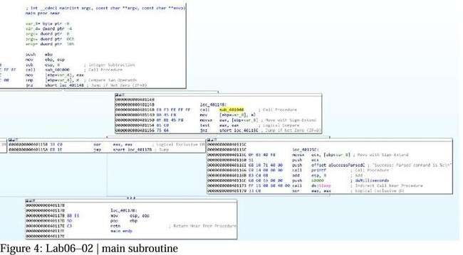

Navigating to sub_401040, we immediately see some key information, which supports the determination that this occurs if there is an internet connection.

The most stand-out information is the two API calls, InternetOpenA and InternetOpenUrlA, which are used to initiate an internet connection and open a URL. We also see some strings at offset addresses just before these, indicating these are passed to the API calls (figure 5).

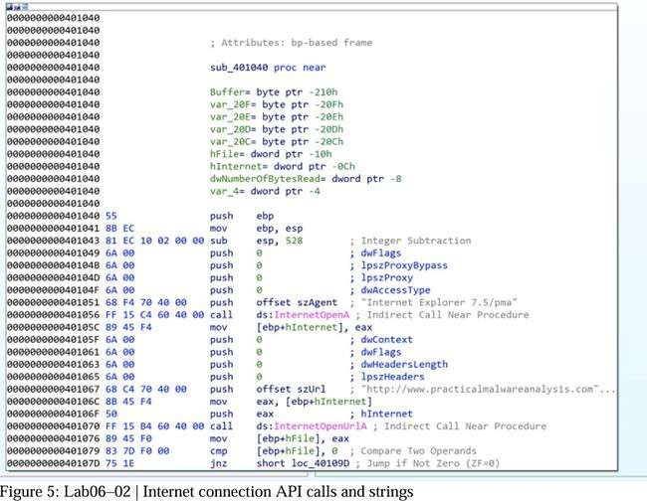

First, szAgent containing string “Internet Explorer 7.5/pma”, which is a User-Agent String, is passed to InternetOpenA. szUrl contains the string

[“http://www.practicalmalwareanalysis.com/cc.htm”](http://www.practicalmalwareanalysis.com/cc.htm) which is the URL for InternetOpenUrlA.

This has another jnz where the jump is not taken if hFile returned from InternetOpenUrlA is 0 (meaning no file was downloaded), where a message is printed “Error 2.2: Fail to

ReadFile\n” and the internet connection is closed.

# What type of code construct is used in sub_40140?

If szURl is found, the program attempts to read 200h (512) bytes of the file (cc.htm) using the API call InternetReadFile (the jnz unsuccessful path leads to “Error 2.2: Fail to

ReadFile\n” printed and connections closed) (figure 6).

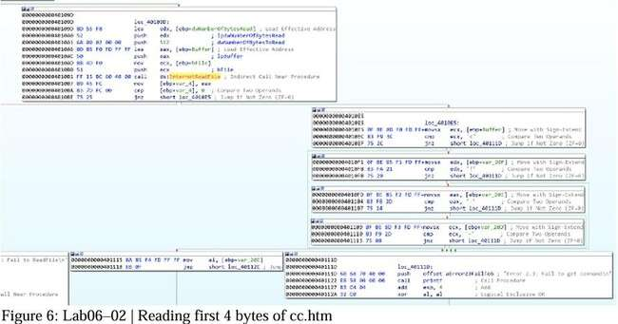

There are then four cmp / jnz blocks which each comparing a single byte from the Buffer and several variables. These may also be seen as Buffer+1, Buffer+2, etc. This is a notable code construct in which a character array is filled with data from InternetReadFile and is read one by one.

These values have been converted (by pressing R) to ASCII. Combined these read <!--,

indicative of the start of a comment in HTML. If the value comparisons are successful, then

Var_20C (likely the whole 512 byes in Buffer, but just mislabeled by IDA) is read. If at any

point a byte read is incorrect, then an alternative path is taken and the string “Error 2.3: Fail to get command\n” is printed.

Looking back at main, if this all passes with no issues, the string “Success: Parsed command is %c\n” is printed and the system does Sleep for 60000 milliseconds (60 seconds) (figure 7). The command printed (displayed through formatting of %c is variable var_8) is the returned value from sub_401040, the contents of cc.htm.

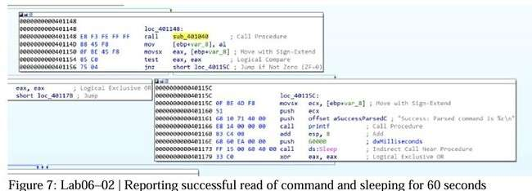

# Analyze the malware found in the file Lab06–03.exe.

* 1. **Compare the calls in main to Lab06–02.exe’s main method. What is the new function called from main?**

For both executables, I have renamed all of the functions that we have already analysed. The differentiator between the two is an additional function once internet connection has been tested, the file has been downloaded, and the successful parsing of the command message has been printed — sub_401130 (figure 9).

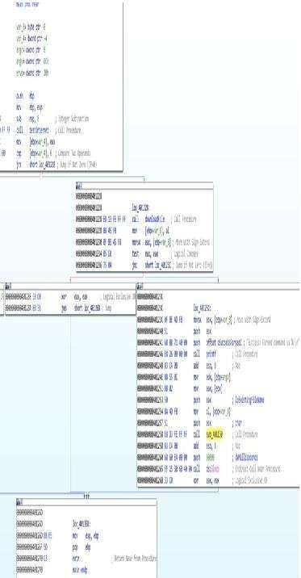

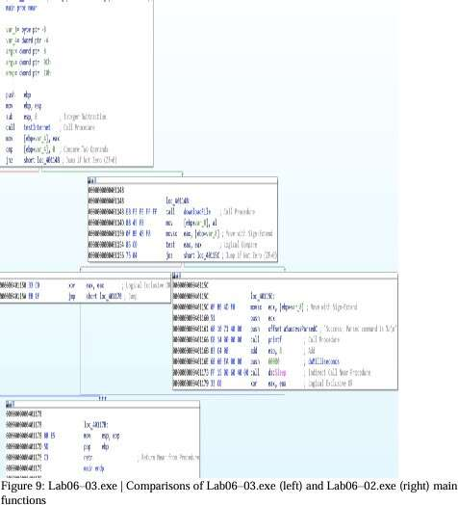

# What parameters does this new function take?

sub_401130 takes 2 parameters. The first is char, the command character read from <http://www.practicalmalwareanalysis.com/cc.htm> and lpExistingFileName (a long pointer to a character string, ‘Existing File Name’, which is the program’s name ( Lab06–03.exe) (figure 10). These were both pushed onto the stack as part of the main function.

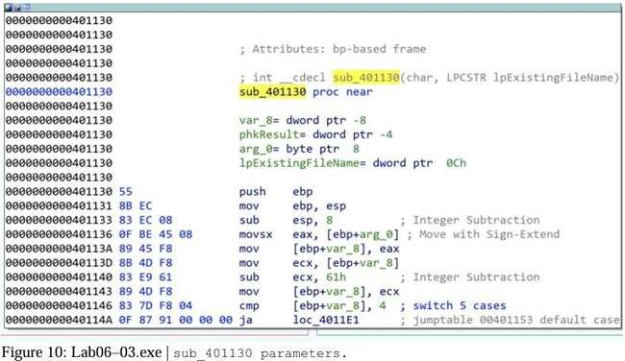

# What major code construct does this function contain?

IDA has helpfully indicated that the major code construct is a five-case switch statement by adding comments for 'switch 5 cases' and the 'jumptable 00401153 default case'. We have previously seen similar cmp which are if statements, however, in this case, there is a possibility of five paths. We can confirm this in the flowchart graph view, where there are five switch cases and one default case (figure 11).

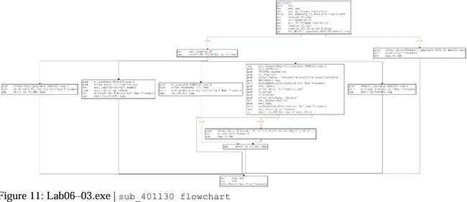

# What can this function do?

The five switch cases are as follows (figure 12):

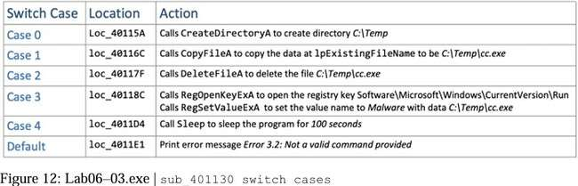

Depending on the command provided (0–4) the program will execute the appropriate API calls to perform directory operations or registry modification. lpExistingFileName is the current file, Lab06–03.exe. Setting the registry key

Software\Microsoft\Windows\CurrentVersion\Run\Malware with file C:\Temp\cc.exe is a method of persistence to execute the malware on system startup.

# analyze the malware found in the file Lab06-04.exe.

* 1. **What is the difference between the calls made from the main method in Lab06–03.exe and Lab06-04.exe?**

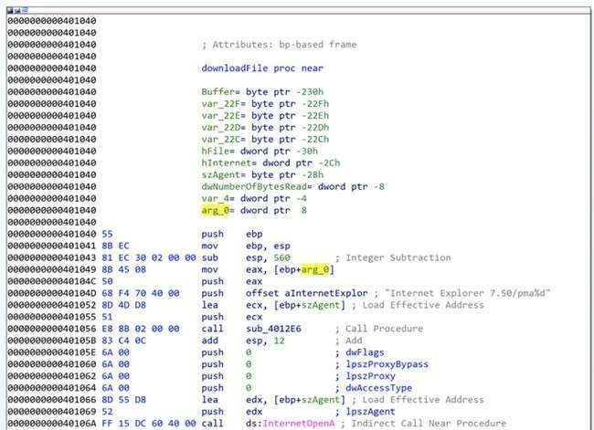

Figure 13: Lab06–04.exe | Modified downloadFile function with arg_0

Of the subroutines called from main we have analysed (renamed to testInternet, printf, downloadFile, and commandSwitch) only downloadFile has seen a notable change. The aInternetExplor address contains the value Internet Explorer 7.50/pma%d for the user-agent (szAgent) which includes an %d not seen previously, as well as a new local variable arg_0

(figure 13).

This instructs the printf function to take the passed variable arg_0 as an argument and print as an int. The variable is a parameter taken in the calling of downloadFile , donated by IDA as var_C(figure 14).

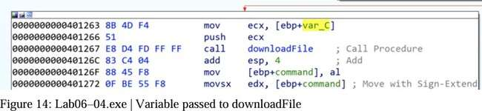

Some of the called subroutines have different memory addresses to what we saw in the previous Lab06–0X.exes, due to the main function being somewhat more complex and expanded.

# What new code construct has been added to main?

main has been developed upon to include a for loop code construct, as observed in the flowchart graph view (figure 15).

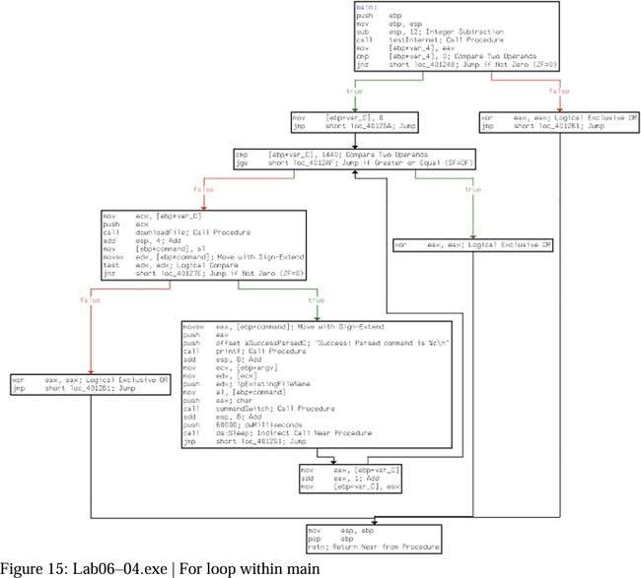

A for loop code construct contains four main components — initialisation, comparison, execution, and increment. All of which are observed within main (figure 16):

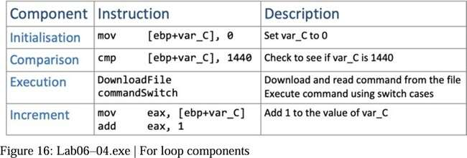

# What is the difference between this lab’s parse HTML function and those of the previous labs?

As previously identified, the parse HTML function (downloadFile) now includes a passed variable. Having analysed this and main, we can determine that it is the for loop’s current conditional variable (var_C) value which is passed through to downloadFile’s user-agent

Internet Explorer 7.50/pma%d, as arg_0 as this will increment by 1 each time, it may potentially be used to indicate how many times it has been run.

# How long will this program run? (Assume that it is connected to the Internet.)

There are several aspects of main’s for loop which can help us roughly work how long the program will run. Firstly, we know that there is a Sleep for 60 seconds, after the

commandSwitch function. We also know that the conditional variable (var_C) is incremented by 1 each loop. (Figure 17).

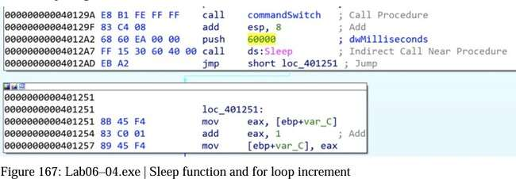

The for loop starts var_C at 0, and will break the loop once it reaches 1440. This means that there are 1440 60second loops, equalling 86400 seconds (24hours). The program may run for longer if the command instructs the switch within commandSwitch to sleep for

100seconds at any of the 1440 iterations.

**Practical 3**

**IDA Freeware,OllyDbg,PE bear**

a. Analyze the malware found in the file Lab07-01.exe.

**i. How does this program ensure that it continues running (achieves persistence) when the computer is restarted?**

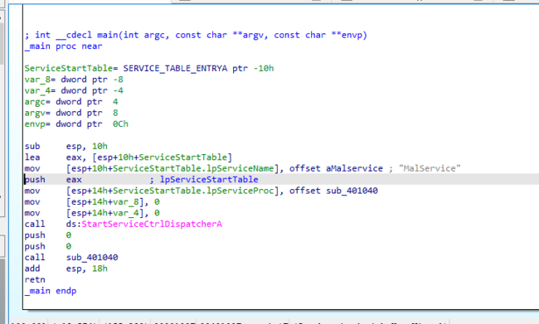

By examining the main function of this program, we can see reference to a service name ‘MalService’, a call to start the Service Control Dispatcher with the service control function sub_401040, and an associated call to a subroutine.

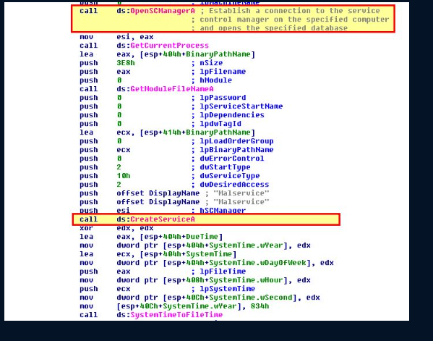

Within this subroutine we can see references to opening the Service Control Manager (SC Manager) and evidence of a service creation which will be used for persistence.

ii. Why does this program use a mutex?

The program uses a mutex to enmsure that only one instance of the program is running at any one time. The program attempts to get a handle on the mutex ‘HGL345’, and if it succeeds the program will terminate. If not, it will create a Mutex with this name.

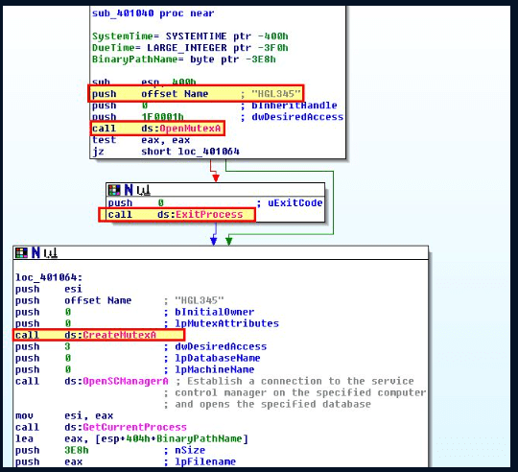

Q3.What is a good host-based signature to use for detecting this program?

Detection of this program can be done by checking any host for the hardcoded mutex ‘HGL345’ or by checking them for any service with the hardcoded name ‘MalService’.

Q4.What is a good network-based signature for detecting this malware?

For this go to function name tab select STARTADDRESS in IDAVIEW-A you will see this diagram

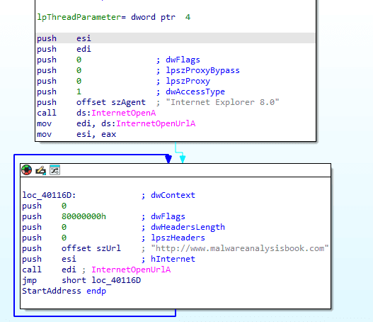

By examining the looping function of this program, we can see that it uses the User Agent “Internet Explorer 8.0” and communicates with the URL “http://www.malwareanalysisbook.com” which are network-based indicators which can be used to identify execution of this program.

v. What is the purpose of this program?

By examining the program’s execution after creating a service for persistence, we can see that it sets up a timer checking for when the year is 2100 (834h), or midnight on January 1st 2100. At this time it will create 20 (14h) threads and with them execute the subroutine pointed to by ‘StartAddress’.

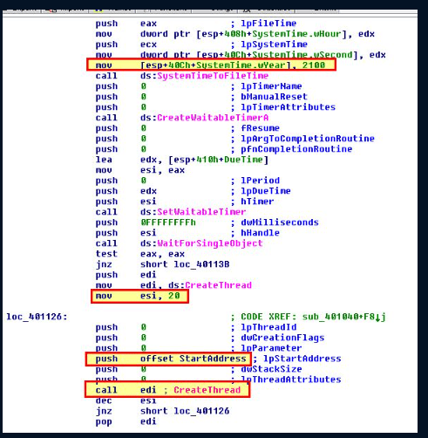

This routine attempts to open the URL http://www.malwareanalysisbook.com which leads us to believe that this is some sort of Denial of Service (DoS) program, which when multiple machines have this setup will cause a DDoS against <http://www.malwareanalysisbook.com>

vi. When will this program finish executing?

Looking back at the looping function mentioned previously, this function has no compare statement, and is an unconditional jump statement which runs the routine again. Based on this the program will never finish executing.

**b. Analyze the malware found in the file Lab07-02.exe.**

i. How does this program achieve persistence?

When examining the program, we can’t see any evidence of persistence being created. The program shows no evidence or strings relating to creation of common persistence mechanisms such as run keys, scheduled tasks, services, or startup files.

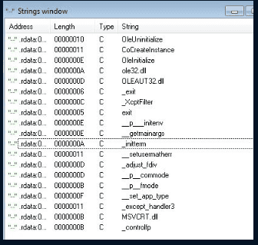

ii. What is the purpose of this program?

After open lab 07-02.exe files in IDA it will show

Based on the program executing OleInitialize, we can infer that this has execution of a COM Object, as this initialises the COM Library.

By viewing further we can see this indeed creates an object which is then passed execution of the string: http://www.malwareanalysisbook.com/ad.html

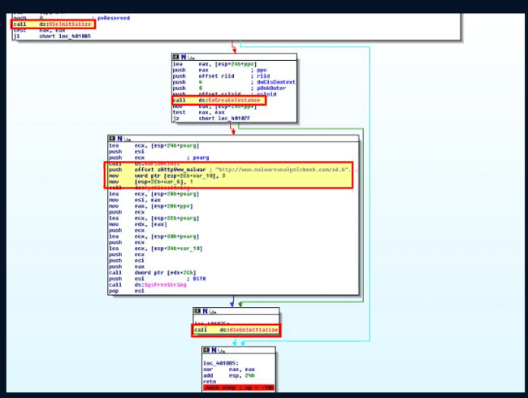

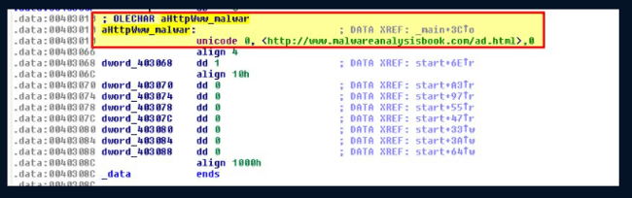

Based on this we can begin to assume this initialises a COM object (likely Internet Explorer) and uses this to open a URL with ad.html, which may infer this is associated with an advertisement. By running the executable we can confirm our assumptions are correct.

iii. When will this program finish executing?

The program finishes executing after it is run and the webpage is opened. It’s likely this is part of adware which has been dropped on a users machine, potentially as part of further bundled software or malware.

**c. For this lab, we obtained the malicious executable, Lab07-03.exe, and DLL, Lab07- 03.dll, prior to executing. This is important to note because the mal- ware might change once it runs. Both files were found in the same directory on the victim machine. If you run the program, you should ensure that both files are in the same directory on the analysis machine. A visible IP string beginning with 127 (a loopback address) connects to the local machine. (In the real version of this malware, this address connects to a remote machine, but we’ve set it to connect to localhost to protect you.)**

i. How does this program achieve persistence to ensure that it continues running when the computer is restarted?

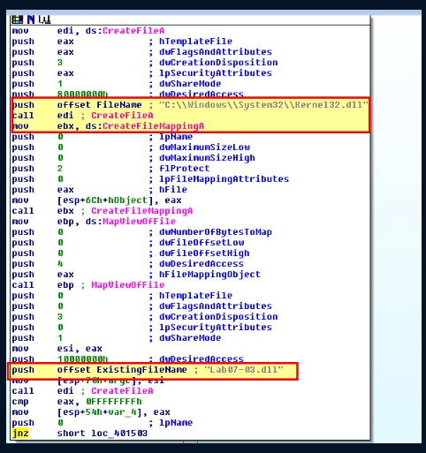

When examining the program and associated DLL we once again cannot see any obvious evidence of persistence; however there’s some elements which raise suspicions. First off the program shows reference to the DLL supplied with it (Lab07-03.dll), in addition to a well-known Windows DLL of kernel32.dll.

y examining the rest of the application, we can see reference to a similar, yet different DLL name of kerne132.dll, and reference to the supplied Lab07-03.dll DLL being copied into a file with this name at C:\Windows\System32 before we see a reference to subdirectories within C:\.

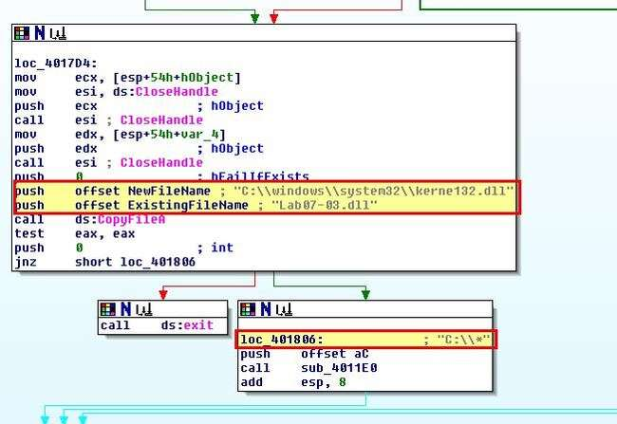

By looking inside the function call to sub_4011E0, within this we can see a statement that indicates files are being checked within C:\* which was passed to the program.

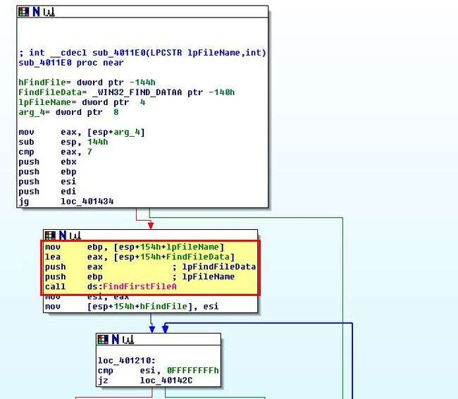

At this point a lot of comparisons and jump statements occur; however, this is of no interest to our analysis. By searching further within this function, we can see that a comparison occurs that checks if a file is a .exe, and if not a jump occurs.

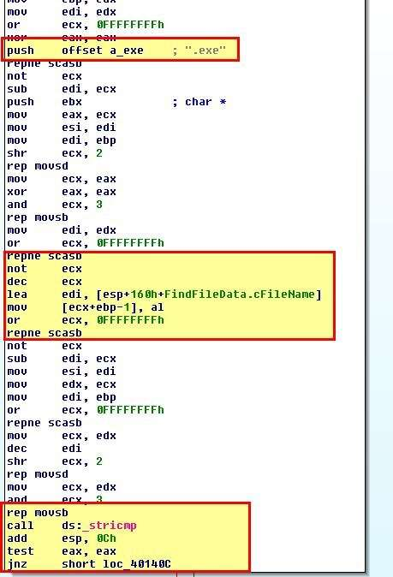

Based on this we can infer that something the file system located at C:\ is being recursively checked for .exe files, and if one is found something occurs. By checking the function sub_4010A0 which runs if the jump is not performed, we can gather what occurs when an executable file is found. 3 key calls we find are [CreateFile](https://docs.microsoft.com/en-us/windows/win32/api/fileapi/nf-fileapi-createfilea), [CreateFileMapping](https://docs.microsoft.com/en-us/windows/win32/api/winbase/nf-winbase-createfilemappinga), and [MapViewOfFile](https://docs.microsoft.com/en-us/windows/win32/api/memoryapi/nf-memoryapi-mapviewoffile).

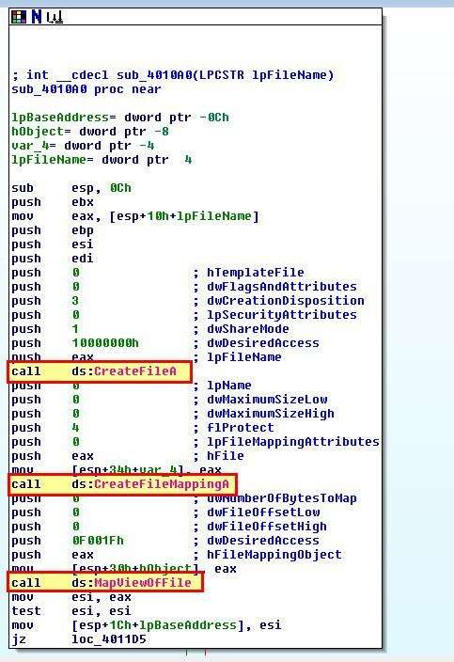

Based on this we can infer that if an executable file is located, it is is mapped into memory and can then be modified by this program. Looking further at the program we can see that it compares kernel32.dll to a location within the executable, and if it isnt found, it will jump and repeat the process. Where it is found it proceeds to copy a value referenced by dword_403010 over the top of it.

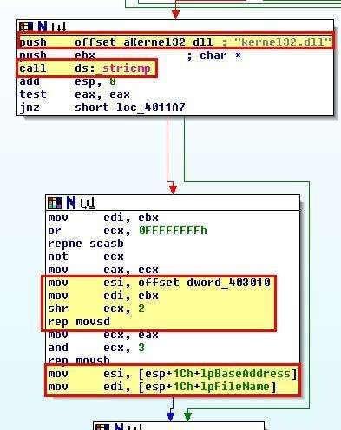

Looking into this IDA believes it is a DWORD value specified as ‘6E72656Bh’.

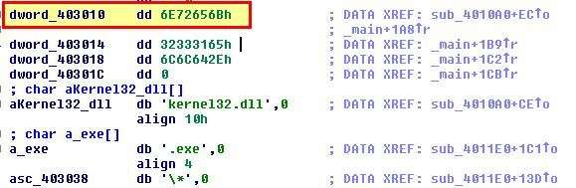

By converting this to an ASCII string using ‘A’ or Edit > Strings > ASCII, we can see that it translates to something more legible.

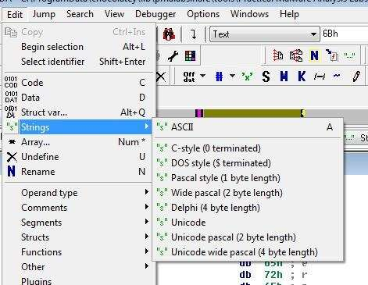

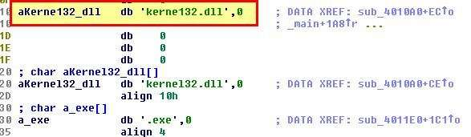

With this we can infer that the program searches for executables recursively within C:\, and when they’re found it will open them, and directly in memory modify the file to replace any instances of kernel32.dll with kerne132.dll for persistence. Based on this we can infer the program is a type of file infector and uses the copied kerne132.dll (Lab07-03.dll) for its main payload. A brief look into Lab07-03.dll confirms that this has some form of C2 function and is likely a malicious implant used in tandem with this executable.

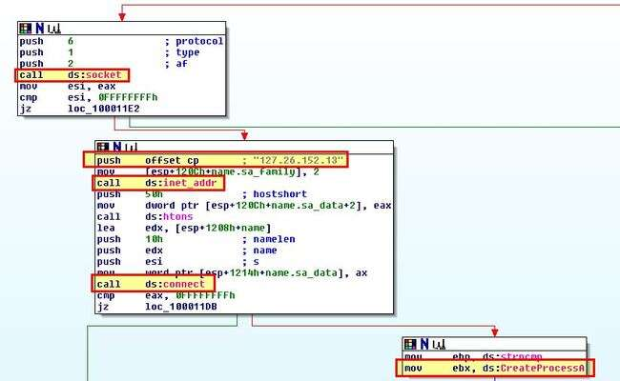

**Question 2**

ii. What are two good host-based signatures for this malware?

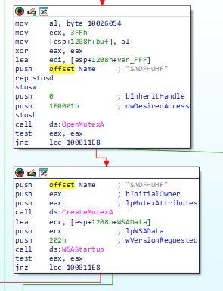

Two good host-based signatures for this malware include the presence of kerne132.dll on disk, and the presence of Mutex ‘SADFHUHF’ which can be found within Lab07-03.dll

iii. What is the purpose of this program?

From what we’ve gathered in question 1, we can conclude that this program is a file infector that infects executables on the system to load a malicious remote access trojan that connects back to the IP 127.26.152[.]13. By examining Lab07-03.dll, we can conclude that this trojan takes either the command sleep, or exec, which is used to start a process of interest.

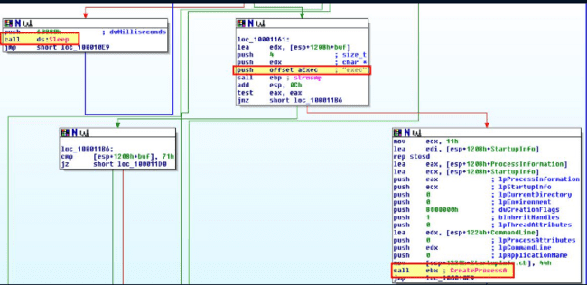

iv. How could you remove this malware once it is installed?

Due to the malware infecting every executable on disk it is very difficult to remove. You could remove the malicious kerne132.dll from disk; however, it’s likely this will be in use by every process and be unable to be removed. Further if it is removed during deadbox analysis, it is likely the system will crash when booting due to no variant of kernel32.dll being present. To remediate you’ll be able to modify kerne132.dll to be the legitimate kernel32.dll, or even change the malware actions and recompile to instead modify all executables to point to the legitimate kernel32.dll instead of kerne132.dll. As another resort it may be easier to rebuild the system or restore from backup.

d. Analyze the malware found in the file Lab09-01.exe using OllyDbg and IDA Pro to answer the following questions. This malware was initially analyzed in the Chapter 3 labs using basic static and dynamic analysis techniques.

i. How can you get this malware to install itself?

For this use software names OllyDbg

Opening up the malware in OllyDbg open files select lab09-01.exe

we can see that it immediately pauses as soon as it hits the specified executable entry point.

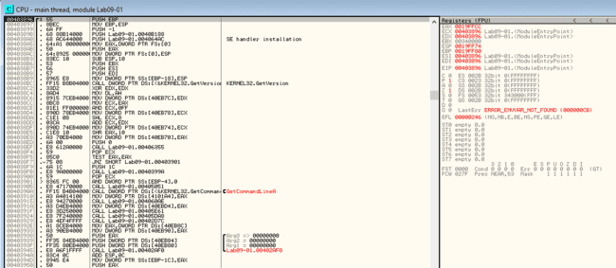

By examining the function at address 0x403945 we can see that 3 arguments are available to be passed to the program and what looks to be the start of the main function.

Using F8 we can step over instructions of the program, and once we reach the instruction past ‘GetCommandLine’, we can see that EAX has been updated to reflect the program command line, which in this case was running the application without any arguments.

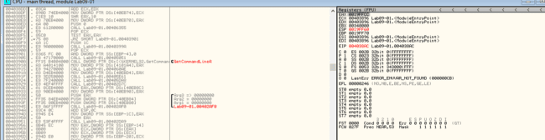



Once we reach the main function, if we press F8 the program runs through it which isn’t what we want. By pressing F7 we can step into the function to continue analysis with F8.

Upon hitting 0x402AFD we can see a comparison takes place to see if the number of arguments passed to the program is equal to one.

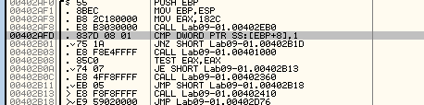

As no arguments were passed the comparison fails. As such a jump is not taken and the program continues to call 0x401000.

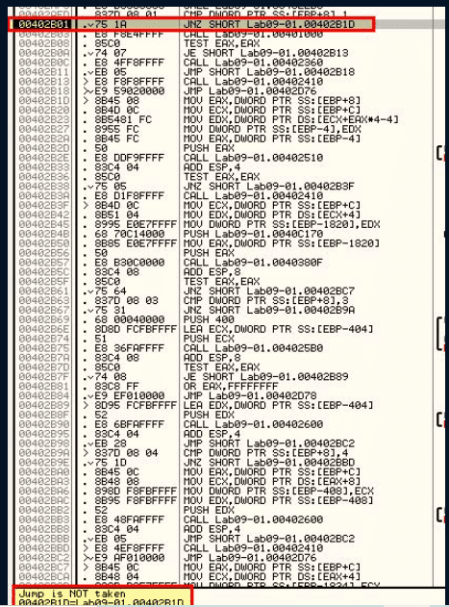

Once again by stepping into this with F7 we can examine some more. Inside this function stands out a particular check for what looks to be a typo’d registry key ‘HKLM\SOFTWARE\Microsoft \XPS’. As this doesn’t exist the jump statement after is never taken and we instead jump to 0x401066 (once again we can step into this with F7).

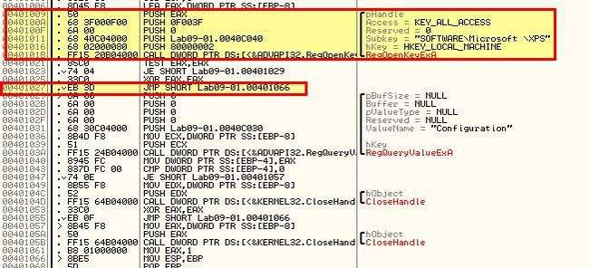

After this a return occurs and after a few more comparisons we wind up at 0x402410. By stepping through this once more, using F8 to skip Windows API calls as required, we find that the malware begins to build an instruction designed to delete the malware as it was run without any kind of parameters. This is a common anti-analysis technique.

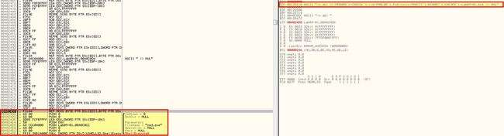

Because we’re running the program in OllyDbg an open handle exists on the program and deletion fails.

At this point we know that running the program is not enough to install it, so we re-examine the comparisons undertaken when the program runs, first up is ‘-in’.

By using Debug > Arguments, we can add in -in as a command line argument and restart using CTRL+F2. Once again we move through analysis, except this time a Jump is taken, and we can see a comparison will be run on our provided argument ‘-in’.

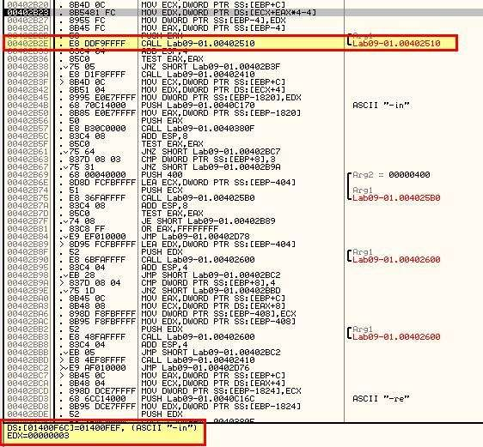

Looking inside of 0x402510 which is called we can see that a number of arithmetic operations occur but no functions are called. In this instance it looks to be a check for certain characters, so we can assume that ‘-in’ may be for installing the malware, and this may be checking for some sort of password. What we’re aiming to achieve from this function is to return EAX with a value of 1 (signifying a success in relation to the calling conditions). Highlighted in red are conditions that if evaluated will jump past the statement that sets EAX to 1. Highlighted in blue is our end goal, but as we can see straight away the first comparison fails and we jump straight to the end of the function without setting EAX to 1.

One way to completely bypass the check is to patch it so that it returns with EAX = 1, or by modifying the value of EAX to return one after the checks fail.



This time by stepping through we can see that a jump does occur and we move past 0x402410 that executes binary deletion.

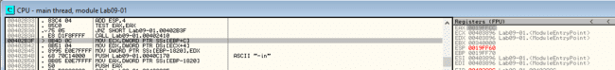

Stepping through we hit another function at 0x40380F. If we continue to step through this we will see more comparisons taking place to ensure that the parameters provided match expected parameters of the program. This passes; however, at one point we will find ourself falling back into 0x402410 again due to a comparison that checks if more than 3 elements have been passed to the program (noting that the application name is passed as an argument). Due to the comparison failing we wind up again in a state of deletion.

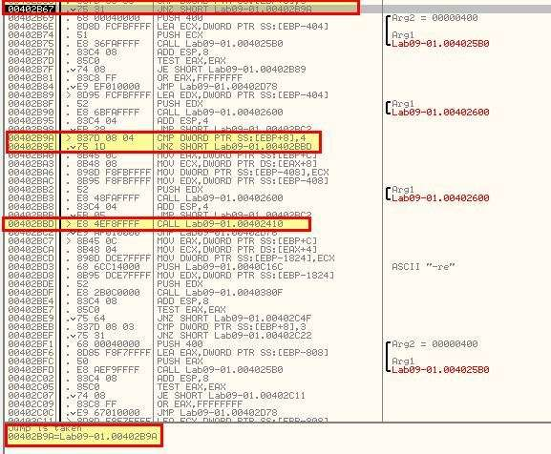

After stepping over this function we can see that a service has been created pointing to %SYSTEMROOT%\system32\Lab09-01.exe and that the malware has indeed copied itself to this directory indicating it has been successfully installed.

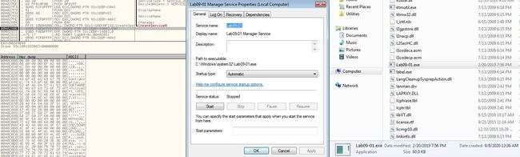

ii. What are the command-line options for this program? What is the pass word requirement?

Answers - n addition to the mentioned ‘-in’ argument check, we can see 3 other command-line options in this malware. “-re” “-c” and “-cc”

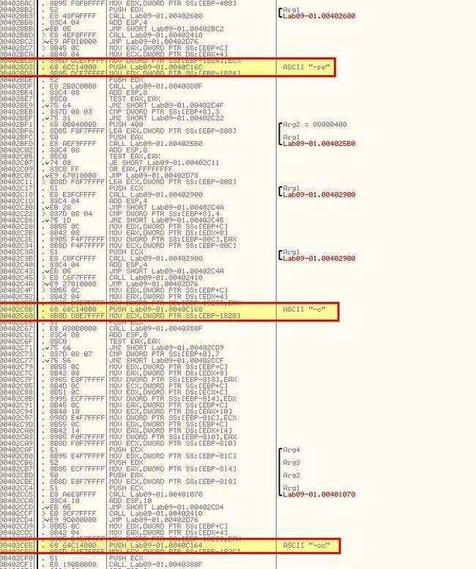

The password requirement mentioned previously can be uncovered by carefully examining how many checks occur in this function and breaking down what each comparison is used for knowing that we want their comparisons to be true. As such we need to also look at activity occurring before the comparison, and if required examine the current stack content as we move through it.

First off we can see that the password is 4 characters long, then we look for it containing (61) ‘a’ as the first letter, then we compare the result of letter 2 (62) take letter 1 (61) and see if it equals 1, then we compare whether the next character is c (63), before finally adding 1 to this and checking if the next character is d (64).

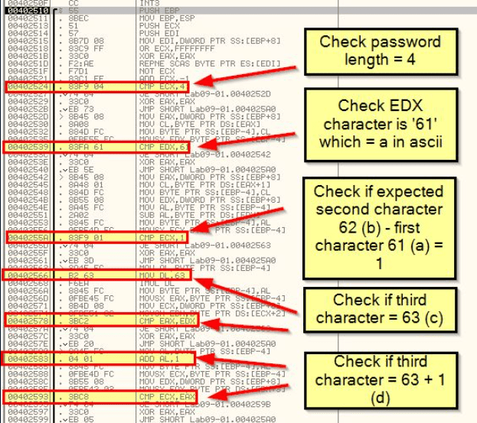

If we break down how the value ‘b’ is obtained, we can see that it is derived directly from what we’ve pushed to the stack.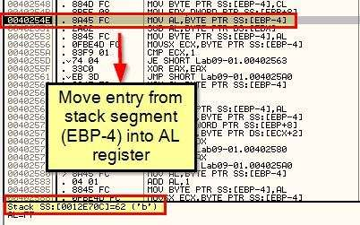 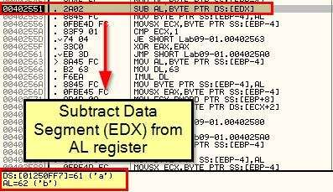 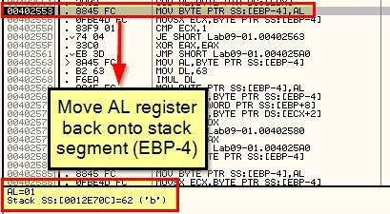 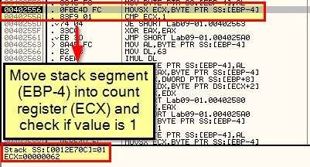

By using the ‘-re abcd’ argument (or any of the others, we can see this still performs the same password check, so this indicates abcd needs to be passed to the malware to run unless you want it to simply remove itself.

By stepping through and stepping over this execution as required, we reach a point where the Service Control Manager is instructed to delete a service.

By using the ‘-cc abcd’ argument we see that the application looks for its current configuration that’s been stored at: ‘HKLM\SOFTWARE\Microsoft \XPS’ and dumps it to the programs output.

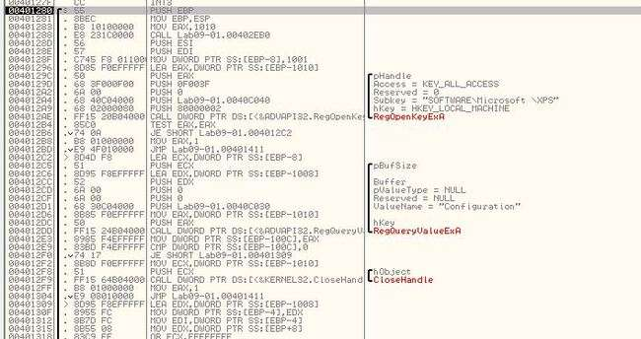 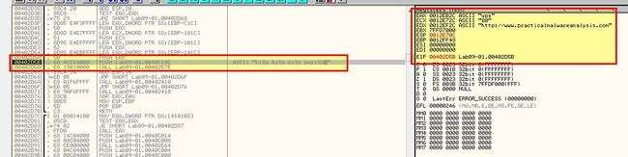 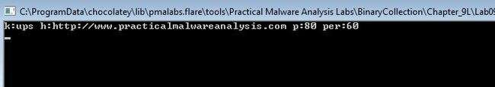

iii. How can you use OllyDbg to permanently patch this malware, so that it doesn’t require the special command-line password?

**Answer** As mentioned in answer 1, this malware can be patched under 0x402510 to always return with EAX = 1. To do this we right click the start of the function call, click edit, and use the assocviated HEX values to make it assign EAX as 1.

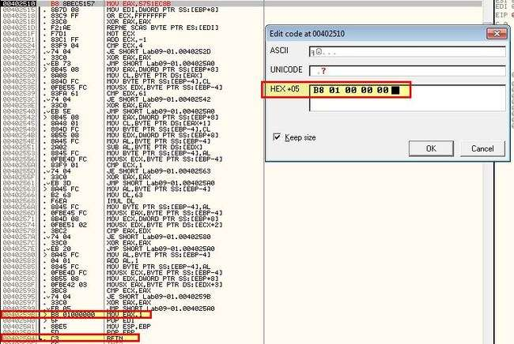

After this we edit the next HEX values to immediately make it return from the function signalling a successful outcome.

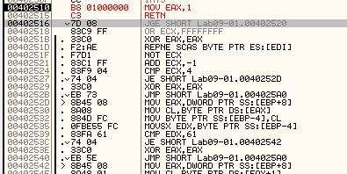

To patch the binary we can right click and select copy to executable > all modifications, before right clicking and selecting save file. At this point if we open the modified binary and run as normal, we can now run commands without the need for a password.

What are the host-based indicators of this malware?

Host-based indicators of this malware include the registry key used to store the malware configuration:

* ‘HKLM\SOFTWARE\Microsoft \XPS’

The service created for persistence with the name:

* “ Manager Service"or
* “ Manager Service"

and finally the presence of a binary at:

* %SYSTEMROOT%\Windows\System32

With the name of the service name argument passed, or the binary name.

v. What are the different actions this malware can be instructed to take via the network?

For this use procexp software or use IDA freeware software

By opening this using IDA we can find sub_402020 which contains a number of instructions that help determine what different actions this malware can be instructed to take. This is also seen at 0x402020 in OllyDbg.

In this instance functions have been renamed to “Command_*” for readability.

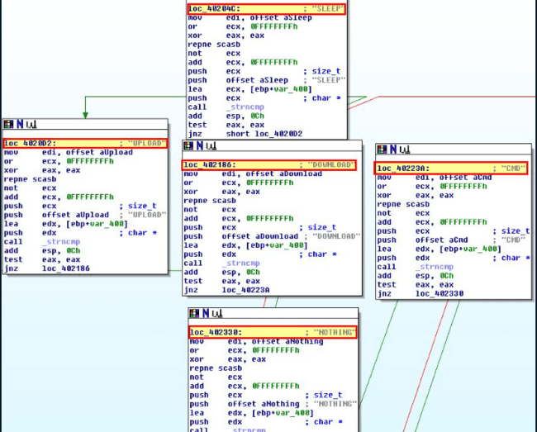

* SLEEP: Do nothing for a certain amount of seconds. Note: This is registered in milliseconds so the value passed is multiplied by 1000.

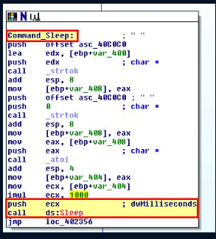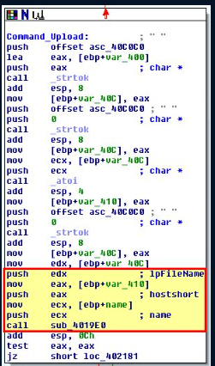

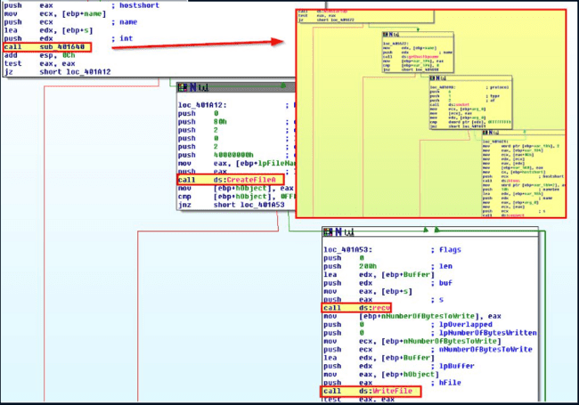

After uploading file it will show this is format where is the call function

* DOWNLOAD: Upload a file from disk to a web resource. Note: This isn’t a typo, in this instance download is in fact uploading to a remote the host.

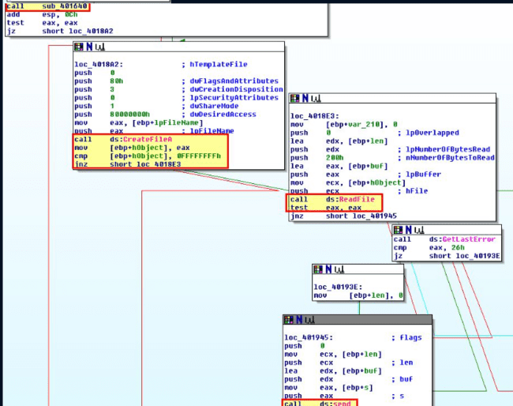

* CMD: Execute a command and send back the output to a web resource.

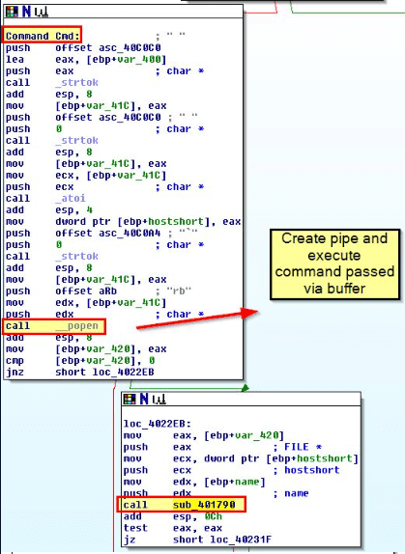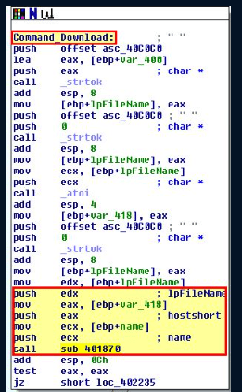

* NOTHING: Do nothing

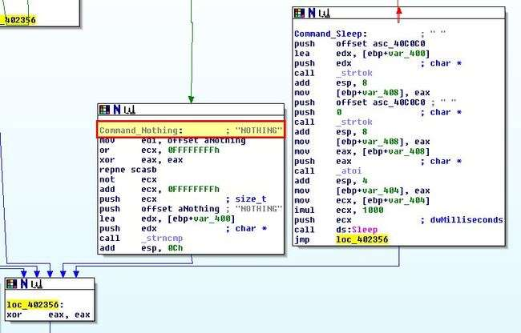

vi. Are there any useful network-based signatures for this malware?

For this use software called IDA freeware

We know from previous analysis of this malware that configuration is stored in the registry so by default it communicates with:

* http://www.practicalmalwareanalysis.com

To analyse how this communication occurs and whether there’s any other network-based indicators we look back to sub_402020 and the function it calls prior to comparing the response received to one of the mentioned commands. This function is sub_401E60.

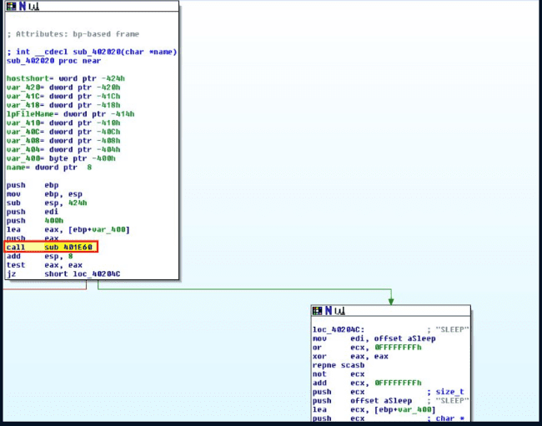

This contains a number of unusual string comparisons and operations based on backticks and apostraphes.

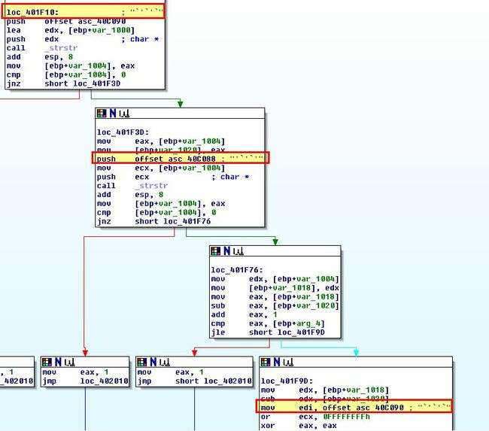

Moving back to Ollydbg we can move back to debugging the application in an attempt to understand this. Starting out we add a breakpoint at 0x401E60 by using CTRL + G to jump to this address and using F2 to toggle a breakpoint.

We need to confirm the application isn’t running with any command line parameters and move through with F8 until the breakpoint we set is hit. From here we can begin to analyse specific register or stack values before and after a number of subroutines are run by setting breakpoints similar to the below

After running through the first function by using F9 twice, we see reference to WinINet API and the previously mentioned domain which leads us to believe this is likely using FTP or HTTP for communication.

Repeating the process with F9 twice reveals our ECX register with the value ‘80’.

Based on what we know and it being stored in a value ‘p’, we can infer that this is the port that the malware communicates via. Repeating the process once more reveals what looks like it may be part of a URL

By repeating the process once more we see that it fails to run through to our later break points in our isolated environment. Subsequent analysis shows that the URL elements mentioned above change. If we step through to 0x401EF9 we can see that this is indeed being passed as an argument to a function at 0x401AF0.

Stepping into this function we can see evidence this is making a HTTP/1.0 Get request to the server for C2 without any headers.

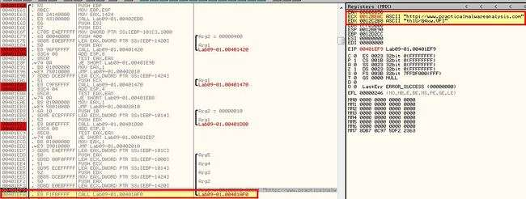

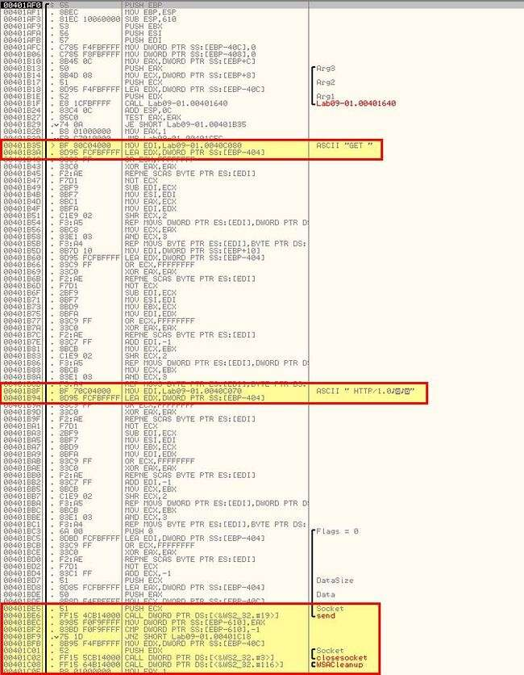

After the request is made there are some comparisons based on returned backtick and apostraphes as we found earlier, and this looks to be determining exactly how the C2 process will execute the command passed to it (how the C2 protocol works).

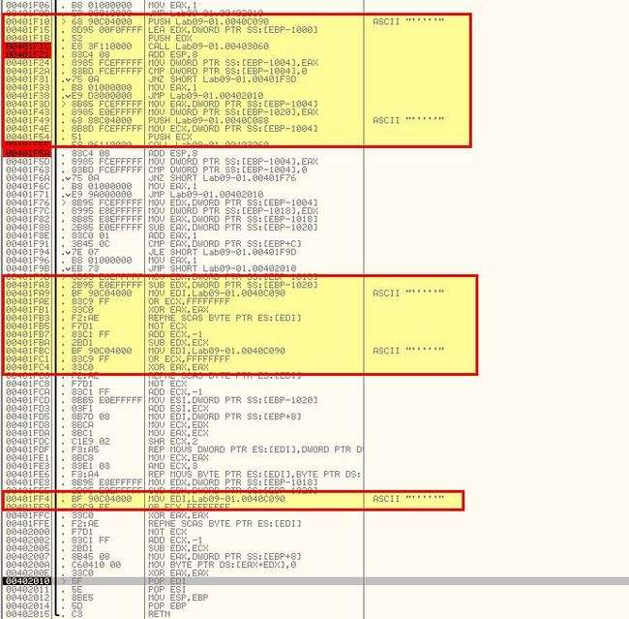

Based on all of this we can conclude that Get requests using HTTP/1.0 beaconing to http://www.practicalmalwareanalysis.com/xxxx/xxxx.xxx without any headers or user agent is a network indicator of this malware.

e. Analyze the malware found in the file Lab09-02.exe using OllyDbg to answer the following questions.

i. What strings do you see statically in the binary?

Running Strings over the binary reveals a number of entries for what look like imports or function names, and ‘cmd’, but other than that not a lot else.

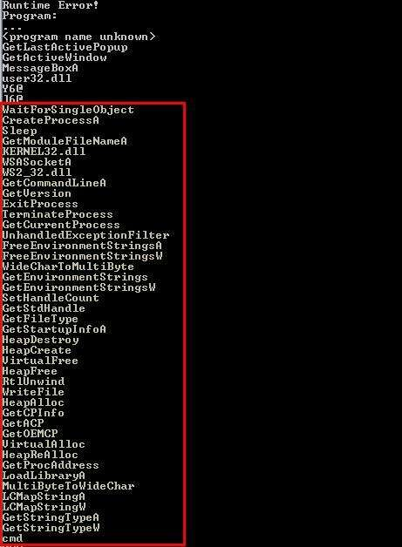

ii. What happens when you run this binary?

Attempting to run the binary results in it terminating almost instantly without showing any other visible actions.

iii. How can you get this sample to run its malicious payload?

By stepping through the program with a debugger and a few break points, we can see that after the call at 0x401626, EDX is filled with the value “ocl.exe”, and this remains throughout the program until a comparison check to it fails and the program terminates.

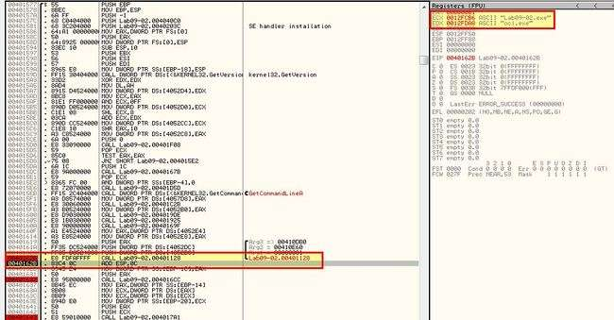

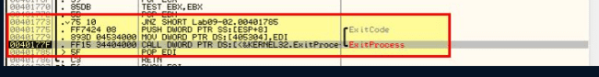

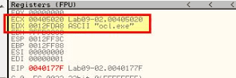

Based on this we can assume that the program checks if it is named ocl.exe, and if it isn’t then it terminates. If we rename it and continue to debug, we realise that termination doesn’t occur here anymore.

iv. What is happening at 0x00401133?

f we examine 0x00401133 we can see that a number of Hex values are being moved onto a relevant area of the stack segment.

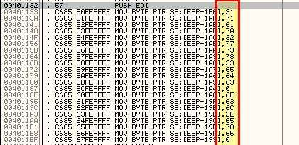

This is a common string obfuscation technique to make analysis more challenging.

If we take the hex values accounting for the null values present and convert this to ascii we get the following:

* 31 71 61 7a 32 77 73 78 33 65 64 63 = 1qaz2wsx3edc
* 6F 63 6C 2E 65 78 65 = ocl.exe

v. What arguments are being passed to subroutine 0x00401089?

Adding breakpoints and running through the application later reveals the presence of 1qaz2wsx3edc which is being passed to subroutine 0x00401089 and a pointer to 0x12FD58 (Incl ESI).

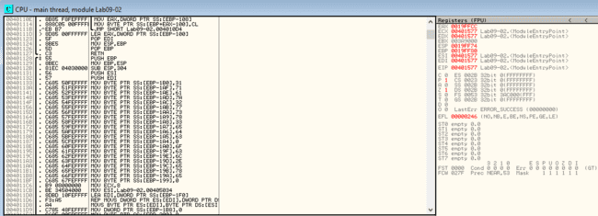

vi. What domain name does this malware use?

By running through this program to our next breakpoint we can see that it flows through the decoding routine at 0x00401089 and reveals the domain used by this malware in EAX ready to be passed to the ‘gethostname’ imported function: [www.practicalmalwareanalysis.com](http://www.practicalmalwareanalysis.com)

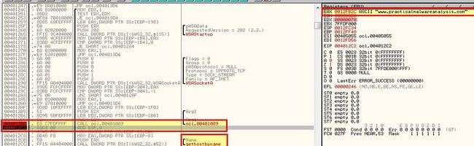

vii. What encoding routine is being used to obfuscate the domain name?

To figure this out we need to move into the encoding routine at 0x00401089. Here we can see a routine that loops and contains reference to an XOR command against EDX (which we know contains the random string we discovered earlier).

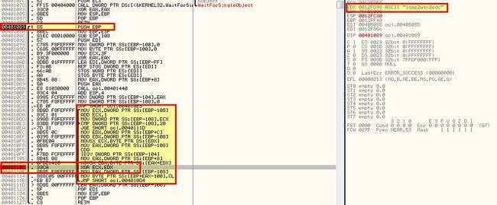

By adding a breakpoint at this command and running the program we can see that it performs this XOR against a letter one by one, and in the first instance it XORs 46 and 31 (first letter of our key).

Running the program again reveals it XORs 6 and 71 (second letter of our key)

By creating a break point at the comparison statement that occurs, and following the associated memory dump, we’re able to see the string being decoded in real time as we run through the program and hit our breakpoints.

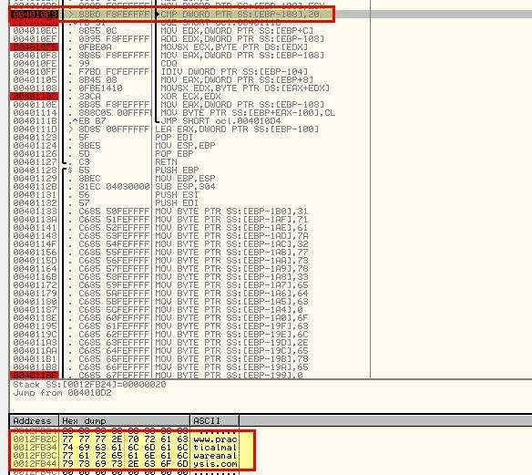

viii. What is the significance of the CreateProcessAcall at 0x0040106E?

for this use OllyDbg software upload the files mentioned above in the main question

This function isn’t called when we run through the program as there’s no successful beacon to the C2 we uncovered previously. Having said this we can see from this function that CreateProcessA looks to be run with cmd.exe as the process before waiting indefinitely in a loop

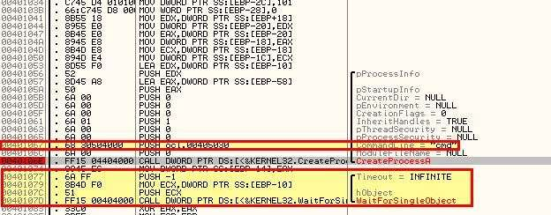

By examining this in IDA Freeware for more context, we can see that it is making the cmd.exe window hidden, in addition to specifying the standard input, output, and error streams be sent to an argument that’s passed into this function

. 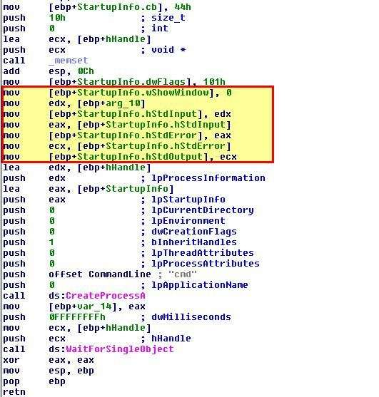

Looking at the only calling function to this, we can see that the argument passed to this is the established socket to the C2. We now know that this process acts as the reverse shell allowing access to this host.

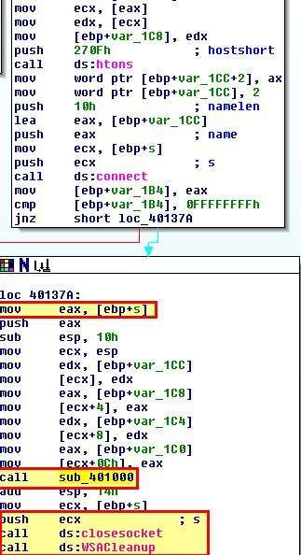

f. Analyze the malware found in the file Lab09-03.exe using OllyDbg and IDA Pro. This malware loads three included DLLs (DLL1.dll, DLL2.dll, and DLL3.dll ) that are all built to request the same memory load location. Therefore, when viewing these DLLs in OllyDbg versus IDA Pro, code may appear at different memory locations. The purpose of this lab is to make you comfortable with finding the correct location of code within IDA Pro when you are looking at code in OllyDbg

i. What DLLs are imported by Lab09-03.exe?

Upload the files in IDA freeware go to import there you will see all the library that are imported

In addition to these, if we examine calls to the WinAPI ‘LoadLibraryA’, we can find another 2 DLLs that are dynamically loaded into memory from the running program.

* DLL3.dll
* user32.dll

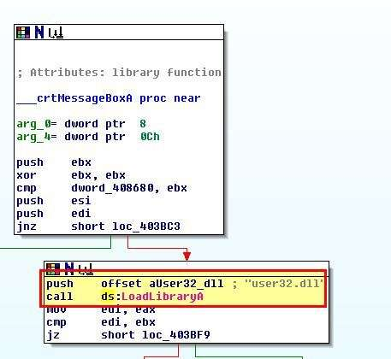

ii. What is the base address requested by *DLL1.dll*, *DLL2.dll*, and *DLL3.dll*?

By opening these up in PE-bear, we’re able to see that they all have an image base set to 0x10000000.

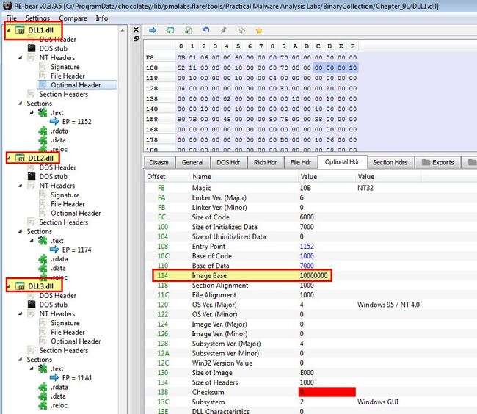  
iii. When you use OllyDbg to debug *Lab09-03.exe*, what is the assigned based address for: *DLL1.dll*, *DLL2.dll*, and *DLL3.dll*?

Because we know that DLL3.dll is dynamically loaded in we’ll need to add a breakpoint after this loadlibrary call to check when all 3 are loaded into memory.

To view where these are in memory we can use ALT+M to view the programs memory. Note: These values will likely differ per run through or system.

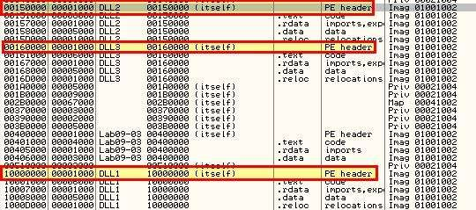

In this instance the results are:

* DLL1: 0x10000000
* DLL2: 0x00150000
* DLL3: 0x00160000

iv. When *Lab09-03.exe* calls an import function from *DLL1.dll*, what does this import function do?

Because this occurs prior to the breakpoint we previously set, we can get our first glimpse on what has happened by viewing the program output while it is at our breakpoint.

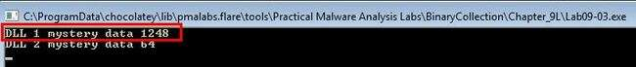

This appears to display an output of “DLL 1 mystery data”, and then a number. By disassembling this in IDA we can get more information on what is happening.

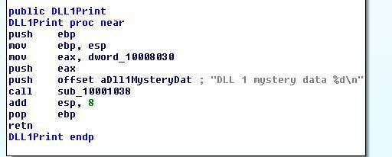

Based on this we conclude that this is printing out the current processID of the process in which the DLL has been loaded into.

v. When *Lab09-03.exe* calls WriteFile, what is the filename it writes to?

To get this answer we need to look at both DLL2.dll, and Lab09-03.exe. In Lab09-03.exe we can see that this calls and moves the output into ebp+hObject before passing it a buffer of the characters “malwareanalysisbook.com” to write.

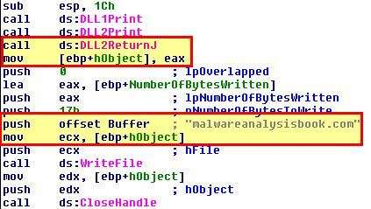

By examining DLL2.dll, and looking at the exported DLL2ReturnJ function, we can see that this returns a value stored under dword_1000B078. When we examine this we can see it is being assigned based on the DLLs Main method as a handle to a file with the name “temp.txt”.

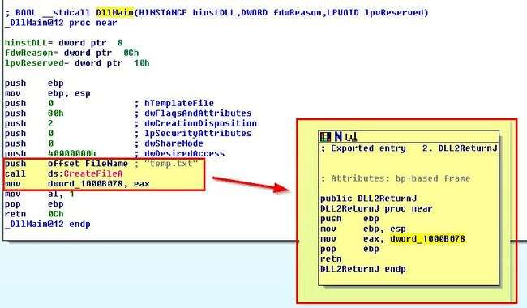

Based on this we know that this writes “malwareanalysisbook.com” into a file called “temp.txt”.

vi. When *Lab09-03.exe* creates a job using NetScheduleJobAdd, where does it get the data for the second parameter?

Ans Use IDA freeware software to find out.

If we look at this execution we can see that it passes 3 parameter items: JobID, Buffer, and Servername.

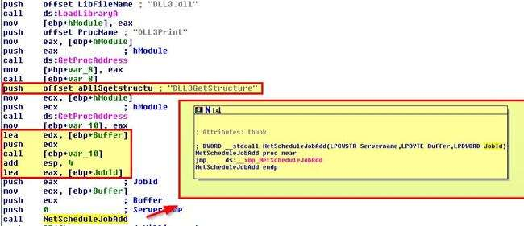

Buffer is called from the output of Dll3GetStructure which once again is determined by the DLLs main function. 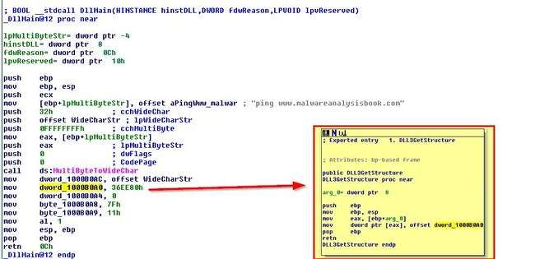

f we examine the [NetScheduleJobAdd function documentation](https://docs.microsoft.com/en-us/windows/win32/api/lmat/nf-lmat-netschedulejobadd) we can see that buffer needs to be a pointer to an AT_INFO structure defining the job to submit.

By using IDA we can add in the AT_INFO structure and then apply this to dword_1000B0A0. After first adding it to the structures window:

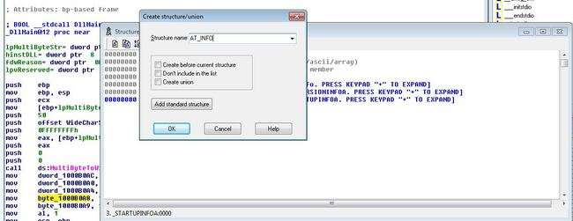

By viewing dword_1000B0A0 in memory and clicking Edit > Struct Var to AT_INFO we can change this directly and make more sense of the data at hand.

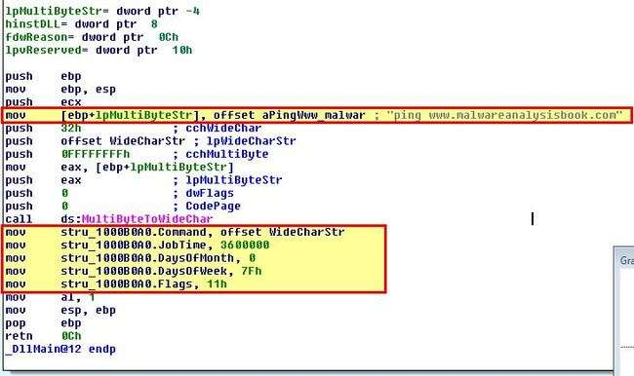

Based on this we can see that it will ping www.malwareanalysis every day at 3600000 milliseconds (60mins) past midnight (1am).

While running or debugging the program, you will see that it prints out three pieces of mystery data. What are the following:

DLL 1 mystery data 1, DLL 2 mystery data 2, and DLL 3 mystery data 3?

We already know what these are by the analysis conducted in previous questions. These are outputted from the values found in our relevant DLL files.

* DLL 1 mystery data 1: Process ID DLL is running under. (This was found in Question 4)
* DLL 2 mystery data 2: Handle ID for the Handle on file temp.txt. (This was found in Question 5).
* DLL 3 mystery data 3: Memory location of “ping www.malwareanalysisbook.com”. (This was found in Question 6).

**Practical No. 4**

**Process Monitor**

**a. This lab includes both a driver and an executable. You can run the executable from anywhere, but in order for the program to work properly, the driver must be placed in the C:\Windows\ System32 directory where it was originally found on the victim computer. The executable is Lab10-01.exe, and the driver is Lab10-01.sys**

**i. Does this program make any direct changes to the registry?**

By running procmon and filtering on reg set events related to the executable lab10-01, we can see that only one direct change to the registry has been recorded: HKLM\SOFTWARE\Microsoft\Cryptography\RNG\Seed.

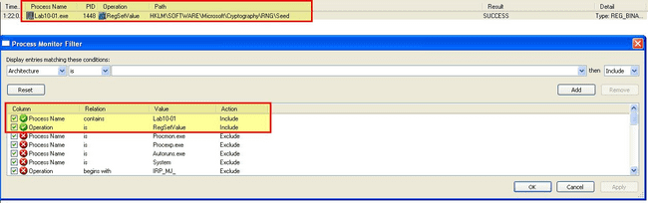

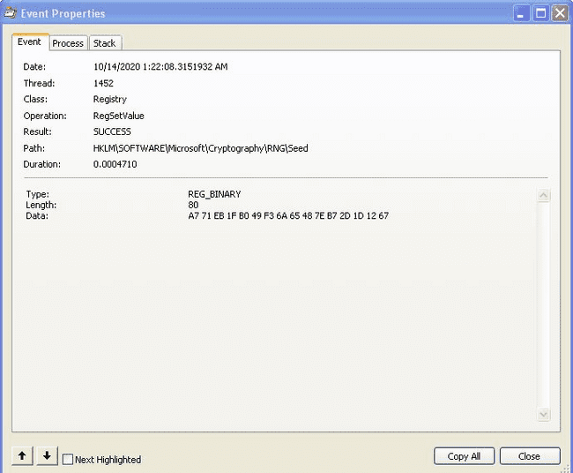

**ii. The user-space program calls the ControlService function. Can you set a breakpoint with WinDbg to see what is executed in the kernel as a result of the call to ControlService?**

To do this we will need to setup a breakpoint using WindDbg in our VM and be analysing kernel operations using WinDbg on our host. First we need to determine where the breakpoint in our VM will be that calls the ControlService function.

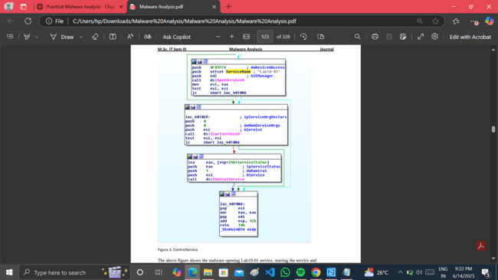

Next, while running our VM with debugging enabled and connected to our host instance of WinDbg, we open this executable in WinDbg (in our VM) and set a breakpoint at this address.

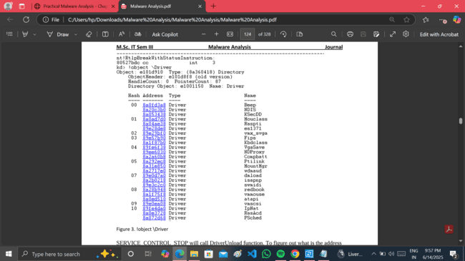

SERVICE_CONTROL_STOP will call DriverUnload function.

**kd> bu Lab10_01!DriverEntry**

Lab10_01.sys is loaded. Use step out till you see this nt!IopLoadUnloadDriver+0x45.

**kd> !object** **\Driver**

to list the loaded drivers, then we use display type (dt) to display out the LAB10-01 driver.

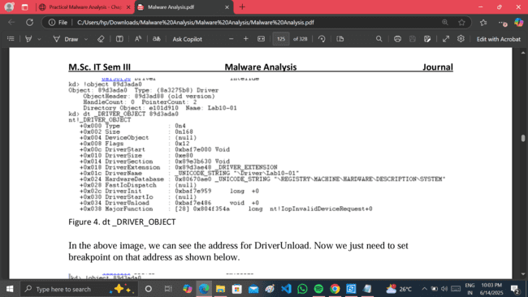

dt _DRIVER_OBJECT

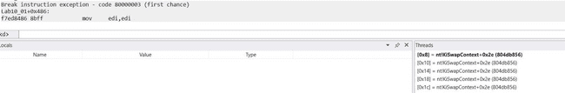

Breakpoint

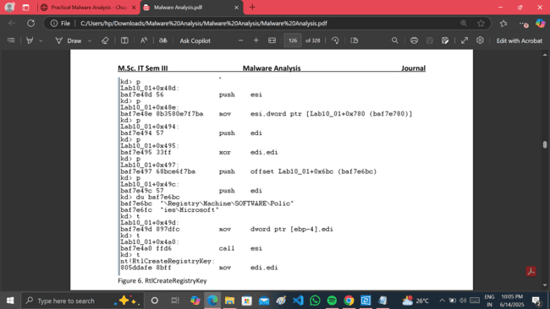

RtlCreateRegistryKey

The following image is the dissembled code of the driver in IDA Pro.

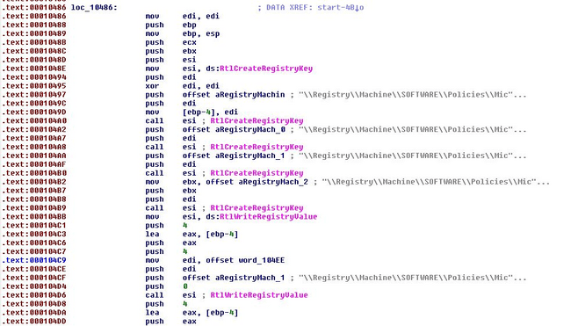

**iii. What does this program do?**

The malware creates a service Lab10-01 that calls the driver located at “c:\windows\system32\Lab10-01.sys”.we can examine the binary in question within IDA and see it creates a kernel service which is then used to stealthily update the registry to disable the Windows Firewall before being unloaded.

The following are the registry modification made by the driver.

• RtlCreateRegistryKey: \\Registry\\Machine\\SOFTWARE\\Policies\\Microsoft

•RtlCreateRegistryKey:\\Registry\\Machine\\SOFTWARE\\Policies\\Microsoft\\WindowsFirewall

•RtlCreateRegistryKey:\\Registry\\Machine\\SOFTWARE\\Policies\\Microsoft\\WindowsFirewall \\DomainProfile

•RtlCreateRegistryKey:\\Registry\\Machine\\SOFTWARE\\Policies\\Microsoft\\WindowsFirewall\\StandardProfile

•RtlWriteRegistryValue:\\Registry\\Machine\\SOFTWARE\\Policies\\Microsoft\\WindowsFirewa ll\\DomainProfile – 0 (data)

•RtlWriteRegistryValue:\\Registry\\Machine\\SOFTWARE\\Policies\\Microsoft\\WindowsFirewa ll\\StandardProfile – 0 (data)

**b-The file for this lab is Lab10-02.exe**

**i. Does this program create any files? If so, what are they?**

By running this program and examining it with Procmon we can see that it creates a kernel driver and writes it to disk.

C:\Windows\System32\Mlwx486.sys

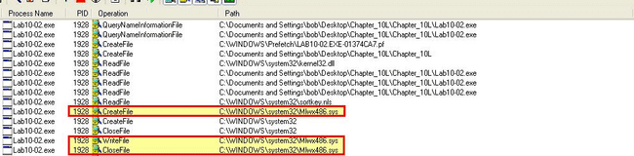

We can see the files are loaded.

By examining the imported functions of this binary using peview, we can see that it is likely going to examine the contents of its resource section and write a file to disk. This helps to confirm what we saw with Procmon.

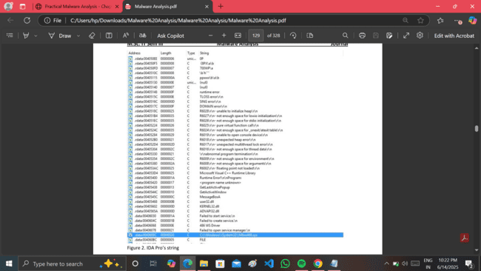

IDA Pro’s string

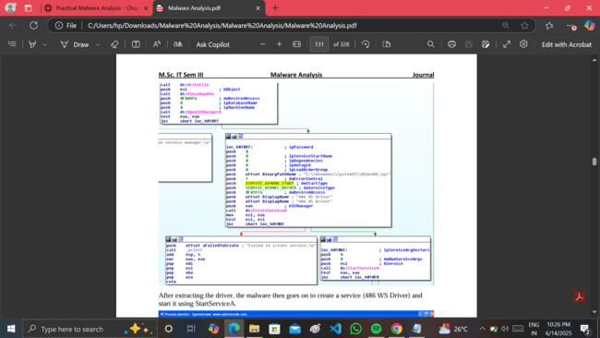

After extracting the driver, the malware then goes on to create a service (486 WS Driver) and start it using StartServiceA.

**ii. Does this program have a kernel component?**

Upon analyzing the resource section of lab10-02.exe with the aid of resource hacker, we can confirm that it conceals an executable of a certain nature. In this case, the Program Database (pdb), which contains debugging references, further suggests that this may include a kernel component or rootkit.

**iii. What does this program do?**

DrierEntry directs us to the subsequent subroutine in IDA Pro (0x10706). The malware is attempting to alter the flow of the kernel Service Descriptor Table, specifically targeting the NtQueryDirectoryFile for hooking. The malware invokes

MmGetSystemRoutineAddress to retrieve the pointer to both the NtQueryDirectoryFile and the KeServiceDescriptorTable subroutine. It then iterates through the service descriptor table in search of the address of NtQueryDirectoryFile. Upon locating it, the malware will replace the address with a malicious hook (custom subroutine).

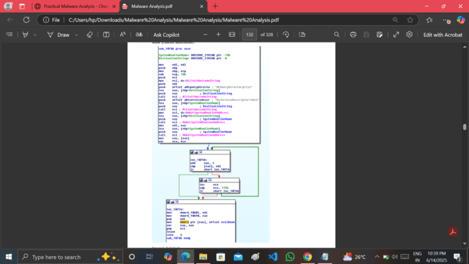

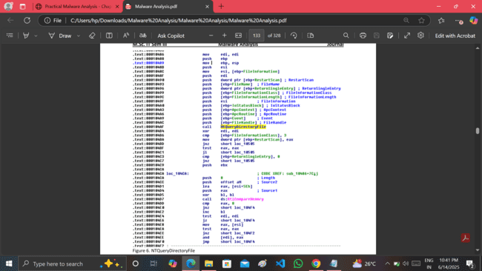

NTQueryDirectoryFile

In the driver, the NTQueryDirectoryFile function is utilized. As stated by MSDN, this function provides various types of information regarding files within the directory identified by a specific file handle. Additionally, it is noted that RtlCompareMemory is invoked.

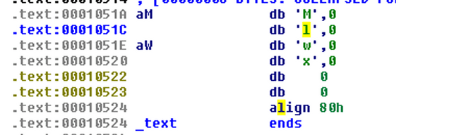

Mlwx string

**kd> dps nt!KiServiceTable l 100**

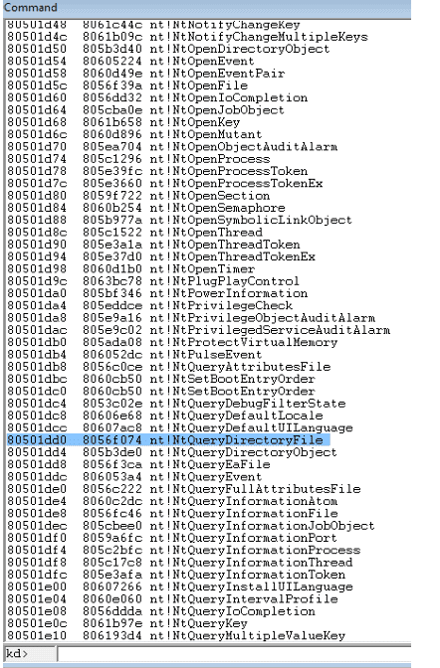

Default Service Descriptor Table

To set a breakpoint, use the command bu Mlwx486!DriverEntry. Then, run Lab10-02.exe and windbg should hit the breakpoint. Next, set a breakpoint at nt!IopLoadDriver+0x66a and let the program continue running. When the kernel breaks, you can execute !object \Driver to see the loaded drivers. At this point, DriverInit for the malware hasn't been executed yet, so you can set your breakpoint from here.

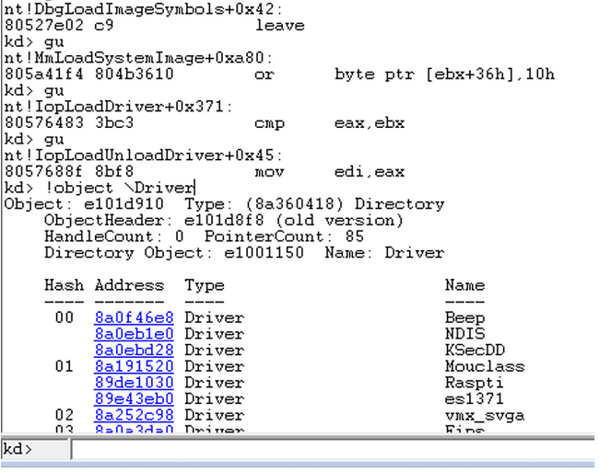

Break @ DriverEntry

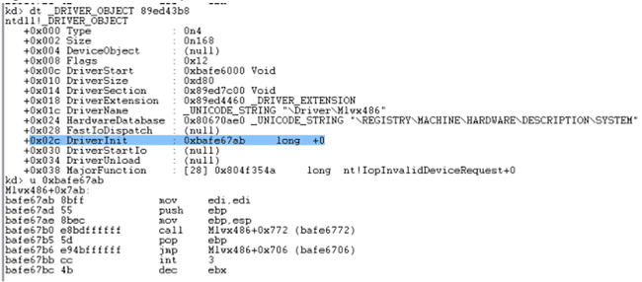

DriverInit

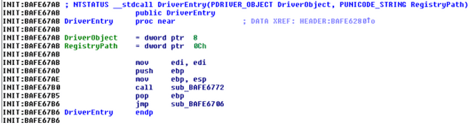

DriverEntry

Running kd> dps nt!KiServiceTable l 100 now indicates that the service descriptor table has been altered.

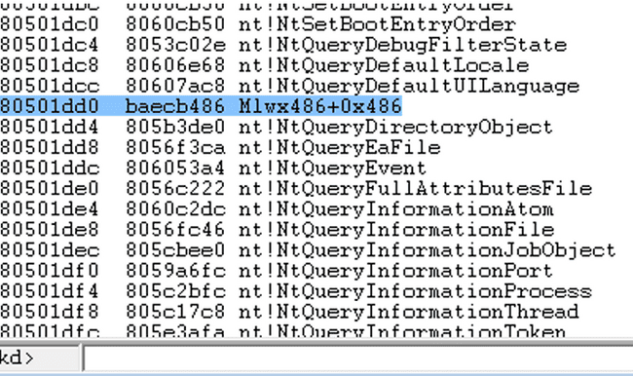

Service Descriptor Table modified

In conclusion, the malware employs a ring 0 rootkit to conceal files that begin with "Mlwx" by hooking into the service descriptor table.

**PRACTICAL NO: 5**

**Cerefire Profiler,PPEE(puppy),IDA**

**A -Analyze the malware found in Lab11-01.exe**

**i). What does the malware drop to disk?**

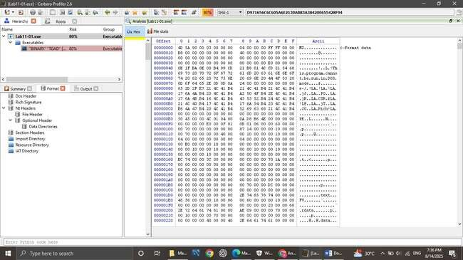

Figure 1. Binary resource in Lab11-01.exe’s TGAD

There is a binary in the resource section of Lab11-01.exe. **ii. How does the malware achieve persistence?**

As shown above persistence is achieved by registering msgina32.dll, which is pulled from its resource section, as a custom GINA DLL in the Windows Registry at the below location:

• HKLM\SOFTWARE\Microsoft\Windows NT\CurrentVersion\Winlogon\GinaDLL

By examining the documentation on [GINA,](https://docs.microsoft.com/en-us/windows/win32/secauthn/gina) we can see that this is loaded into winlogon, and can have credentials passed through it that can be captured.

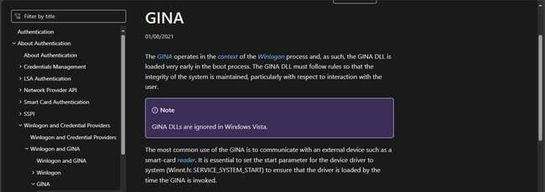

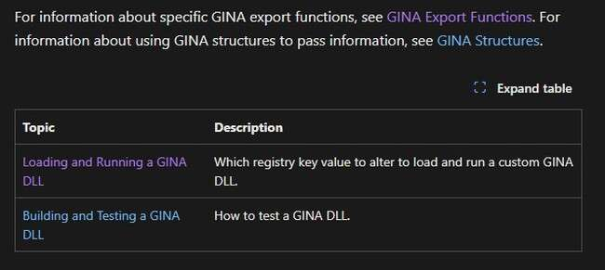

Click On the Loading And Running a GINA DLL

In Related Topic Click On the GINA Export Functions

In Authentication Functions Click On GINA Export Functions. In GINA Export Functions Find for [**WlxLoggedOutSAS**](https://learn.microsoft.com/en-us/windows/desktop/api/Winwlx/nf-winwlx-wlxloggedoutsas) Double Click on that.

One of the methods of doing this is to implement the WlxLoggedOutSAS which will be passed user credentials whenever someone tries to logon at the logon screen.

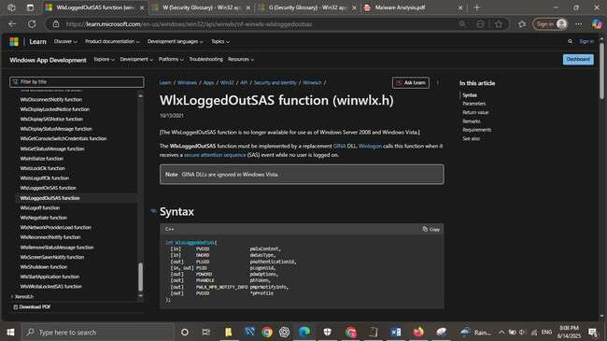

**iii. How does the malware steal user credentials?**

By using CFF Explorer VIII we can see that msgina32.dll exports a number of functions that correlate to known functions that need to be exported by a legitimate GINA DLL as it is prepended with Wlx.

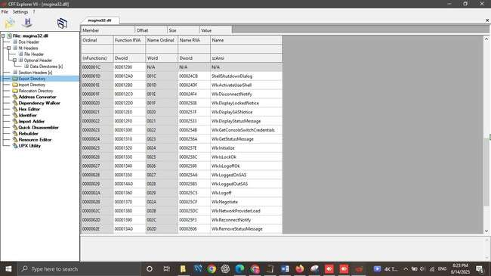

By looking at the strings on this DLL we can see that it contains a couple of interesting strings that look to be formatting related, and reference to msutil32.sys which we haven’t seen used.

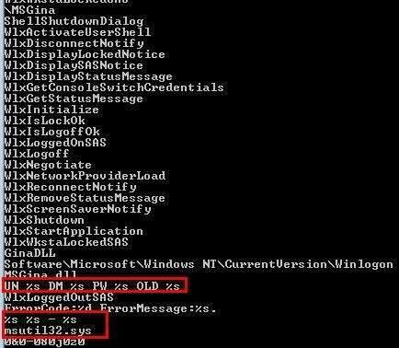

Opening this up in IDA, we can use msutil32.sys as a pivot point by looking for it in the code. Upon finding it we can use CTRL + X to find cross references to the function using this string which may give us more context into what it’s used for.

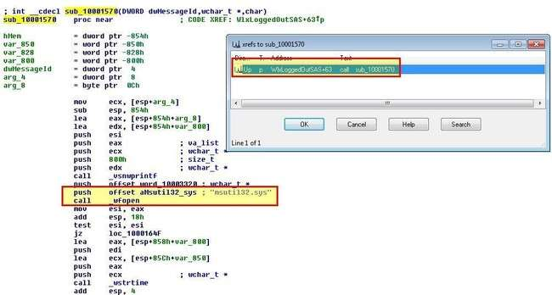

immediately we can see that this calls _wfopen which indicates there’s a file by the name msutil32.sys which will be opened. Examining the reference to this function gives us the impression that the below formatted string will be written to the file msutil32.sys

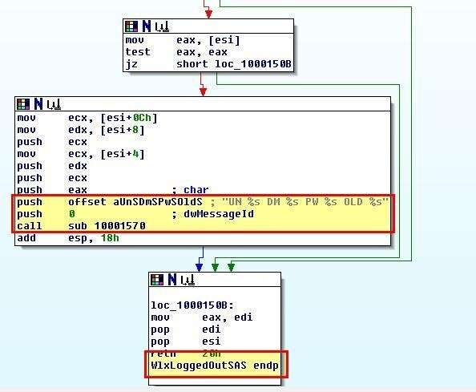 •

UN %s DM %s PW %s OLD %s

It should be noted that %s will be replaced with the appropriate dynamic strings pushed to the stack. Of interest is that this has come from the function ‘WlxLoggedOutSAS’. Looking at what arguments are passed to this function leads us to an interesting discovery.

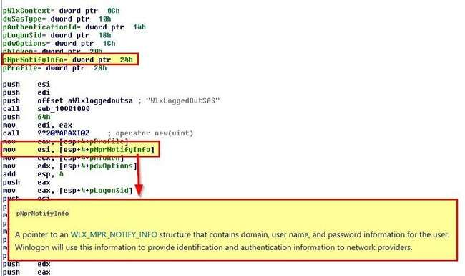

Looking at documentation of this function, ‘pNprNotifyInfo’ which is passed to WlxLoggedOutSAS points to a structure that contains Domain, Username, and Password information for a user. This leads us to believe that this malware steals user credentials by using a custom GINA DLL which intercepts user passwords when no user is logged on.

**IV). What does the malware do with stolen credentials?**

Looking back at sub_10001570 it appears that this is getting the date, time, and another value which it is being place inside of msutil32.sys in addition to a new line character.

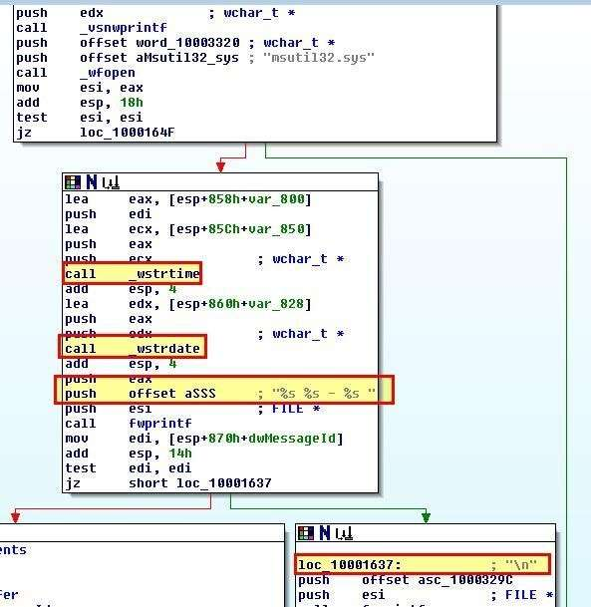

Based on what we see of this function the final value being written to this file is the contents passed by the calling function: UN %s DM %s PW %s OLD %s.

Placing all of this together we can make the informed decision that the malware will create a file called msutil32.sys which will contain the date, time, Domain, Username, and Password of a particular user every time a call is made to the exported function WlxLoggedOutSAS of msgina32.dll. Because this will be run by winlogon.exe we can expect this to fall within the directory C:\Windows\System32.

**V). How can you use this malware to get user credentials from your test environment?**

Because GINA DLLs are ignored in Windows Vista and later, this will only work in Windows XP or prior. Once the GINA DLL has been installed the system needs to be restarted. This is to ensure the new GINA DLL will be loaded into Winlogon.

Upon restarting and logging in we can see a new file is created.

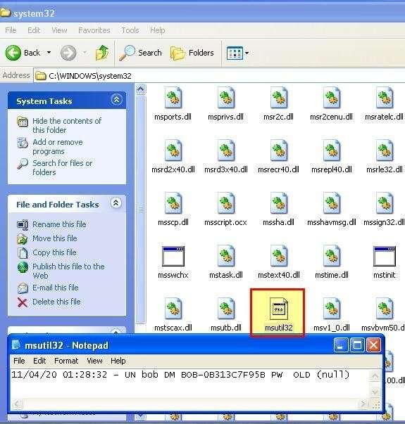

At this point we can confirm it has logged some relevant information as expected, and because no password was present it hasn’t logged an entry for ‘PWD’. If we log out and back in we can see a new entry has been added. By changing our password to ‘password’, logging out, and logging in we can see that the new credentials have been logged by this stealthy credential stealer.

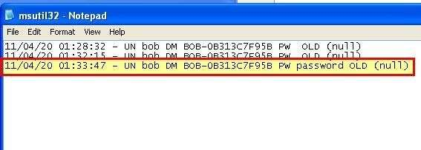

at this point we know how the GINA DLL functions and where it stores credentials

**B. Analyze the malware found in Lab11-02.dll. Assume that a suspicious file named Lab11-02.ini was also found with this malware.**

**i.) What are the exports for this DLL malware?**

Instead of using the same tools we’ve looked at, we examine another tool called [PPEE (puppy)](https://www.mzrst.com/) to get this information.

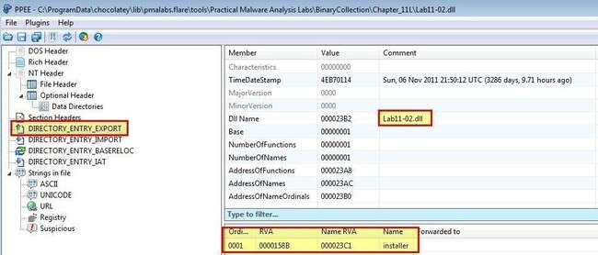

Based on the above we can see that this only has one export ‘installer’.

**ii). What happens after you attempt to install this malware using rundll32.exe?**

Given that this is a DLL which exports the function ‘installer’, we can use rundlle32.exe to run this exported function with the below.



By running procmon with a filter looking for only events from rundll32, we can then run this and see 311 events have been generated in our Windows 7 VM.

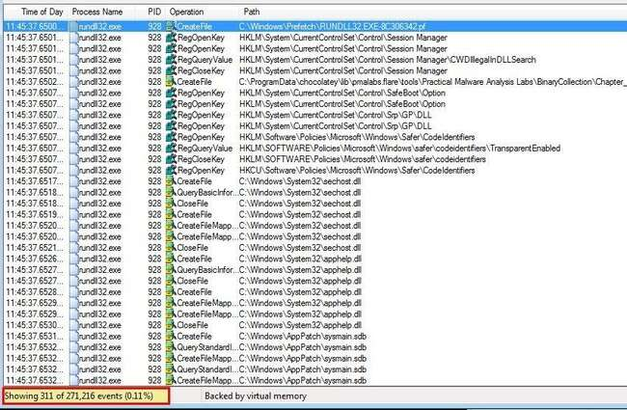

Naturally there’s a lot of requests that we won’t be interested in. One way to reduce the number of irrelevant entries is to add a filter that only shows operations that contain the words ‘set’ or ‘create’. Although this may seem like we miss out on interesting file reads, the ‘CreateFile’ API call is used both in file or I/O creation, or reading. This gives us coverage of these interesting events. By making this change we’re reduced to 99 entries.

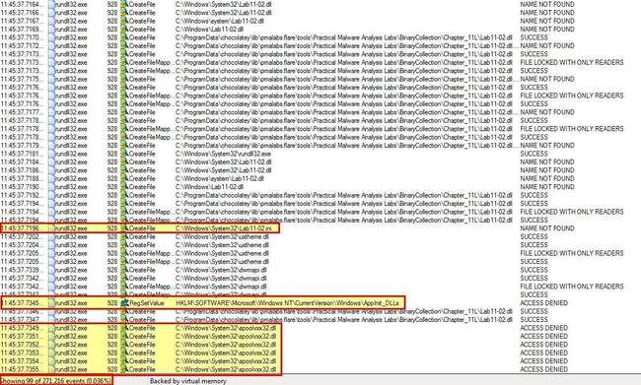

From the above we can see 3 main entries of interest. The first is that it issues a CreateFile API call to the below:

* C:\Windows\System32\Lab11-02.ini

Because we know that the CreateFile can be used for either creating or reading a file, we can look a little bit deeper at the properties of this event. By doing this we see that it is only looking to open the file with read privileges, rather than write to it.

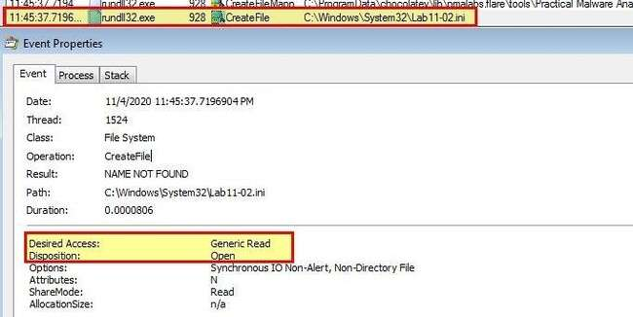

If you compare this to the event for CreateFile on the below, we can see that

* C:\Windows\System32\spoolvxx32.dll

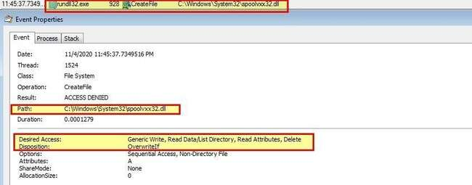

In addition to this the malware attempts to add an entry to add the above DLL into ‘AppInit_DLLs’ within the registry. If we take a look into this and the security [implementations added to Windows 7,](https://docs.microsoft.com/en-us/windows/win32/win7appqual/appinit-dlls-in-windows-7-and-windows-server-2008-r2) we can gather that this is used to load the specified DLL into every user mode process on the system; however, because this is designed for Windows XP, there’s no modification to

‘RequireSignedAppInit_DLLs’ which is required to allow unsigned modules from being loaded in this manner.

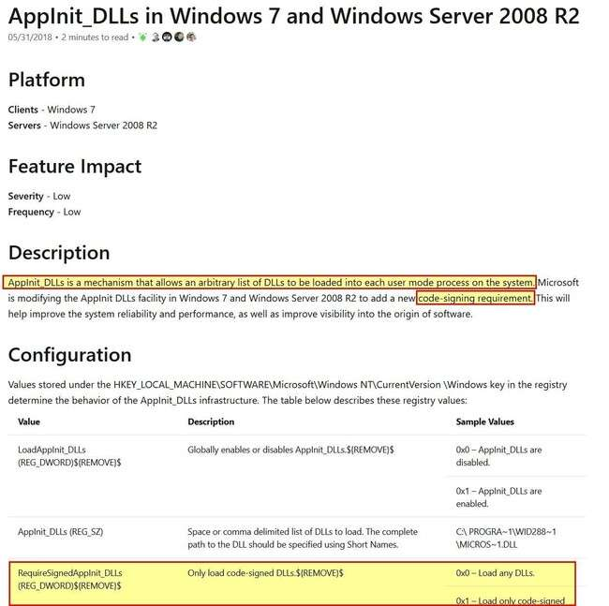

**iii). Where must Lab11-02.ini reside in order for the malware to install properly?**

Based on the above analysis we can conclude that Lab11-02.ini must reside at

C:\Windows\System32\Lab11-02.ini for the malware to install itself. Given this is on a Windows 7 system which introduces code signing requirements (without a registry modification) then this installation won’t be truly successful, even if you are running it as an administrator. From this we know that this was likely created with a target of Windows XP or older in mind.

**iv). How is this malware installed for persistence?**

Based on the analysis in question 2, the malware installs itself as an AppInit_DLL for persistence which then means it will be loaded into any user mode process (anything that loads a user interface e.g. using User32.dll) on a system making it difficult to fully remove if every user process is running the malware. This has publicly been reported as a tactic used (even in 2020) by nation state and cyber criminals. If we open this up in IDA and view the exported installer function we can see evidence that backs up what we’ve seen.

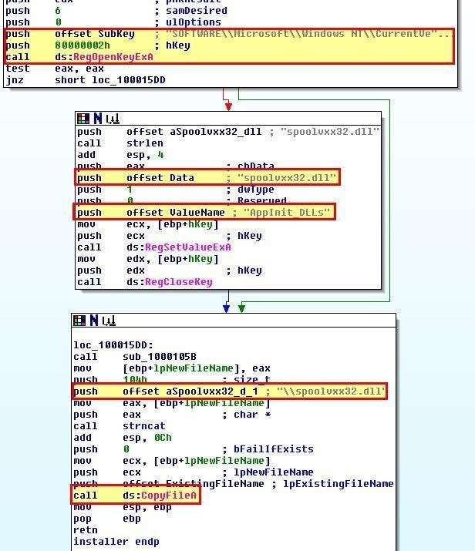

**V).What user-space rootkit technique does this malware employ?**

To understand this we first need to take a look at this in IDA to get an idea of its functions. Using CTRL + F12 to view the call flow of this DLL is an excellent way to get an idea of its functions.

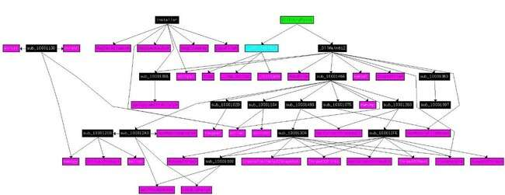

From this we can see that installer doesn’t seem to perform many more calls than what we’ve already identified. Of interest is that DllMain seems to have a number of extra calls, so we’ll look further into that. In particular the subroutine sub_100014B6 seems to make the most calls and is worth investigating.

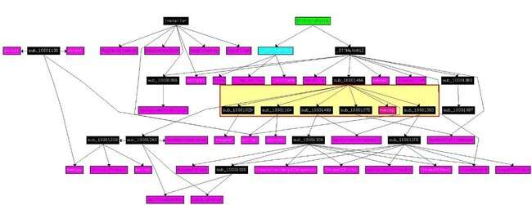

If we examine this subroutine we can see that it contains a number of checks which appear to be looking for a specific process name.

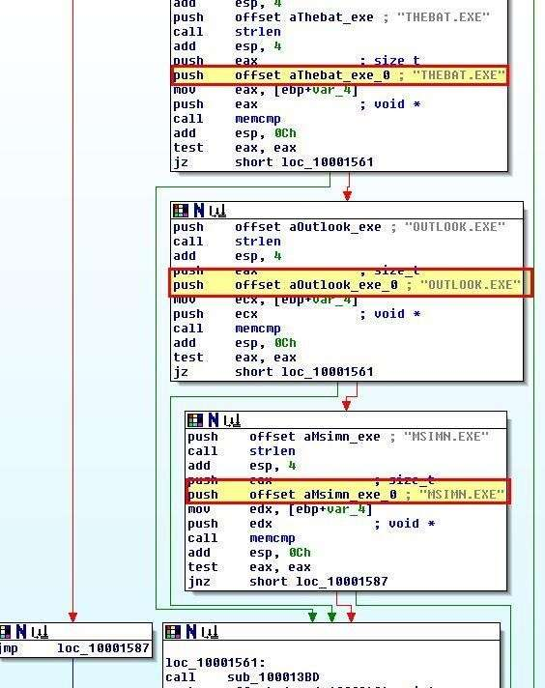

Where the DLL is running inside of a process with any of the below names:

* MSIMN.exe
* THEBAT.exe
* OUTLOOK.exe

The DLL will proceed to call the below subroutines.

* sub_100013BD
* sub_100012A3
* sub_10001499

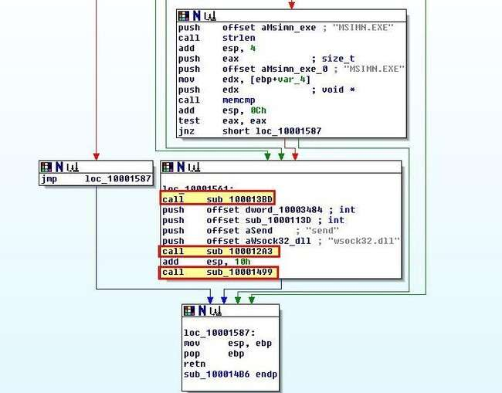

Of interest is that we can see reference to ‘send’ and ‘wsock32.dll’. Examining sub_100012A3 more closely, we can begin to see evidence that this gets a handle on wsock32.dll before GetProcAddress is used to get the send function of this DLL before passing them to sub_10001203.

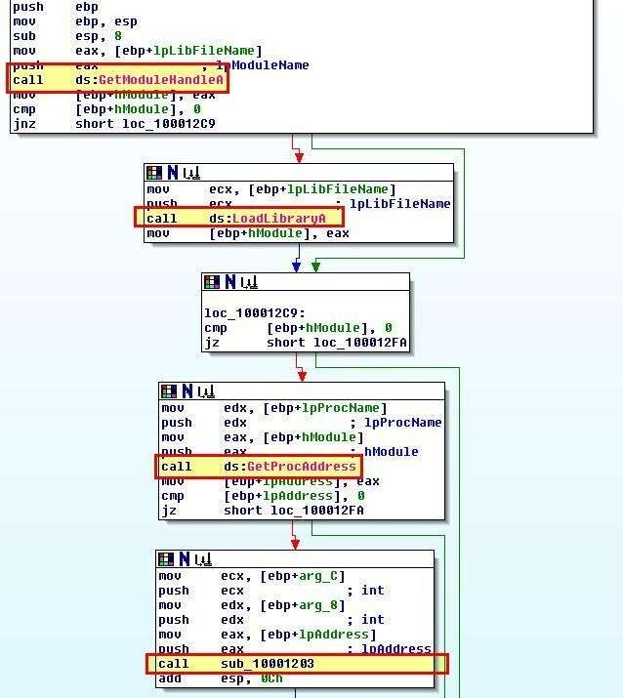

Based on this it looks like the program is using inline hooking via this DLL as a form of user-space rootkit. The hooking code looks to primarily be installed from within ‘sub_10001203’. **vi). What does the hooking code do?**

Examining ‘sub_10001203’ there’s a number of operations which occur due to the complexities of adding an inline hook.

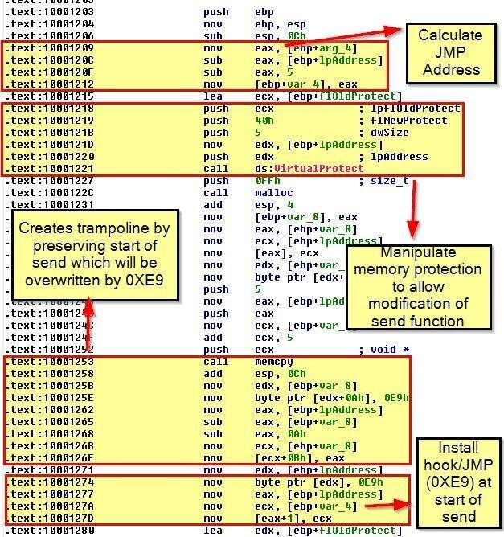

Essentially this installation will calculate the correct jump address before modifying memory protections so that the ‘send’ function can be changed. This then creates a trampoline which will preserve the first 5 bytes of the send instruction, prior to overwriting these 5 bytes with the JMP instruction to what is now located in var_4. To understand what’s in var_4 we need to look back at what is being passed to this hook installation, as this is what is performing the hook function.

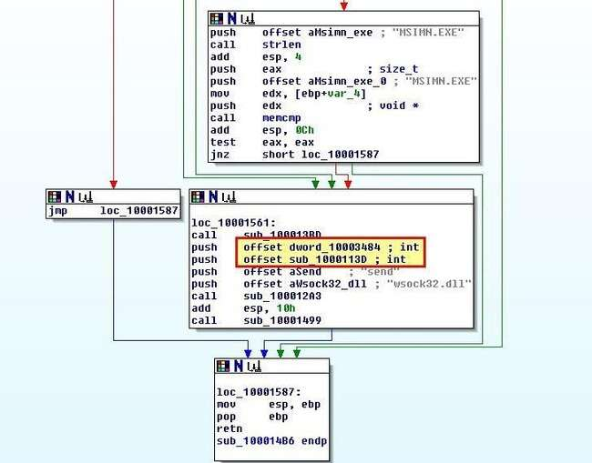

Based on this we can infer that ‘sub_1000113D’ and ‘dword_10003484’ are being sent as part of the hooking function and should be analysed. A quick look at sub_1000113D reveals similarities with the ‘send’ function. Because this needs to implement the same arguments as the send function it can be defined by setting the function type.

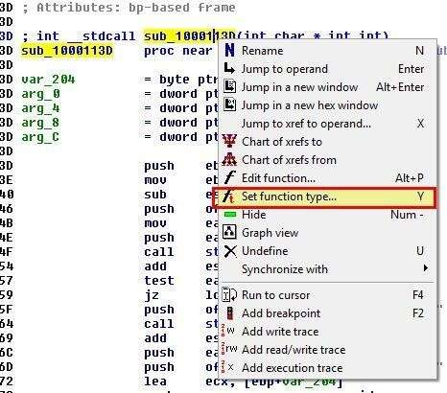

This makes it a little bit clearer. Looking at it we can see that it seems to be modifying in memory specified recipients by adding an entry involving ‘RCPT TO:’ and an unknown value specified by ‘byte_100034A0’.

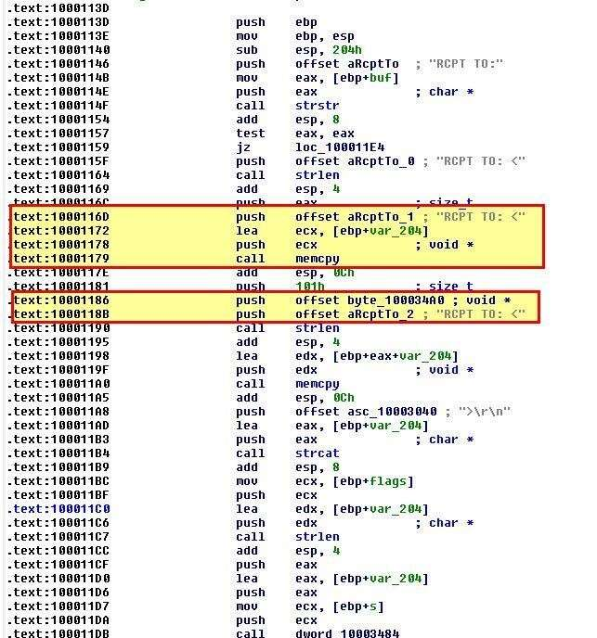

To get more context on what this will contain we need to look for the operation which reads bytes into this offset.

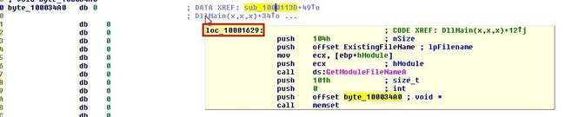

Examining the main function which adds elements to this we can see that the data is pulled from

Lab11-02.ini before calling the subroutine ‘sub_100010B3’

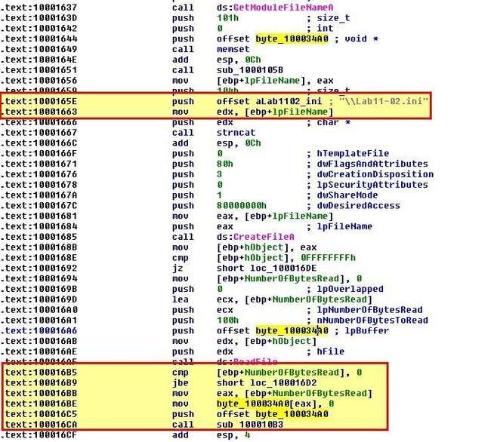

Looking at the contents of Lab11-02.ini, we see that it looks to be ‘gibberish’ or more likely that some type of encoding is being used, which leads us to believe that ‘sub_100010B3’ may be a decoding routine.

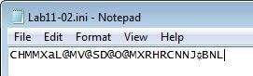

**vii). Which process(es) does this malware attack and why?**

Based on our analysis in Question 5 and 6, this malware only attacks the below processes.

* MSIMN.exe
* THEBAT.exe
* OUTLOOK.exe

This is because they are specific email clients and this malware is designed to hook a specific API call only for the specified email clients.

**viii). What is the significance of the .ini file?**

Revisiting sub_100010B3 we’re under the impression it performs some decoding. Given this is quite challenging to work through manually in IDA, we move back to OllyDbg to perform some dynamic analysis of this subroutine. We’re able to do this by using the ‘loaddll’ binary.

By jumping to ‘0x100016CA’ which is what calls this suspected decoding routine and creating a breakpoint at the function, and directly after the function, we can then copy ‘Lab11-02.ini’ to C:\Windows\System32 where we know it is attempted to be loaded from. Running the program w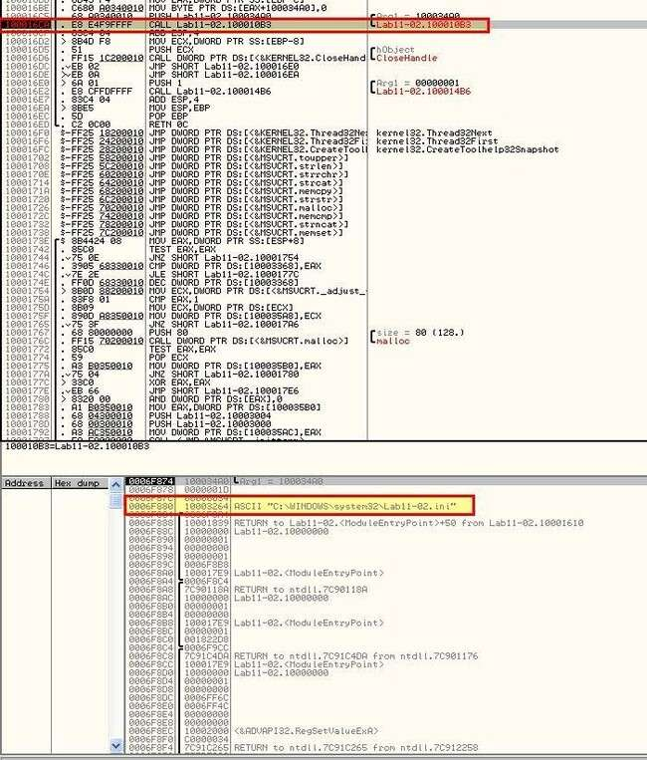

e hit our breakpoint.

By stepping over this routine ensuring that the second breakpoint has been added, we can now see the below value appear on the stack.

• billy@malwareanalysisbook.com

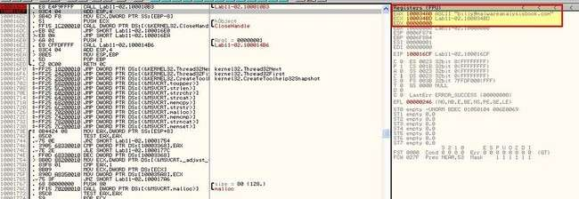

This leads us to believe that the .ini file is encoded and once decoded is used to specify an email which based on our analysis in question 6 will be added to any email sent as a secondary recipient based on the hooked send function

**C. Analyze the malware found in Lab11-03.exe and Lab11-03.dll.**

**Make sure that both files are in the same directory during analysis.**

**i).** **What interesting analysis leads can you discover using basic static analysis?**

If we run strings over Lab11-03.exe we can see a number of strings which relate to loading a library (DLL), manipulating (starting) a service called ‘cisvc’ (a quick search reveals this is the content index service), and reference to a non-existant DLL ‘inet_epar32.dll’.

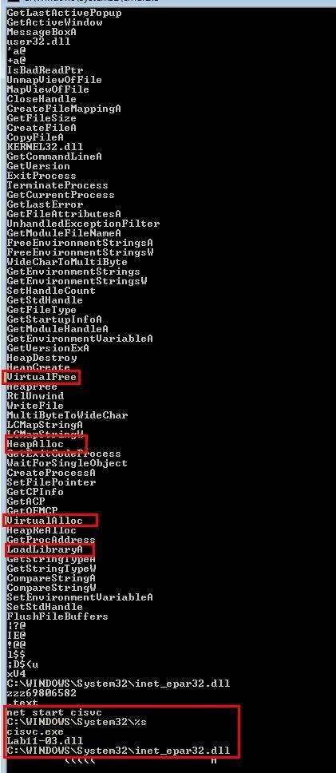

In addition this contains references to ‘VirtualAlloc’, ‘HeapAlloc’, and ‘VirtualFree’ which seems to indicate this will manipulate memory in some fashion. It should be noted that memory manipulation using API’s such as ‘VirtualAlloc’ or ‘VirtualAllocEx’ is often used when injecting shellcode into a process.

If we run strings over Lab11-03.dll we can once again see a number of strings of interest. We can see there’s once again an entry for a non-existant DLL, and an entry for ‘GetAyncKeyState’ which is commonly used in keyloggers.

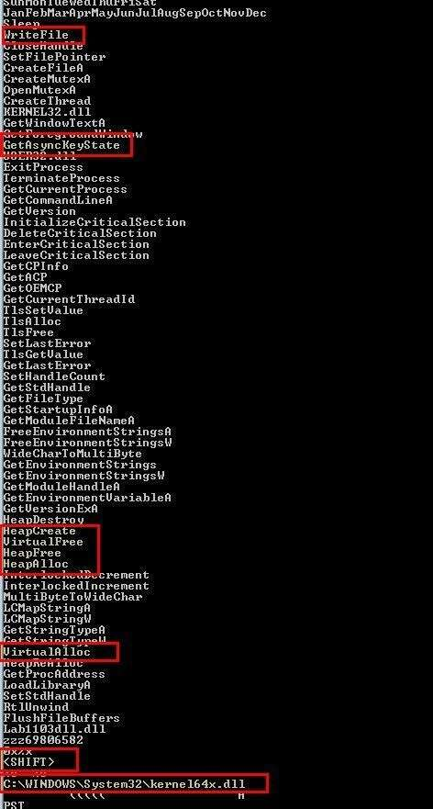

What leads us to believe this may be a keylogger even more is that it has a specific string for ‘' in addition to writing output to a file. The explicit '' declaration is common amongst keyloggers as they need a way of determining if a key pressed is capitalised or not. The same applies for a number of supporting keys such as ''. **ii). What happens when you run this malware?**

If we run Procmon to analyse what happens with this malware is run, we can see that it looks to query Lab11-03.dll prior to creating (and then writing) a file to:

C:\WINDOWS\sytem32\inet_epar32.dll, this leads us to believe it’s copied Lab11-03.dll to this location. In addition this gets Generic Read/Write access to C:\WINDOWS\sytem32\cisvc.exe, but doesn’t perform any type of file write operations.

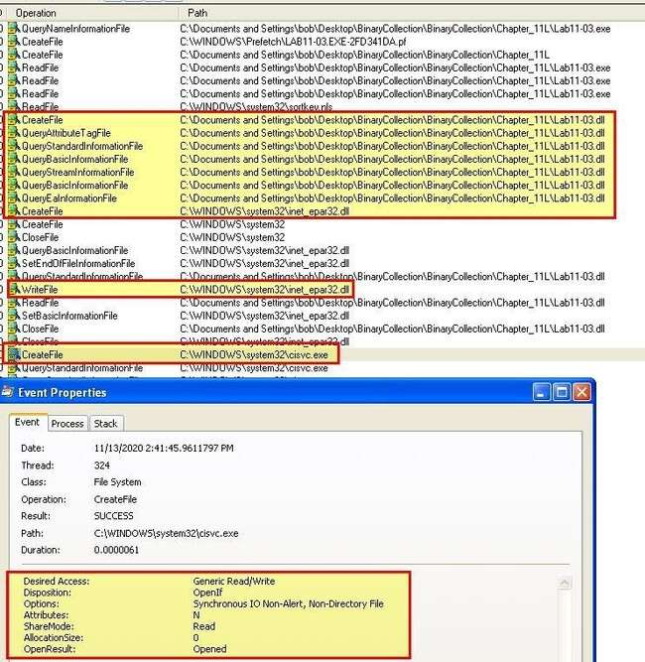

Because we suspect this may have keylogging functionality, we begin typing some text in any application. In addition we expand our procmon search to include any process with the name cisvc.exe, given this seems to be accessed so may hold more information. What immediately is shown is that cisvc seems to look at files from our previous lab11-02, in addition to loading the copied ‘inet_epar32.dll’ file, and creating a file at ‘C:\WINDOWS\sytem32\kernel64x.dll’.

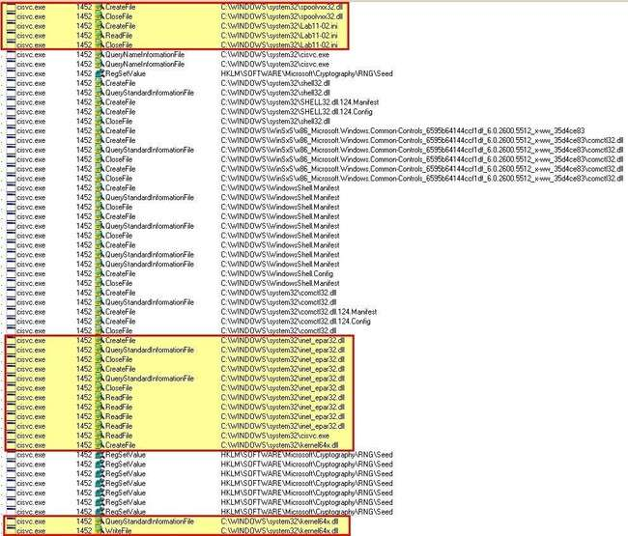

By cross examining the file written by this with the legitimate ‘kernel32.dll’, we can see a number of glaring differences that would indicate this isn’t likely a legitimate DLL. Opening this in notepad confirms that it is indeed logging applications as they shift focus, and appears to be logging keystrokes.

**iii).**

**How does Lab11**

**-**

**03**

**.exe persistently install Lab**

**11**

**-**

**03**

**.dll?**

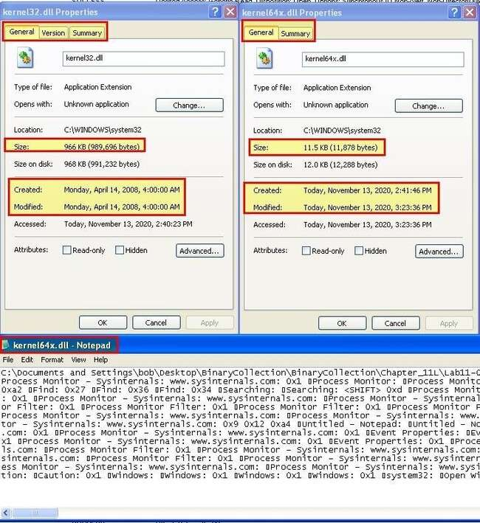

First we take a look at Lab11-03.exe using IDA. Examining the main method it appears as there’s only a couple of custom function calls which leads us to believe the program may be basic.

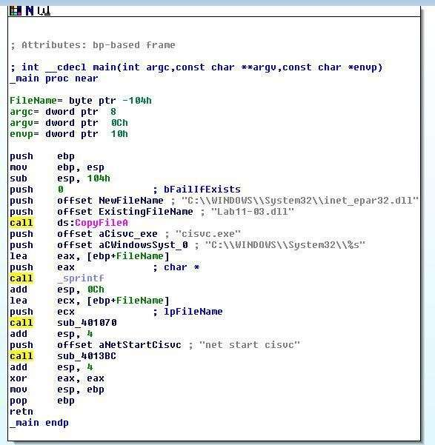

When we graph the call flow of this application we can see that it’s far more complicated than we initially thought with many functions being nested.

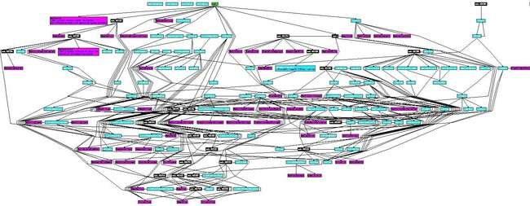

Drilling into this we first look at the cross references to ‘sub_401070’ which is called prior to starting ‘cisvc’.

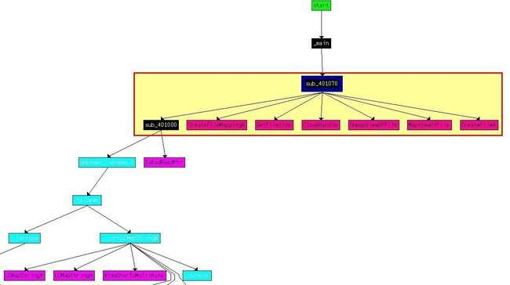

Based on the windows API calls we can assume that a file is being mapped into memory

(C:\WINDOWS\sytem32\cisvc.exe) with functions occurring on the file prior to UnmapViewOfFile is called which writes the file changes ‘lazily’ to disk.

By examining ‘sub_401070’ more in depth we can see that a number of checks occur based on getting a handle on the file in question, memory, and the binary itself; however if these checks are passed an operation occurs in the bottom right of this flow at ‘loc_40127C’ which is of interest.

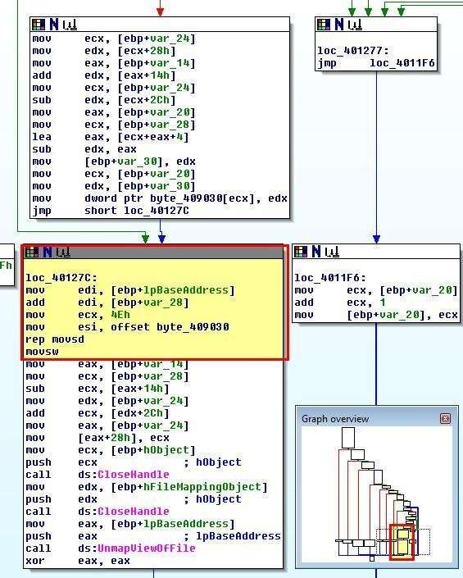

This function is of interest because it uses ‘lpBaseAddress’ to get the base address of the mapped file C:\WINDOWS\sytem32\cisvc.exe and has clear modifications occurring prior to ‘UnmapViewOfFile’ being called.

The function uses an unknown variable of ‘var_28’ as an offset from this base before the counter register (ECX) is set to 4Eh (78 in Hex). As the action occurring is ‘MOVSD’ (Move String, Double Word) using this counter register, we know that this is moving 78 DWORDs starting at ‘byte_409030’. At this point it’s important to note that a DWORD is a 32-bit (4-byte) unsigned integer. Due to this the total number of bytes that will be copied is 78 * 4 = 312 bytes. Examining ‘byte_409030’ we see some entries that don’t make a lot of sense.

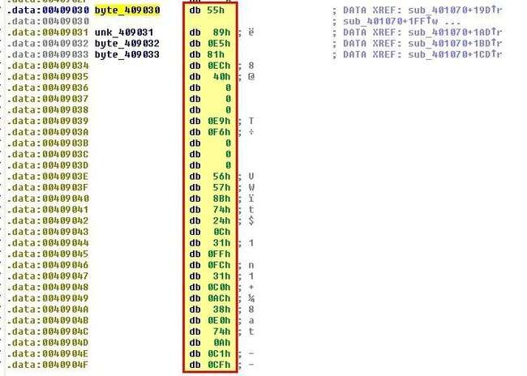

This is shellcode that will be copied directly as assembly to the binary in question and is stored in Hex. Using ‘c’ we can convert this directly to code to see what it is performing. First we look through to see if there’s any obvious strings. At ‘00409139’ and ‘0040915D’ we find some strings of interest if we convert them to ASCII using ‘A’.

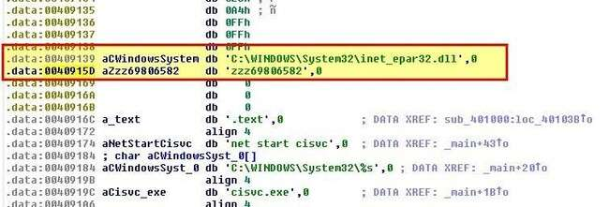

Based on this and the activity we saw running the program we begin to infer that the shellcode will likely dynamically load ‘C:\WINDOWS\System32\inet_epar32.dll’ and run the export ‘zzz69806582’. Looking at the exports of ‘Lab11-03.dll’ which we know is copied to this location, we can see this is a valid export.

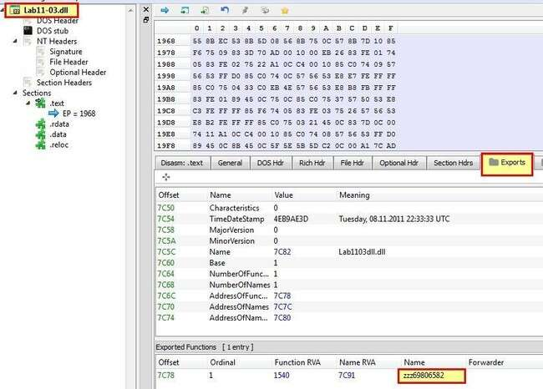

iven ‘zzz69806582’ is an obvious unique string we can use this as a pivot point to open the executable in a program such as ‘HxD’ and find the appropriate shellcode for exporting. We also do this by looking for the expected Hex.

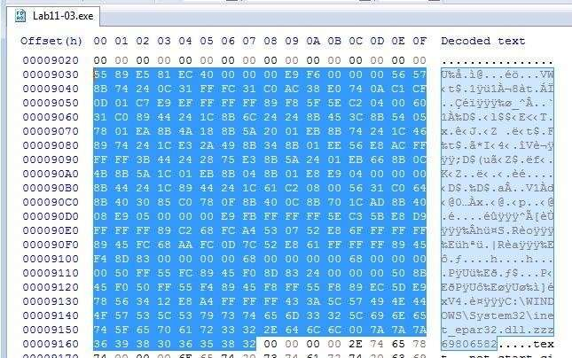

After saving the shellcode to a new file (Lab11-3Shellcode.dat) by copying it to a new file using HxD, we can now use a shellcode debugging tool (scdbg) to confirm what actions were taken by the shellcode we’ve found

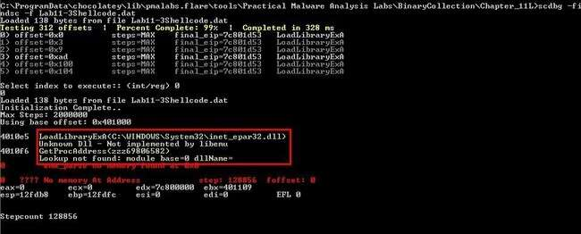

Although an error occurs as we wind up looking into invalid memory, we’re successfully able to step over enough of the shellcode to reveal that it is using ‘LoadLibraryExA’ to load in

C:\WINDOWS\System32\inet_epar32.dll, before using ‘GetProcAddress’ to get the exported function ‘zzz69806582’.

Based on this we conclude that Lab11-03.exe will persistently install Lab11-03.dll by infecting the indexing service binary C:\WINDOWS\sytem32\cisvc.exe to run shellcode that uses ‘LoadLibraryExA’ and ‘GetProcAddress’ to load ‘C:\WINDOWS\System32\inet_epar32.dll’ and run the export ‘zzz69806582’ from this DLL. **iv). Which Windows system file does the malware infect?**

Based on the above analysis we can conclude that this malware infects the indexing service binary

C:\WINDOWS\sytem32\cisvc.exe

**v). What does Lab11-03.dll do?**

Examining Lab11-03.dll in IDA, we start with the export we identified from our previous shellcode analysis (zzz69806582)/

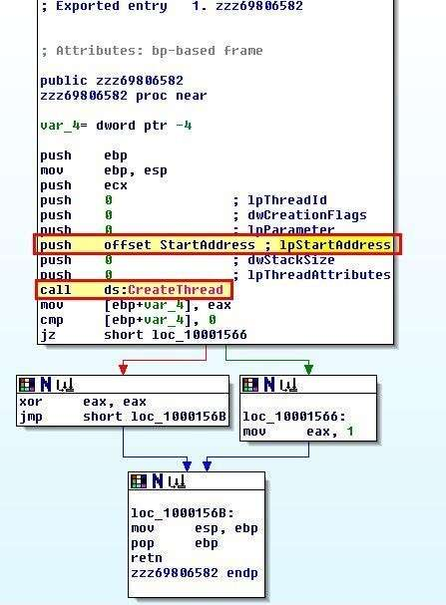

This doesn’t perform much except creating a thread to run actions specified in ‘StartAddress’, so we examine this subroutine for more information. By graphing the user defined cross references to this subroutine we can get an idea of what this may be trying to accomplish.

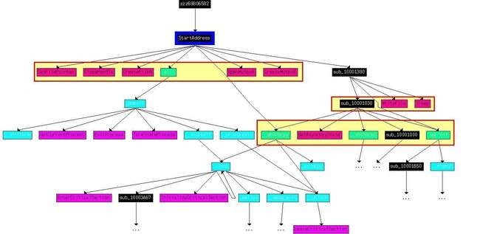

Based on the Windows API calls we begin to get the feeling that this acts as a keylogger that will create a file if it doesn’t exist, open a mutex to ensure only one instance of it is running, calls ‘GetAsyncKeyState’ to log keystrokes, and writes these to a file before sleeping for a period of time and repeating (this would simulate a poll that occurs on a schedule). To confirm this we look closer at what is occurring at ‘0x10001410’.

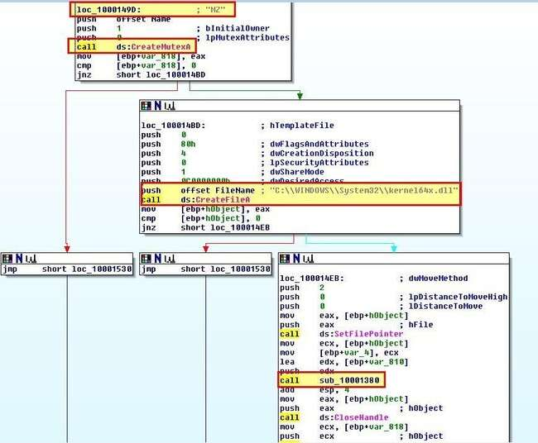

Based on this we can determine that the malware creates a Mutex ‘MZ’ and file at

‘C:\WINDOWS\sytem32\kernel64x.dll’. Drilling into the subroutine at ‘sub_10001380’

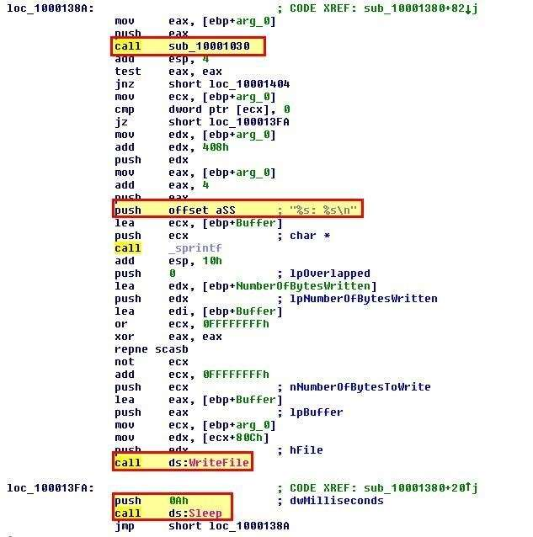

Here we can see evidence of information being written to this file before a timeout of ‘0A’ (10) milliseconds occur and it repeats. We can also see evidence of another subroutine being called at ‘sub_10001030’ and if we look into this we can see lots of evidence it is being used as a keylogger. Based on GetAsyncKeyState being used, we can look into [Virtual-Key Codes](https://docs.microsoft.com/en-us/windows/win32/inputdev/virtual-key-codes) to get an idea of what this is checking for before logging the character “<SHIFT>”.

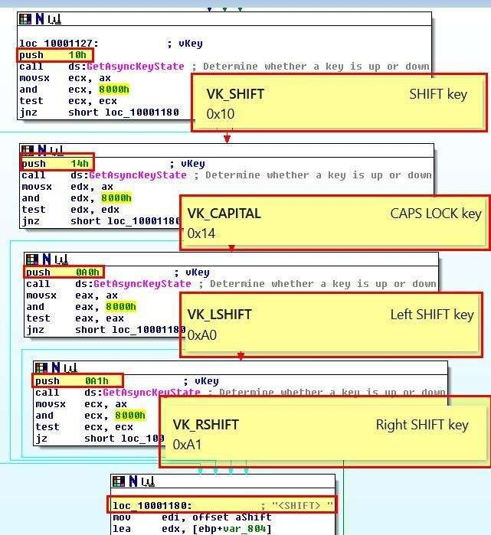

From this context we can infer that Lab11-03.dll is a keylogger which polls frequently and writes keys pushed to C:\WINDOWS\sytem32\kernel64x.dll.

**vii). Where does the malware store the data it collects?**

Based on the above analysis we can confirm that this malware stores keystrokes and window information it collects at ‘C:\WINDOWS\sytem32\kernel64x.dll’.

**Practical No. 6**

**IDA**

**Process Explorer**

a. Analyze the malware found in the file Lab12-01.exe and Lab12-01.dll. Make sure that these files are in the same directory when performing the analysis.

**i. What happens when you run the malware executable?**

A Message box with a incremental number in its title pops up every now and then…

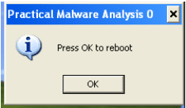

**ii. What process is being injected?**

In the imports table, CreateRemoteThread is used by the exe which highly suggests that the malware might be injecting DLL into processes.

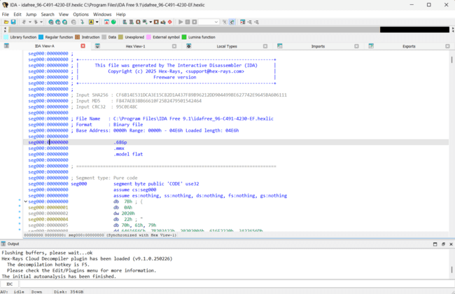

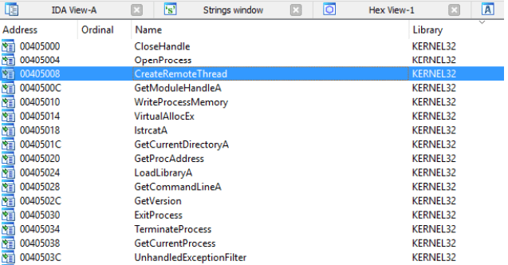

Figure 2. CreateRemoteThread in imports

“explorer.exe” is found in the list of string. X-ref the string and we will come to the following subroutine. Seems like explorer.exe is being targeted to be injected with the malicious dll.

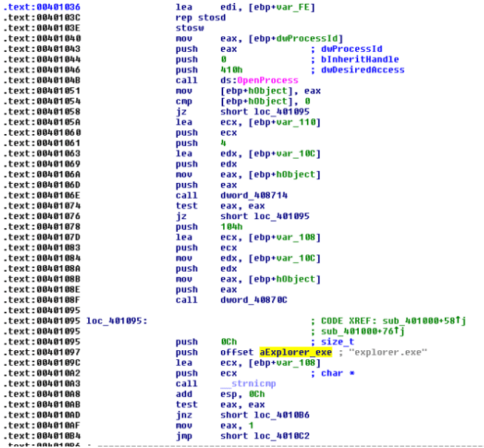

Figure 3. explorer.exe

We can confirm our suspicion using process explorer as shown below.

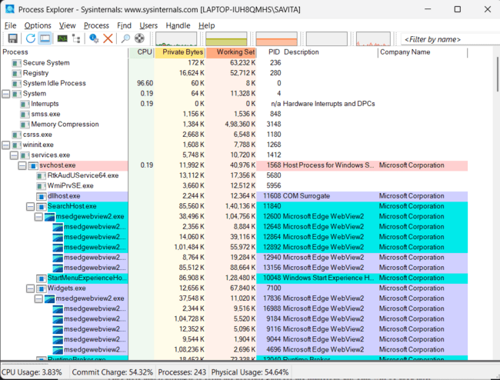

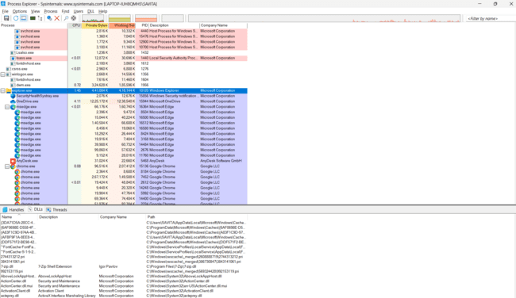

Figure 4. Explorer.exe injected with dll

**iii. How can you make the malware stop the pop-ups?**

Kill explorer.exe and re-run it again

**iv. How does this malware operate?**

**Lab12-01.exe**

The malware begins by using psapi.dll’s EnumProcesses to loop through all running processes. Also note that it attempts to form the absolute path for the malicious dll. This will be used later to inject the dll in remote processes.

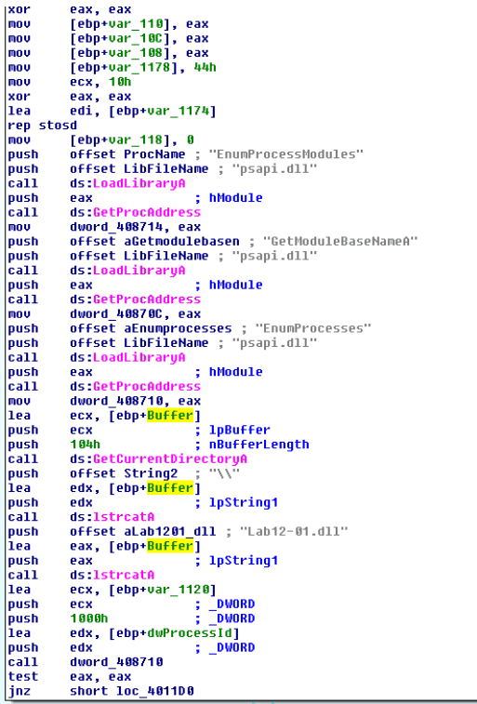

Figure 5. EnumPorcesses

While looping through the processes only “explorer.exe” will be injected. The following figure shows the filtering taking place

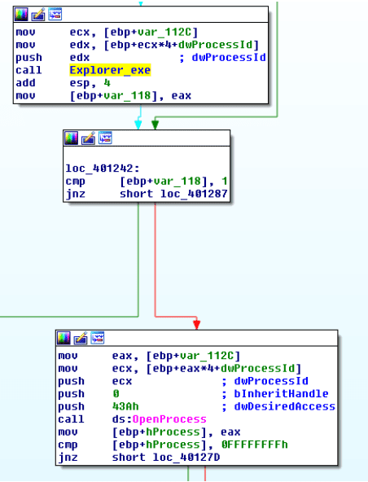

Figure 6. Check for explorer.exe

Once the malware located the “explorer.exe” process, it will ask the remote process (explorer.exe) to allocate a heap space. The space will contains the malicious dll’s absolute path as mentioned earlier. It will then get the LoadLibraryA address of explorer.exe and triggers the function via CreateRemoteThread. Explorer.exe will then invoke LoadLibraryA with the input as the malicious dll’s absolute path which is already in its heap memory and that is how explorer.exe got injected. =)

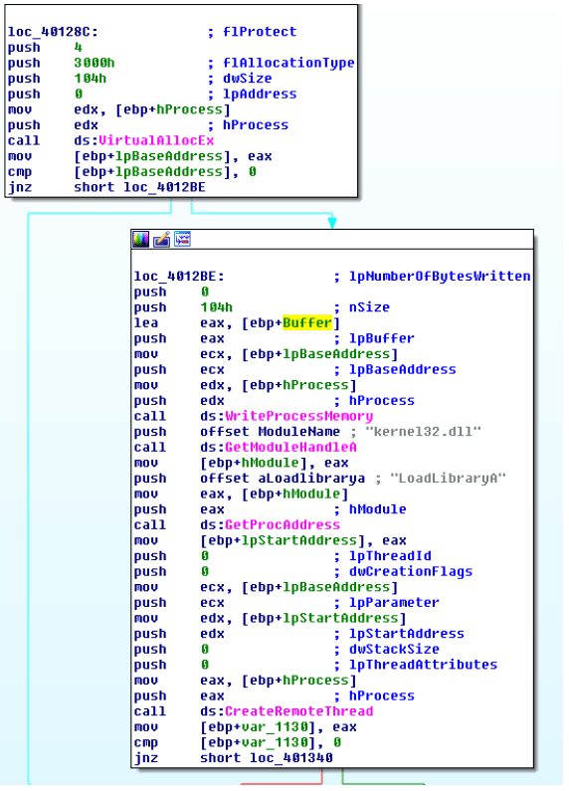

Figure 7. Injecting

**Lab12-01.dll**

The DllMain first creates a thread @ subroutine 0x1001030.

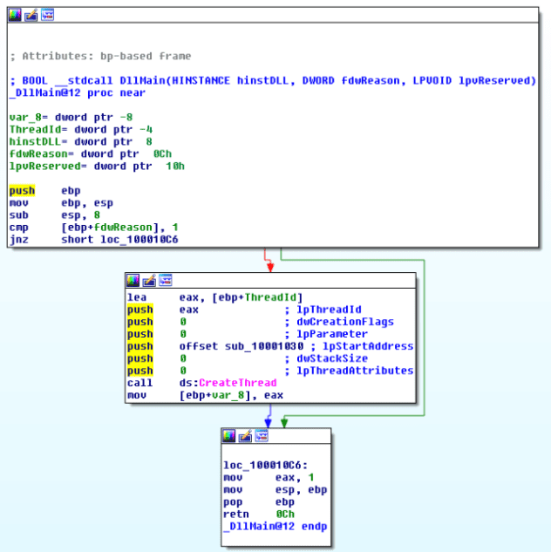

Figure 8. Create Thread

Inside this subroutine, we will find a infinite loop popping a message box every 1 minute. The title of the message box is “Practical Malware Analysis %d” where %d is the value of the loop counter.

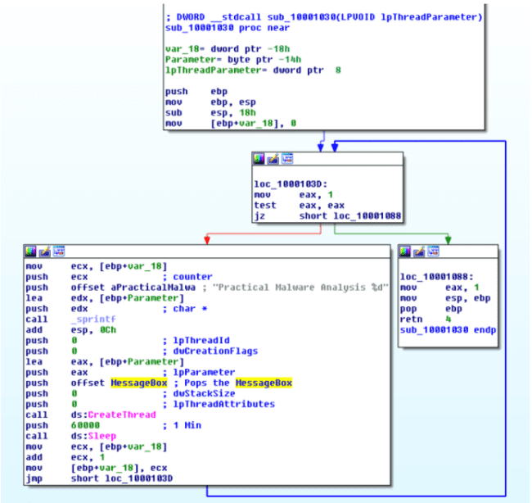

Figure 9. Popping MsgBox every minute

**b. Analyze the malware found in the file Lab12-02.exe.**

**b. What is the purpose of this program?**

Based on dynamic analysis results using procmon and process explorer, we can conclude that this is a keylogger that performs process hollowing on svchost.exe.

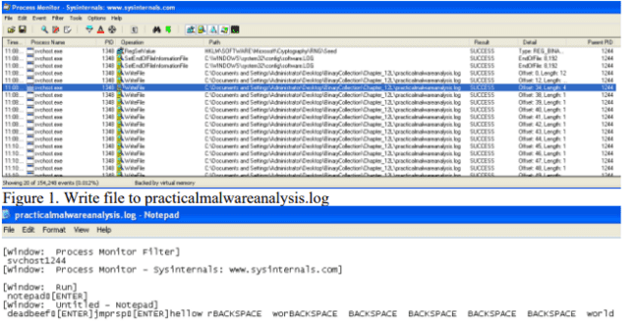

Figure 2. Keystrokes in log file

**ii. How does the launcher program hide execution?**

The subroutine @0x004010EA is highly suspicious. It is trying to create a process in suspended state, calls UnmapViewOfSection to unmap the original code and tries to write process memory in it. Finally it resumes the process. This is a recipe for process hollowing technique in which the running process will look like svchost.exe (in this case) but it is actually running something else instead.

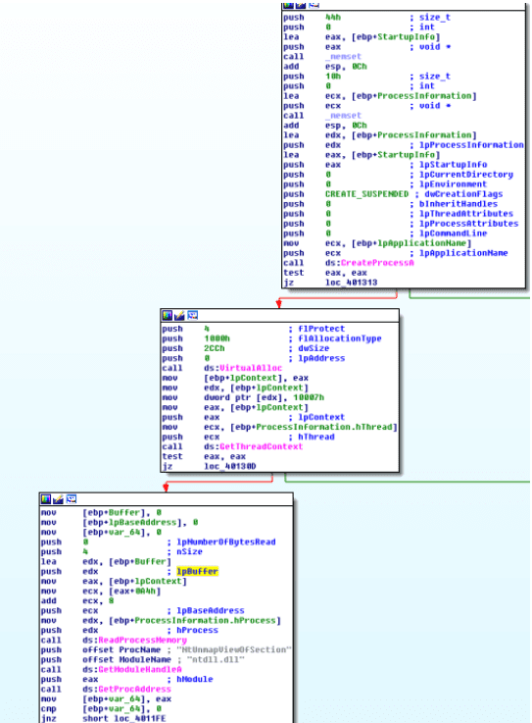

Figure 3. Create Suspended process, unmap memory

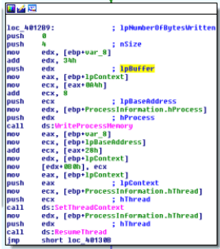

Figure 4. WriteProcessMemory, ResumeThread

**iii. Where is the malicious payload stored?**

In the resource, we can see a suspicious looking payload. IDA Pro further confirmed that this is the payload that will be extracted out.

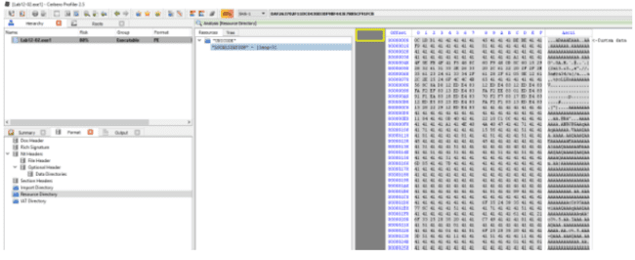

Figure 5. Resource with lots of As in it

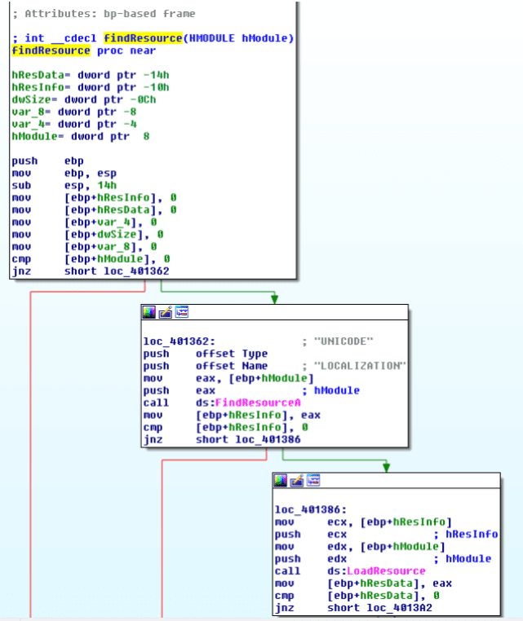

**iv. How is the malicious payload protected?**

By analyzing the find resource function @0x0040132C we will come across the following codes that suggests to us that the payload is XOR by “A”.

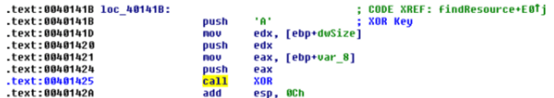

Figure 7. XOR by A

**v. How are strings protected?**

The strings are in plain… correct me if i am wrong

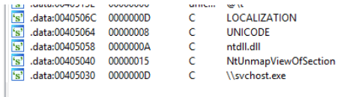

Figure 8. Strings in plain

**c. Analyze the malware extracted during the analysis of Lab 12-2, or use the file Lab12-03.exe**

**i. What is the purpose of this malicious payload?**

The use of SetWindowsHookExA with WH_KEYBOARD_LL as the id which suggests that this is a keylogger

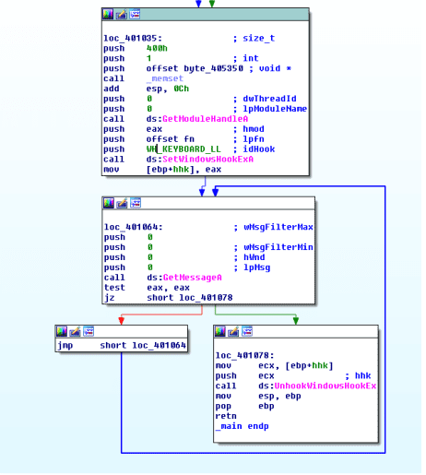

Figure 1. SetWindowsHookExA

**ii. How does the malicious payload inject itself?**

It uses Hook injection. Keystrokes can be captured by registering high- or low-level hooks using the WH_KEYBOARD or WH_KEYBOARD_LL hook procedure types, respectively. For WH_KEYBOARD_LL procedures, the events are sent directly to the process that installed the hook, so the hook will be running in the context of the process that created it. The malware can intercept keystrokes and log them to a file as seen in the figure below.

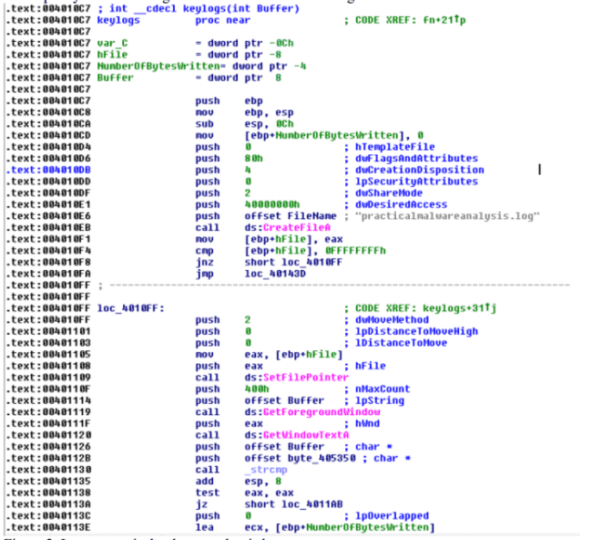

Figure 2. Log to practicalmalwareanalsysis.log

**iii. What filesystem residue does this program create?**

The malware will leave behind a log file containing the keylogs; practicalmalwareanalsysis.log.

**d. Analyze the malware found in the file Lab12-04.exe.**

**i. What does the code at 0x401000 accomplish?**

The subroutine check if the process with the given process id is Winlogon.exe. If it is, it returns 1 else it returns 0.

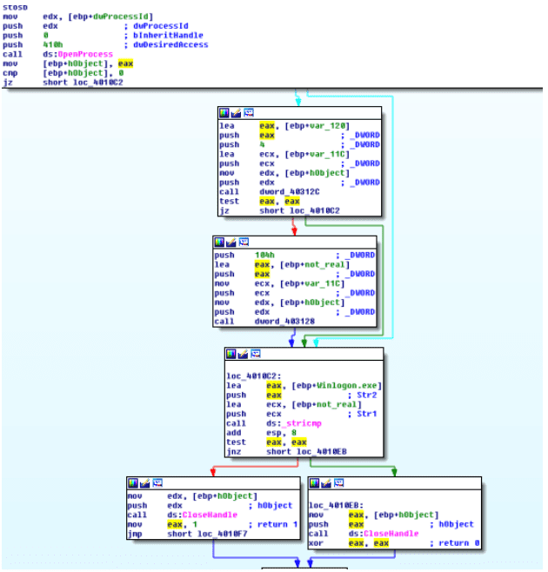

**ii. Which process has code injected?**

Winlogon.exe is being targeted for injection. Subroutine @0x00401174 is responsible for process injection via CreateRemoteThread. If we trace back, we can see that only winlogon’s pid is being passed to the subroutine.

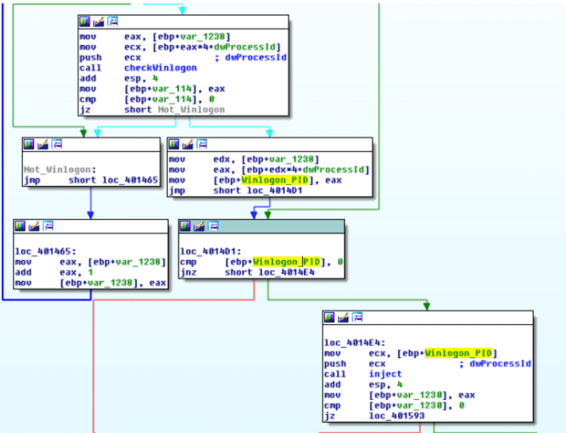

Figure 2. Winlogon Pid being pushed as argument to inject subroutine

**iii. What DLL is loaded using LoadLibraryA? sfc_os.dll**

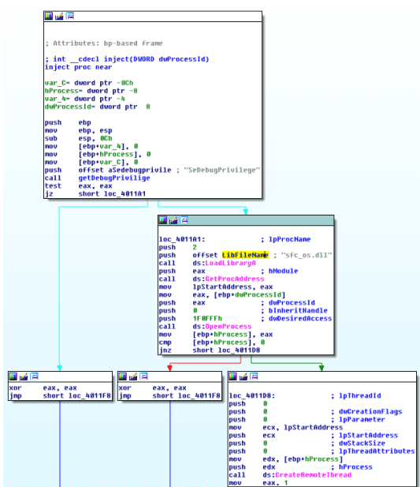

Figure 3. sfc_os.dll

**iv. What is the fourth argument passed to the CreateRemoteThread call?**

Based on figure 3, the fourth argument is lpStartAddress in which if we were to trace up we will uncover that lpStartAddress is the address return by GetProcAddress(LoadLibraryA(“sfc_os.dll”),2). Loading sfc_os.dll in ida pro we can see the exports that points to ordinal 2 which resovles to SfcTerminateWatcherThread() as shown in figure 5..

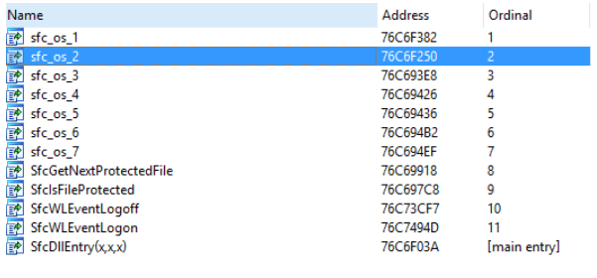

Figure 4. sfc_os.dll’s ordinal 2

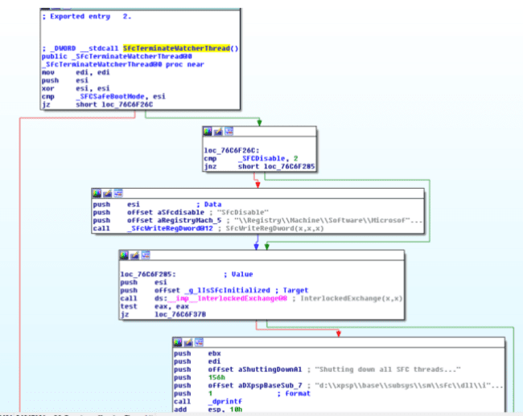

Figure 5. SfcTerminateWatcherThread()

**v. What malware is dropped by the main executable?**

Analyzing the main method, we can see file movement from **“C:\WINDOWS\system32\wupdmgr.exe” to a temp folder “C:\DOCUME~1\ADMINI~1\LOCALS~1\Temp\\winup.exe”**

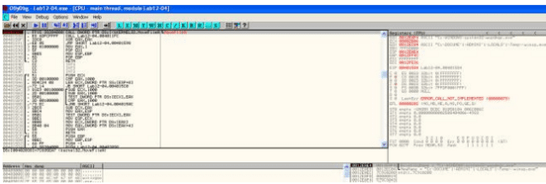

6. Backing up wupdmgr.exe

The following subroutine is then called to extract the resource out from the executable and using it to replace “C:\WINDOWS\system32\wupdmgr.exe”

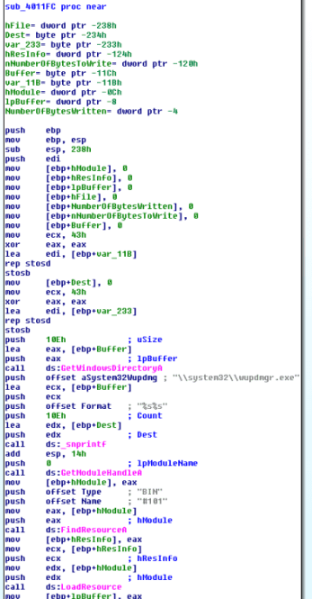

Figure 7. dropping form resource to system32\\wupdmgr.exe

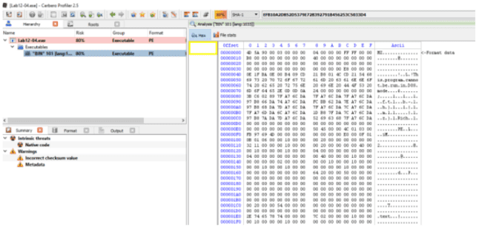

Figure 8. Bin 101 in the resource section

vi. What is the purpose of this and the dropped malware?

Apparently in order for SfcTerminateWatcherThread() to work, the caller must be from winlogon.exe. That explains why the malware goes through the trouble in looping through all running threads to locate winlogon.exe and it even attempts to get higher privileges by using AdjustTokenPrivileges to change token privilege to seDebugPrivilige. With the higher privilege, the malware then calls CreateRemoteThread to ask Winlogon to invoke SfcTerminateWatcherThread(). With that, file protection mechanism will be disabled and the malware can freely change the system protected files until the next reboot.

The dropped malware in “C:\\windows\\system32\\wupdmgr.exe” executes the original wupdmgr.exe (which is now in the temp folder) and it attempts to download new malware from “http://www.practicalmalwareanalysis.com/updater.exe” and save it as “C:\\windows\\system32\\wupdmgr.exe”

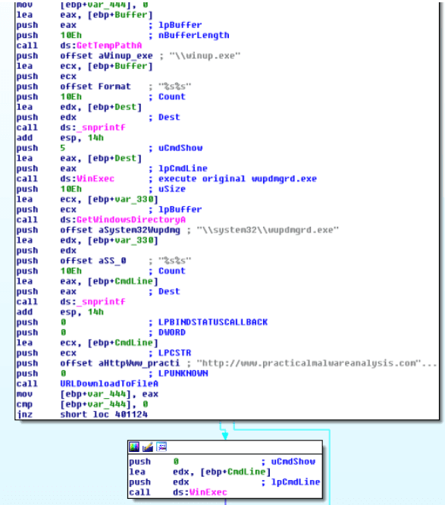

Figure 9. URLDownloadToFileA

# Practical No. 7

**IDA pro**

**Ollydby**

**Aim :Analyze the malware found in the file *Lab13-01.exe*.**

1. **Compare the strings in the malware (from the output of the strings command) with the information available via dynamic analysis. Based on this comparison, which elements might be encoded?**

a. Analysis of malware in Lab13-01.exe

Examine the strings in the malware using the strings command and compare them with dynamic analysis output.

From this comparison, identify which elements appear to be encoded.

In IDA Pro, the visible strings seem meaningless. However, by running the executable, examining memory using Process Explorer, and monitoring network activity,

new strings such as http://www.practicalmalwareanalysis.com are revealed.

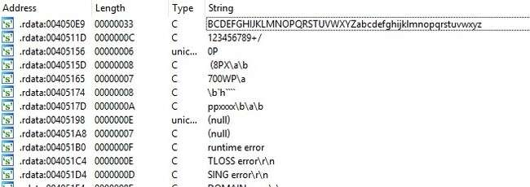

Figure 1. Meaningless string

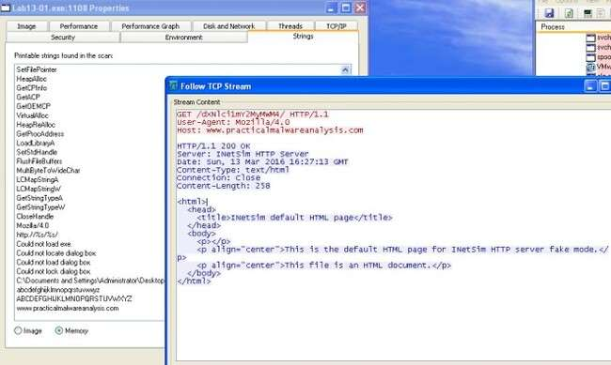

Figure 2. Detected URL

**ii Use IDA Pro to locate potential encoding mechanisms by searching for the keyword "xor". What type of encoding is detected?**

**At subroutine 0x00401300, a resource is loaded and its value XOR-ed with the character ";".**

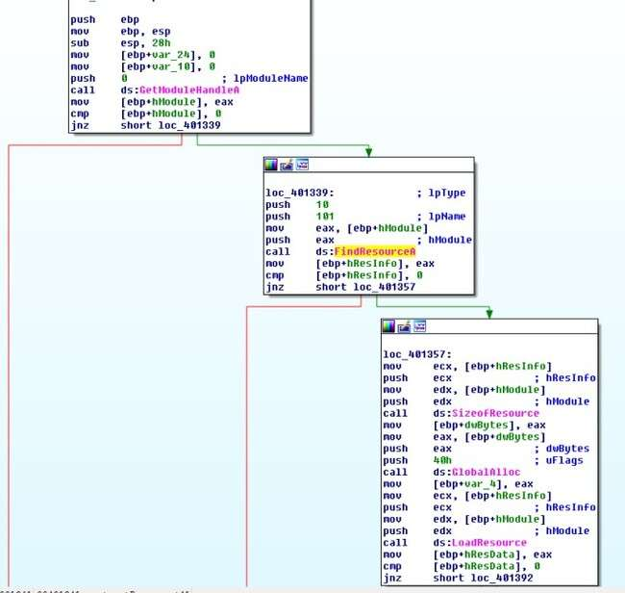

Figure 3. FindResourceA Call

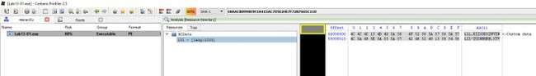

Figure 4. Resource String

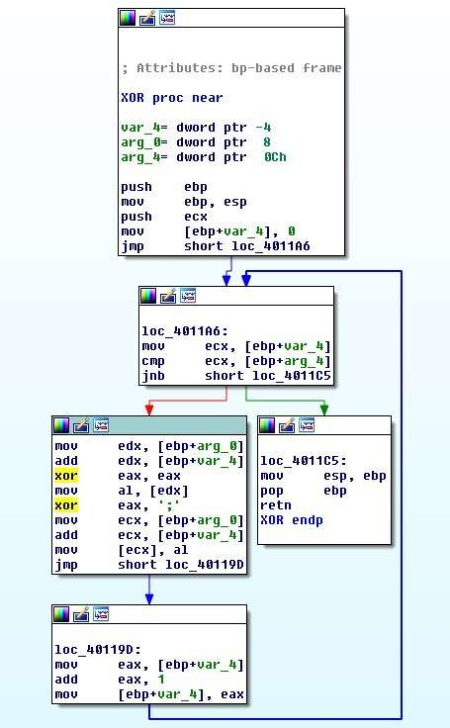

Figure 5. XOR with ";"

What key is used for encoding and what does it decode?

The XOR key used is ";". The resulting decoded string is: <http://www.practicalmalwareanalysis.com.>

**iv. Utilize static analysis tools such as FindCrypt2, Krypto ANALyzer (KANAL), and**

**IDA Entropy Plugin to identify any other encoding mechanisms. What are the findings?**

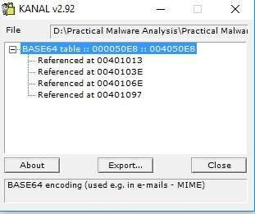

The KANAL plugin identifies four addresses using the string:

ABCDEFGHIJKLMNOPQRSTUVWXYZabcdefghijklmnopqrstuvwxyz0123456789+/

**v. What encoding is used in the network traffic?**

**Base64 encoding is used to encode the computer name.**

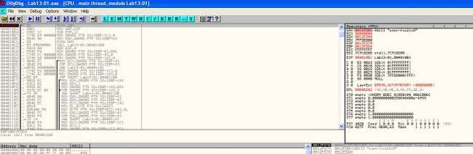

Figure 7. Encoding string

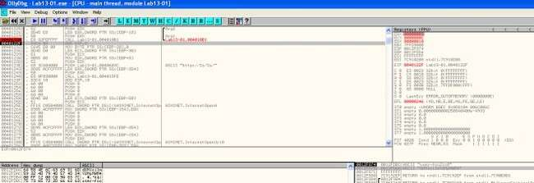

Figure 8. String encoded

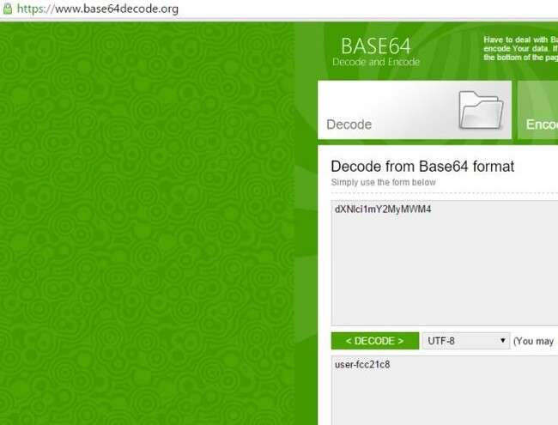

**Figure 9.** Base64 Check string **vi.**

**Vi. Where is the Base64 encoding function located?**

At address 0x004010B1..

**vii. What is the maximum length of the Base64-encoded data transmitted, and what is encoded?**

The maximum is 12 characters. In base64, this corresponds to 16 bytes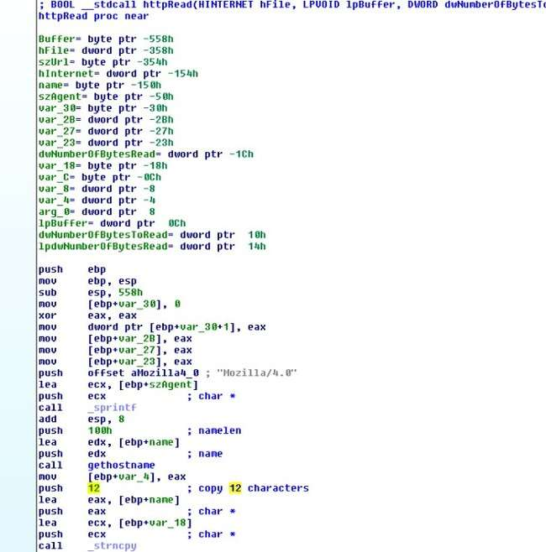Figure

10. Only 12 Characters

**Viii. Will this malware use padding characters (= or ==) in Base64-encoded strings?**

**According to documentation, padding appears when the input isn't divisible by 3.**

**What is the malware's function?**

It continuously sends the computer name (max 12 bytes) to http://www.practicalmalwareanalysis.com every 30 seconds until the first character of the server's response is 0x6F.

**b. Analyze the malware found in the file *Lab13-02.exe***

**i. Using dynamic analysis, determine what this malware creates.**

A file with size 6,214 KB is written on the same folder as the executable every few seconds. The naming convention of the file is **temp[8xhexadecimal]**. The file created seems random.

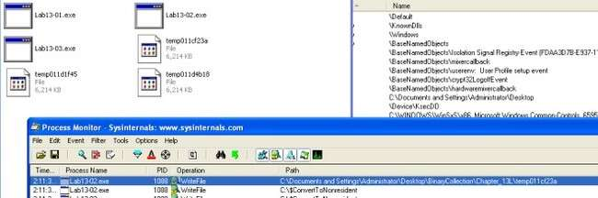

Figure 1. Proc Mon

1. **Use static techniques such as an xor search, FindCrypt2, KANAL, and the IDA Entropy Plugin to look for potential encoding. What do you find?**

Only managed to find XOR instructions. Based on the search result, we would need to look at the following subroutine

* 1. 0x0040128D
  2. 0x00401570
  3. 0x00401739

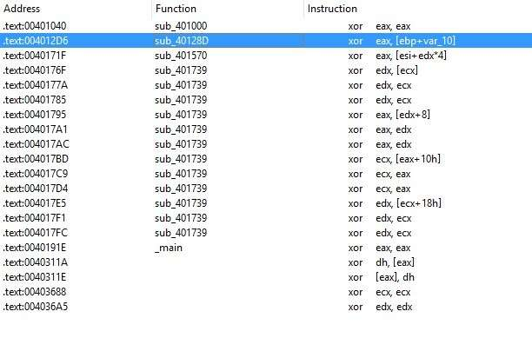

Figure 2. XOR

1. **Based on your answer to question 1, which imported function would be a good prospect for finding the encoding functions?**

WriteFile. Trace up from WriteFile and we might locate the function responsible for encoding the contents. **iv. Where is the encoding function in the disassembly?**

The encoding function is @0x0040181F. Tracing up from WriteFile, you will come across a function @0x0040181F. The function calls another subroutine(0x00401739) that performs the XOR operations and some shifting operations.

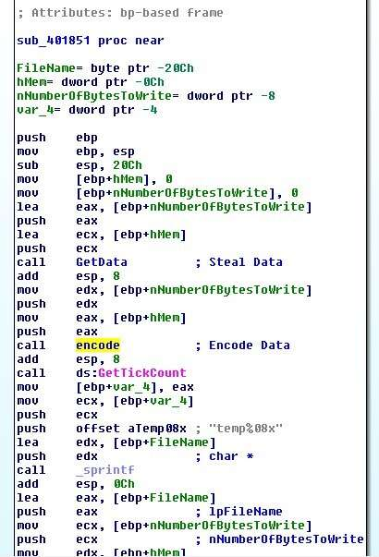Figure 3. encode

**v. Trace from the encoding function to the source of the encoded content. What is the content?**

Based on the subroutine @0x00401070. The malware is taking a screenshot of the desktop.

[GetDesktopWindow:](https://msdn.microsoft.com/en-us/library/windows/desktop/ms633504(v=vs.85).aspx) Retrieves a handle to the desktop window. The desktop window covers the entire screen. The desktop window is the area on top of which other windows are painted.

[GetDC:](https://msdn.microsoft.com/en-us/library/windows/desktop/dd144871(v=vs.85).aspx) The **GetDC** function retrieves a handle to a device context (DC) for the client area of a specified window or for the entire screen. You can use the returned handle in subsequent GDI functions to draw in the DC. The device context is an opaque data structure, whose values are used internally by GDI.

[CreateCompatibleDC:](https://msdn.microsoft.com/en-us/library/windows/desktop/dd183489(v=vs.85).aspx) The **CreateCompatibleDC** function creates a memory device context (DC) compatible with the specified device.

[CreateCompatibleBitmap:](https://msdn.microsoft.com/en-us/library/windows/desktop/dd183488(v=vs.85).aspx) The **CreateCompatibleBitmap** function creates a bitmap compatible with the device that is associated with the specified device context.

[BitBlt:](https://msdn.microsoft.com/en-us/library/windows/desktop/dd183370(v=vs.85).aspx) The **BitBlt** function performs a bit-block transfer of the color data corresponding to a rectangle of pixels from the specified source device context into a destination device context.

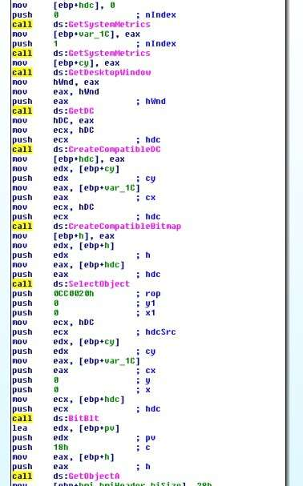

Figure 4. Screenshot

1. **Can you find the algorithm used for encoding? If not, how can you decode the content?**

The encoder used is pretty lengthy to go through, However if we look at the codes in 0x401739, we can see lots of xor operations. If it is xor encoding we might be able to get back the original data if we call this subroutine again with the encrypted data.

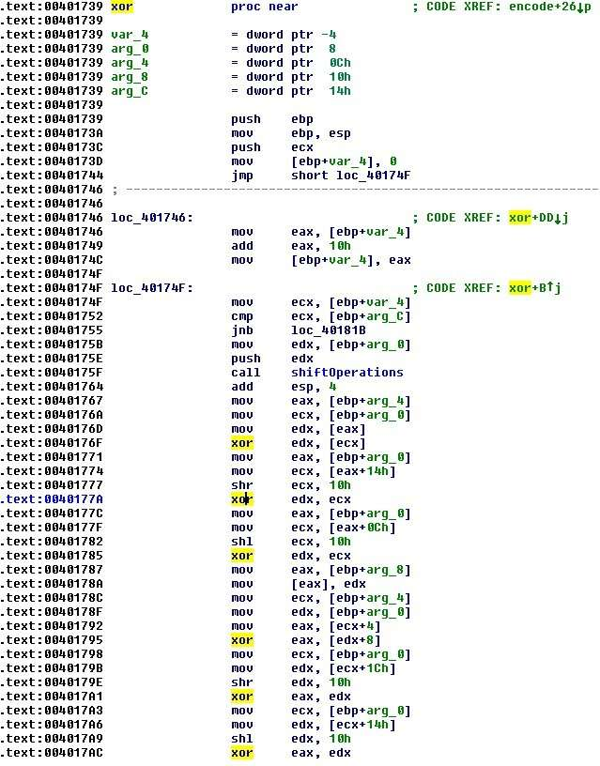

Figure 5. xor operations

1. **Using instrumentation, can you recover the original source of one of the encoded files?**

My way of decoding the encoded files is to use DLL injection. To do that, i write my own DLL and create a thread to run the following function on **DLL_PROCESS_ATTACHED**. To attach the DLL to the malware process, we first run the malware and use a tool called **Remote DLL injector** by securityxploded to inject the DLL into the malicious process.

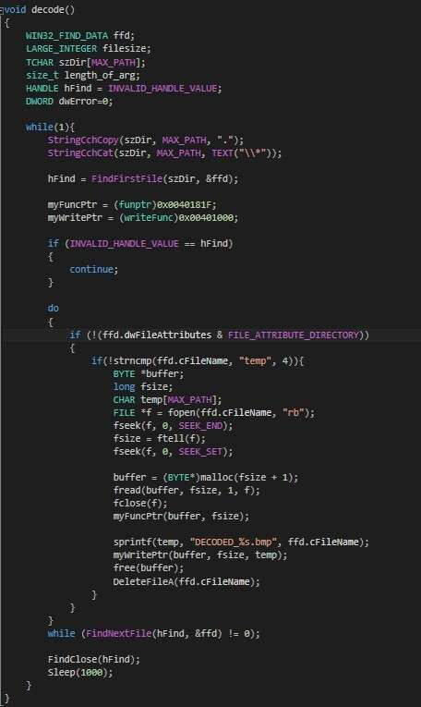

Figure 6. Decode Function

The above codes simply scan the path in which the executable resides in for encoded files that start with “**temp**“. It then reads the file and pass the data to the encoding function **@0x40181F**.

Once the data is decoded, we make use of the function **@0x401000** to write out the file to “**DECODED_[encoded file name].bmp**“. Last but not least i shall delete the encoded file so as not to clutter the folder.

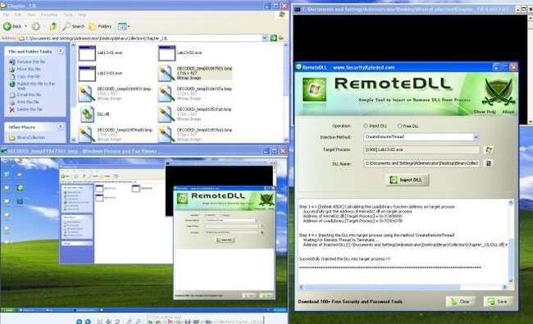

**c. Analyze the malware found in the file *Lab13-03.exe*.**

1. **Compare the output of strings with the information available via dynamic analysis. Based on this comparison, which elements might be encoded?**

Based on Wireshark and program response we could see the following strings.

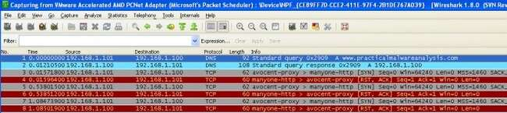

Figure 1. [http://www.practicalmalwareanalysis.com](http://www.practicalmalwareanalysis.com/)

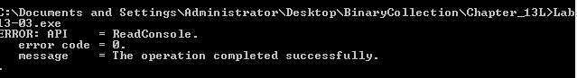

Figure 2. Error Message

In IDA Pro we can see the domain host name and some possible debug messages.

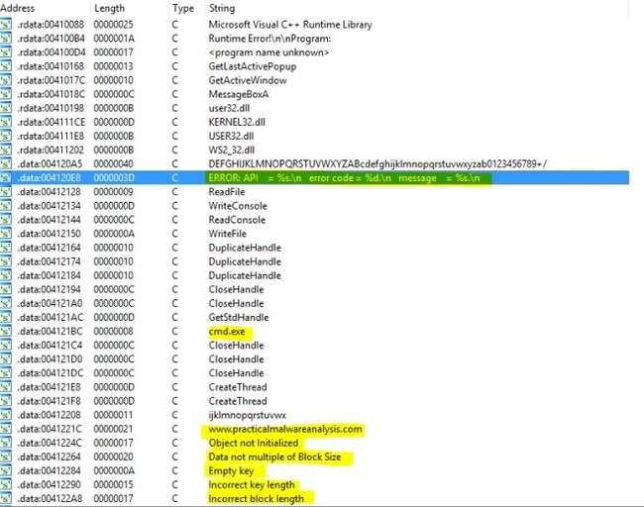

Figure 3. IDA Pro strings

1. **Use static analysis to look for potential encoding by searching for the string xor. What type of encoding do you find?**

There are quite a lot of xor operations to go through. But based on the figure below, it is highly possible that AES is being used; The **Advanced Encryption Standard** (**AES**) is also known as **Rijndae**.

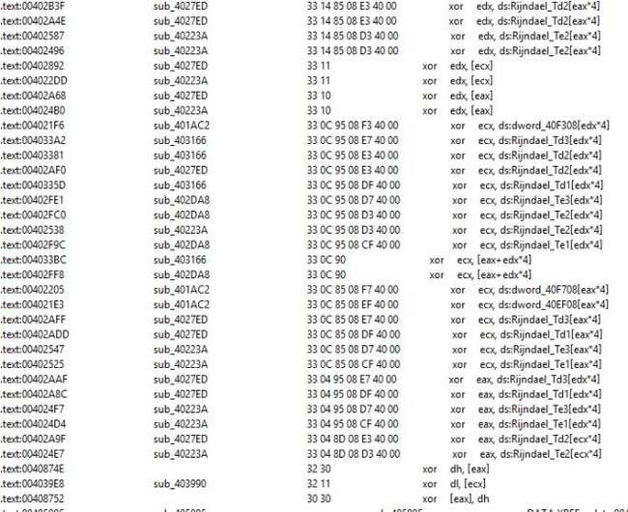Figure

4. XOR operations

**iii. Use static tools like FindCrypt2, KANAL, and the IDA Entropy Plugin to identify any other encoding mechanisms. How do these findings compare with the XOR findings?**

Most likely AES is being used in the malware.

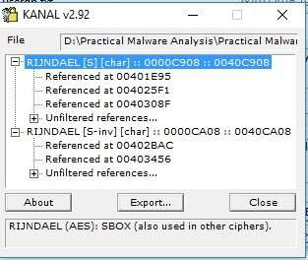

Figure 5. PEID found AES

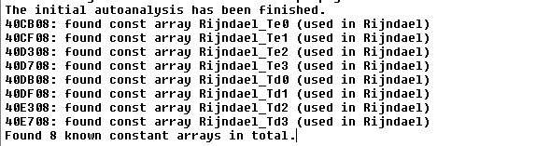

Figure 6. Find Crypt 2 Plugin Found AES **iv. Which two encoding techniques are used in this malware?**

@0x4120A4 we can see a 65 characters string. Which seems like a custom base64 key. The standard base64 key should be

“ABCDEFGHIJKLMNOPQRSTUVWXYZabcdefghijklmnopqrstuvwxyz0123456789+/=” which consists of A-Z, a-z, 0-9, +, / and =.



Figure 7. Custom Base64

A custom Base64 and AES are used in this malware.

**v. For each encoding technique, what is the key?**

The custom base64 string uses

“**CDEFGHIJKLMNOPQRSTUVWXYZABcdefghijklmnopqrstuvwxyzab0123456789+/**”

To test if this key is valid i used a online custom base64 tool to verify.

Online Tool:<https://www.malwaretracker.com/decoder_base64.php>

Using the above tool with the custom key, I encoded HELLOWORLD and pass it to the program via netcat to decode. True enough, the encoded text was decoded back to the original text.

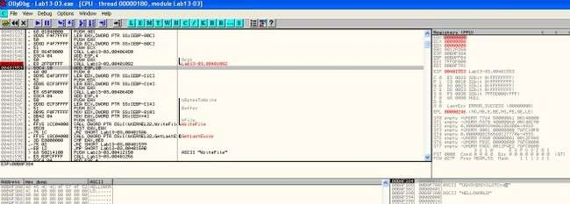

Figure 8. Base64 decode

Based on some debug message, this function (0x00401AC2) seems to be initializing the AES key.

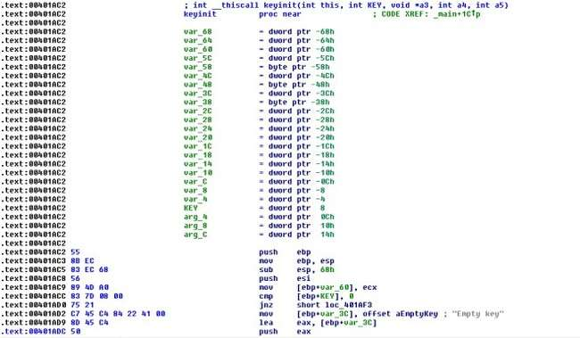

Figure 9. Init Key

x-ref the function and locate the 2nd argument… the key is most likely to be “**ijklmnopqrstuvwx**“.

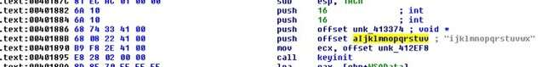

Figure 10. Key pass in as 2nd argument

**vi. For the cryptographic encryption algorithm, is the key sufficient? What else must be known?**

For custom base64, we would just need the custom base64 string.

For AES, we would need the Cipher’s encryption mode, key and IV. **vii. What does this malware do?**

The malware connects to an [http://www.practicalmalwareanalysis.com’s](http://www.practicalmalwareanalysis.com’s/) 8190 port and establishes a remote shell. It then reads input from the attacker. The inputs are custom base64 encoded. Once decoded, the command is pass to cmd.exe for execution. The return results is encrypted using AES and send back to the attacker’s server.

**viii. Create code to decrypt some of the content produced during dynamic analysis. What is this content?**

Using the key, we use CBC mode with no IV to decrypt the AES encrypted packet. The content is the response from the command sent earlier via the remote shell from the attacker.

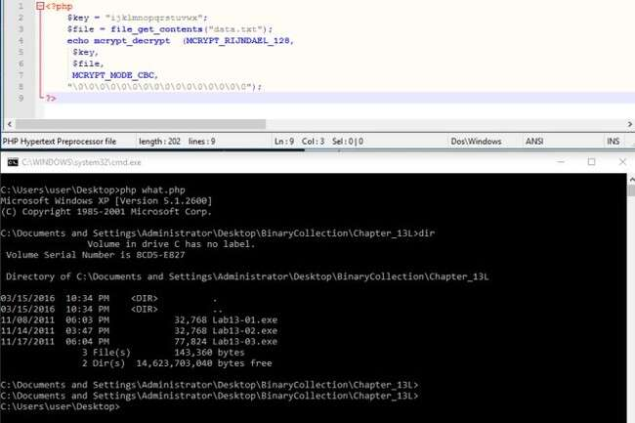

Figure 11. Decrypted Data

**Practical 8**

**PE bear,CFF explorer,Fakenet,IDA freeware**

**a.Analyze the malware found in file Lab14-01.exe. This program is not harmful to your system.**

i. Which networking libraries does the malware use, and what are their advantages?

Ans.Opening the malware using PE-bear, we find that it is importing the Windows DLL urlmon.dll (OLE32 Extensions for Win32) used for Object Linking and Embedding based API calls. Of this it calls the ‘[URLDownloadToCacheFile](https://docs.microsoft.com/en-us/previous-versions/windows/internet-explorer/ie-developer/platform-apis/ms775122(v=vs.85))’ API call which leverages COM objects.

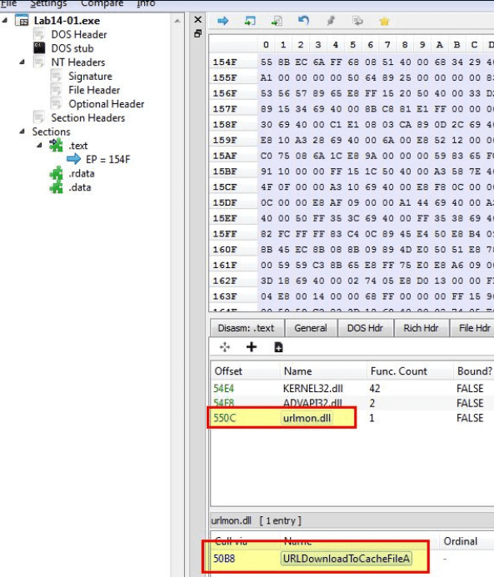

ii.What source elements are used to construct the networking beacon, and what conditions would cause the beacon to change?

Ans. In the above example we can see that the networking beacon came out as ‘ODA6NmU6NmY6NmU6Njk6NjMtSUVVc2Vy’. Running the malware again on the same host reveals the same output.

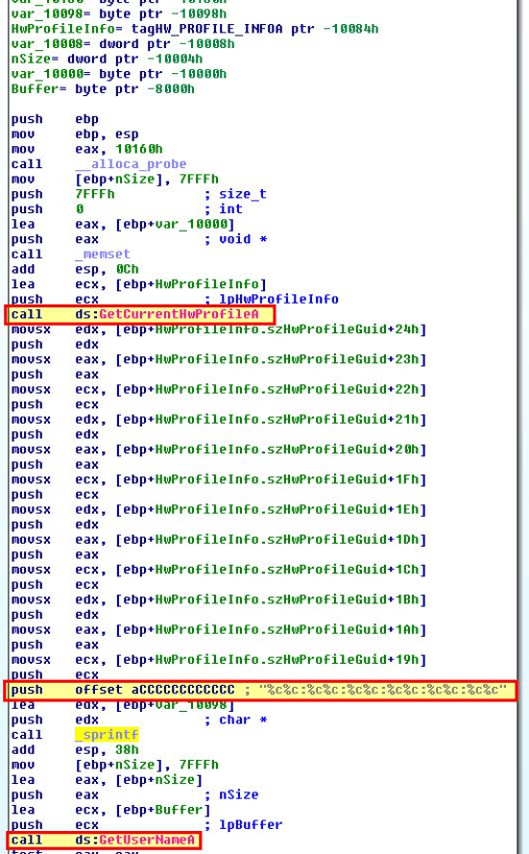

Immediately we can see that a call to [GetCurrentHwProfileA](https://docs.microsoft.com/en-us/windows/win32/api/winbase/nf-winbase-getcurrenthwprofilea) is run prior to a call to [GetUserNameA](https://docs.microsoft.com/en-us/windows/win32/api/winbase/nf-winbase-getusernamea) which helps to back up what we’ve found so far.

Another way of retrieving the GUID referenced by this API is to check the registry.

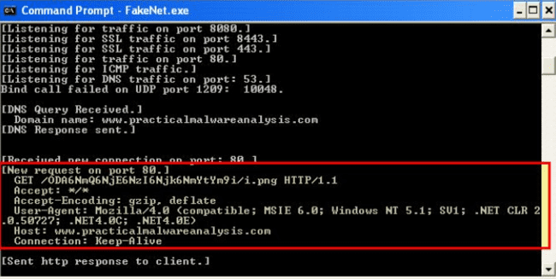

In addition to seeing new Base64-encoded data based on this system GUID and user account.

* 80:6d:61:72:69:6f-bob

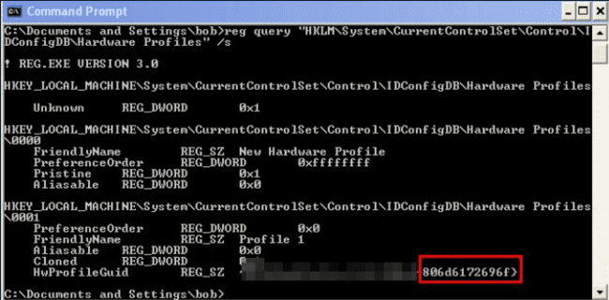

iii.Why might the information embedded in the networking beacon be of interest to the attacker?

Ans.As the information uncovered above is meant to be used for uniquely identifying systems and users, this may be of interest to an attacker who wants to keep track of infected clients and specifically target certain users or systems.

iv.Does the malware use standard Base64 encoding? If not, how is the encoding unusual?

Ans. If we look at the Strings window of this malware we can see what appears to be a Base64-encoding index string.

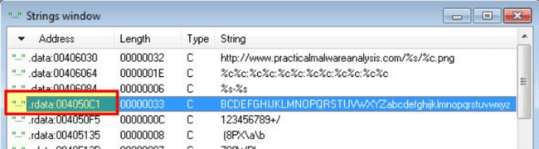

By looking at cross-references to this we can find it is used inside of ‘sub_401000’ which appears to be our encoding routine. Of interest is that this has a modified ‘padding’ character used as ‘61h’ (a) meaning that any padding required in the Base64-encoded data will appear as the letter ‘a’ rather than the standard ‘=’.

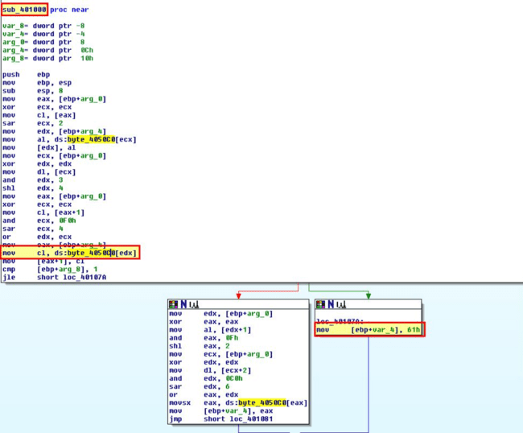

v.What is the overall purpose of this malware?

Ans.To determine this we need to move back to the main method of this malware and examine the call it makes to ‘sub_4011A3’ after the base64-encoding routine occurs. Within this routine we find that a call is made to [‘URLDownloadToCacheFileA’](https://docs.microsoft.com/en-us/previous-versions/windows/internet-explorer/ie-developer/platform-apis/ms775122(v=vs.85)) which is used to download a file to the internet cache directory and return the file name/location

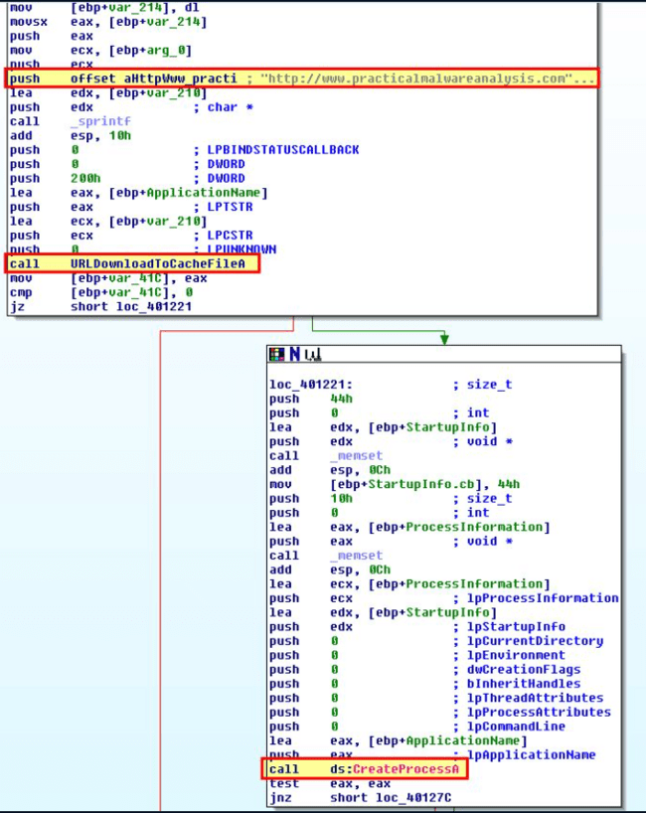

Of interest is that this is also passed directly to CreateProcessA and as such the file downloaded would be immediately run. Examining the calling process reveals this would wait ‘0EA60h’ (60000) milliseconds if this fails and try to download it again.

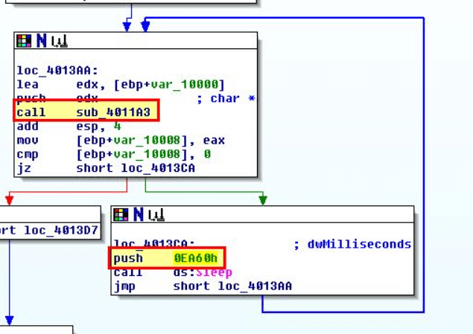

As such this malware can be considered to be a ‘Downloader and Launcher’, or ‘Dropper’ used to download and execute further code.

vi.What elements of the malware’s communication may be effectively detected using a network signature?

Ans. Examining the beacon which is sent we know that it will always send the base64-encoded values followed by a single character png resource which is one element which remains consistent. It should be noted that this character is taken from the final letter in the Base64-encoded content.

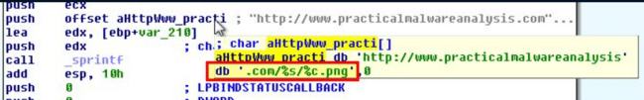

In addition to this we know that it sends base64-encoded data via the %s variable passed to sprintf which contains a MAC reference followed by ‘-‘ and a username. Although the username and specific MAC will likely change, the colons and dash which separate this will remain consistent making it another element that can be used.

Finally the beacon makes a request to www.practicalmalwareanalysis.com which is a consistent C2 in this case, making it once again a useful element to use.

vii.What mistakes might analysts make in trying to develop a signature for this malware?

Analysts may make a signature too broad or too lax. In this instance if analysis wasn’t done on what is creating the beacon and its use of abnormal padding analysis may make it seem like ‘a.png’ is always being retrieved (for example in the case where padding needed to be used and made the end of the base64-encoded string ‘a’). Another mistake would be to target the User-Agent, username, MAC, or another field which is dynamically set based on the system the malware is run on. If this was setup to alert on any traffic to this domain then in the case of a compromised domain or a domain which is reused it would be very easy to make the rule too broad.

viii. What set of signatures would detect this malware (and future variants)?

To detect this malware we’re going to want to create at least 2 Snort rules, one to identify Base64-encoded data sent when fetching the single character png resource, and one to identify any base64-encoded data which has a pattern involving colons and finally a ‘-‘ character.

**b. Analyze the malware found in file Lab14-02.exe. This malware has been configured to beacon to a hard-coded loopback address in order to prevent it from harming your system, but imagine that it is a hard-coded external address.**

i.What are the advantages or disadvantages of coding malware to use direct IP addresses?

Ans.If we consider malware that uses direct IP addresses there are a number of advantages and disadvantages for both the malware author, and the defender. If we take this from the malware author’s perspective the following applies.

ii.Which networking libraries does this malware use? What are the advantages or disadvantages of using these libraries?

Ans. Using CFF Explorer VIII we can see that this makes use of WinInet.dll and its associated API calls.

* InternetCloseHandle
* InternetOpenUrlA
* InternetOpenA
* InternetReadFile

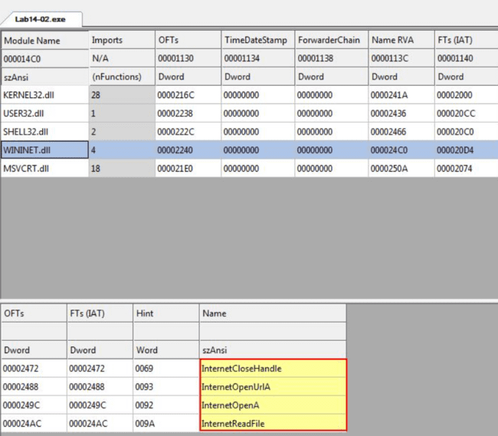

iii.What is the source of the URL that the malware uses for beaconing? What advantages does this source offer?

Ans. If we leverage Fakenet-NG and run the malware we can see that it makes a request to the local system loopback IP of 127.0.0.1 (in this case we pretend this is a C2 IP). This occurs with an unusual user agent which is then followed by another request with an unusual user agent ‘Internet Surf’.

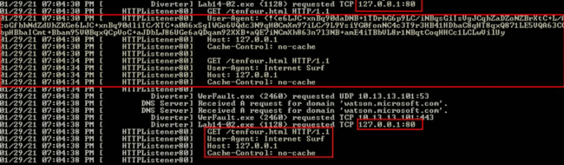

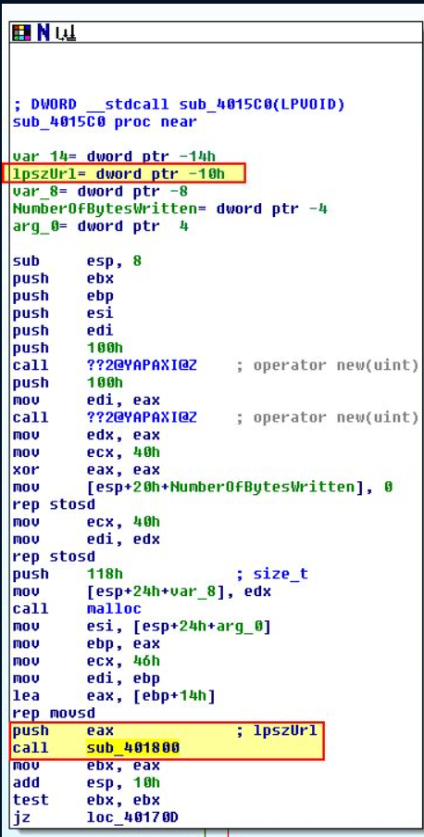

If we look at how this is launched by examining cross-references, we find that these network connections are being launched in their own threads one after another from within WinMain which reflects what we’ve seen during the dynamic analysis above.

iv.Which aspect of the HTTP protocol does the malware leverage to achieve its objectives?

Ans.From our dynamic analysis there looks to be some strange data contained within the User-Agent field so we investigate that further. First we look at the thread creation which uses the anonymous pipe we saw created in the previous section.

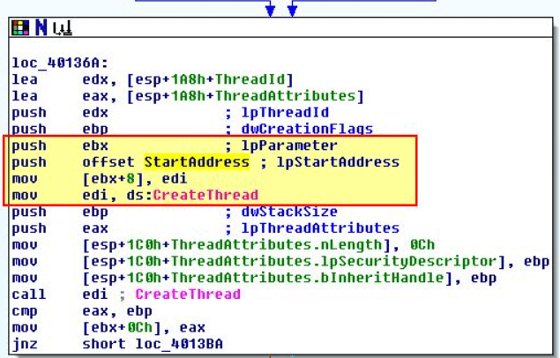

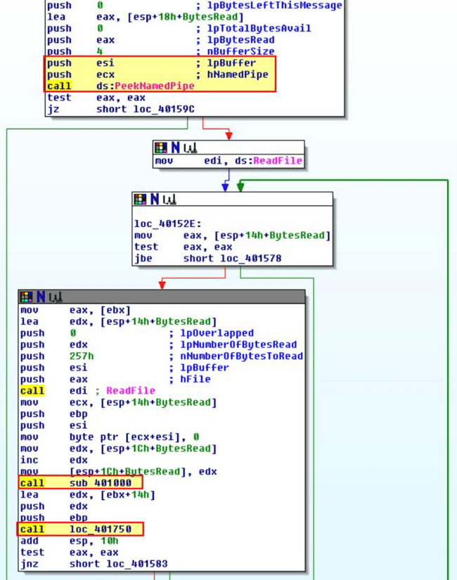

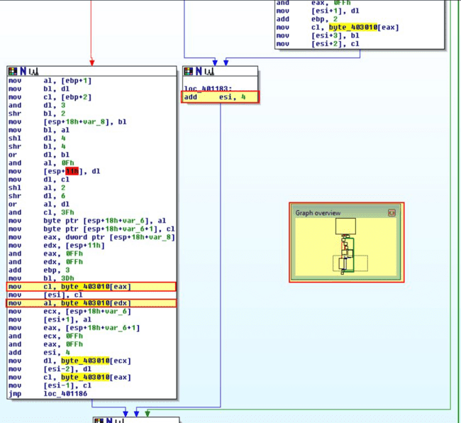

v.What kind of information is communicated in the malware’s initial beacon?

Ans.Taking our output from running the malware and our knowledge from the above analysis on custom Base64 index string used, we can decode the output and confirm this is the standard output of cmd.exe being run.

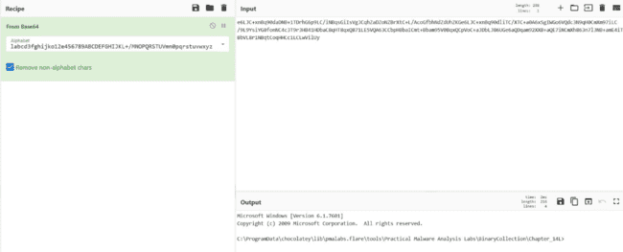

vi.What are some disadvantages in the design of this malware’s communication channels?

Ans. To identify some disadvantages in the design of this malware’s communication channels we can look within ‘sub_4015C0’ which is what is run within the second thread of this malware. Inside of this we immediately see this uses ‘sub_401800’ to make the outgoing internet connection, so we examine this further.

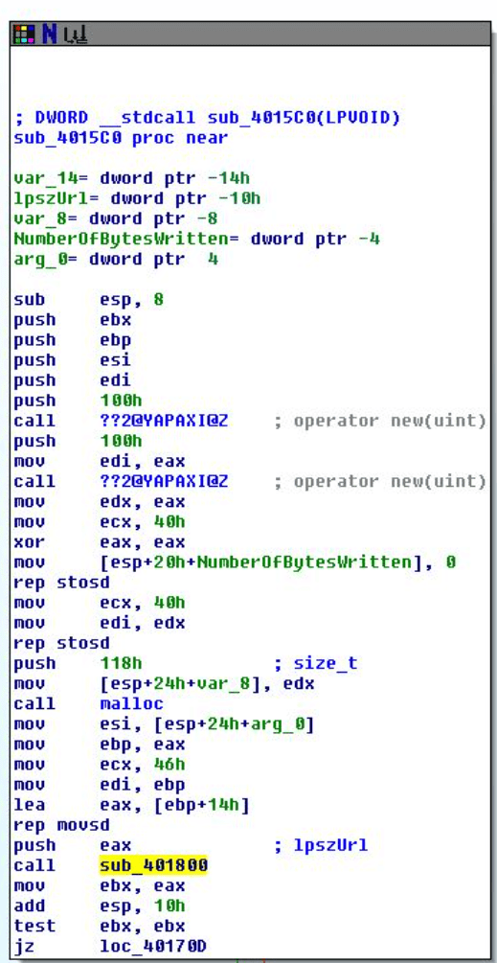

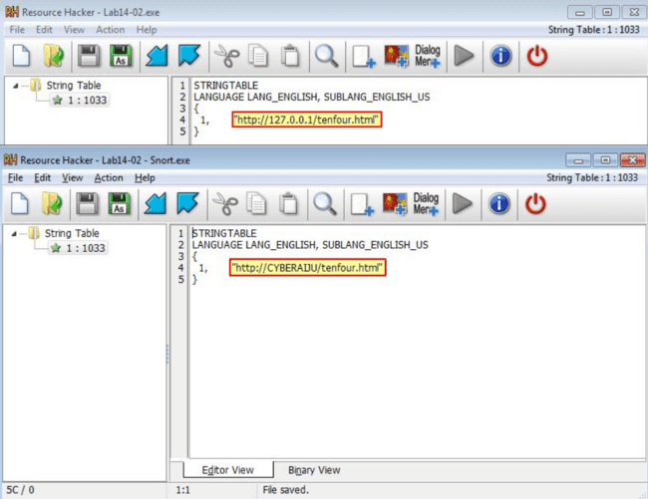

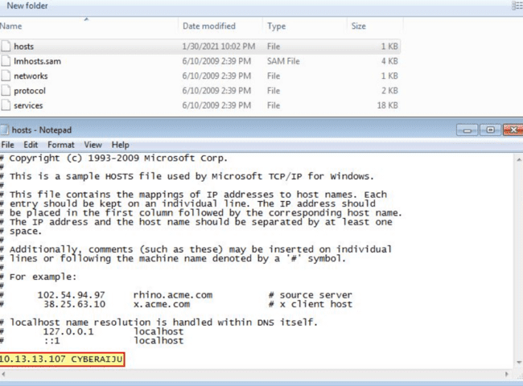

vii.Is the malware’s encoding scheme standard?

Ans.From our analysis in question 4 we know that the malware’s encoding scheme is Base64 but not using the standard index string.

viii.How is communication terminated?

Ans.Looking back into this malware within IDA, after establishing a connection through ‘sub_401800’ contained within ‘sub_4015C0’, a comparison is then made looking for the term ‘exit’.

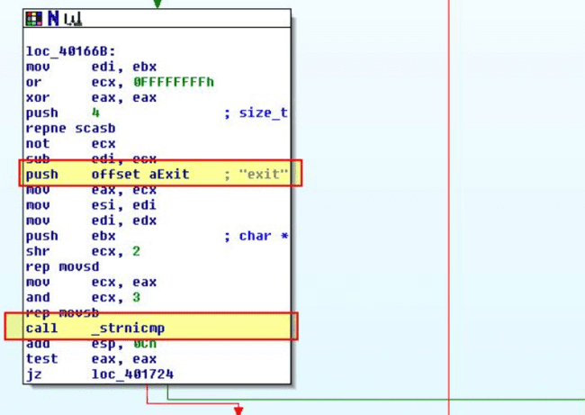

ix.What is the purpose of this malware, and what role might it play in the attacker’s arsenal?

Ans.From our analysis above we know the purpose of this malware is to establish a reverse TCP command shell which passes data through a user-agent to try and evade network analysis techniques. Given the malware attempts to delete itself it’s likely this is only used during initial access to a system prior to further malware or persistence being setup and is simply a disposable means to an end.

**c) This lab builds on Practical 8 a. Imagine that this malware is an attempt by the attacker to improve his techniques. Analyze the malware found in file Lab14-03.exe.**

i.What hard-coded elements are used in the initial beacon? What elements, if any, would make a good signature?

Ans.By running the malware and using Fakenet-NG, we can get a glimpse of the beacon this sends.

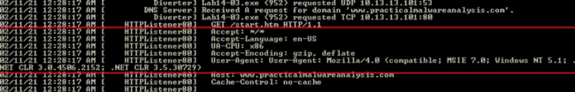

ii.What elements of the initial beacon may not be conducive to a longlasting signature?

Ans.If we examine the hard-coded URL above and where it is referenced, we find that it is located in a function ‘sub_401457’.

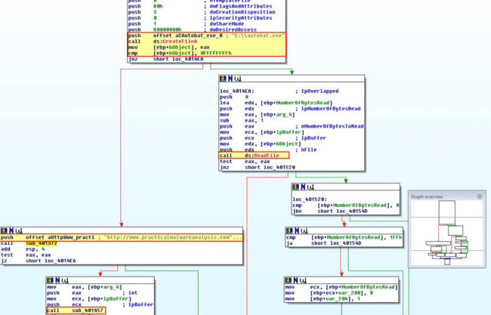

iii.How does the malware obtain commands? What example from the chapter used a similar methodology? What are the advantages of this technique?

Ans.Taking a closer look at sub_4011F3 we found earlier, we can see that after attempting to initiate the C2 beacon connection, we can see that after reading the .htm file hosted in the C2, it begins searching for elements which start with “<no” in addition to performing a subroutine at sub_401000 before comparing other elements.

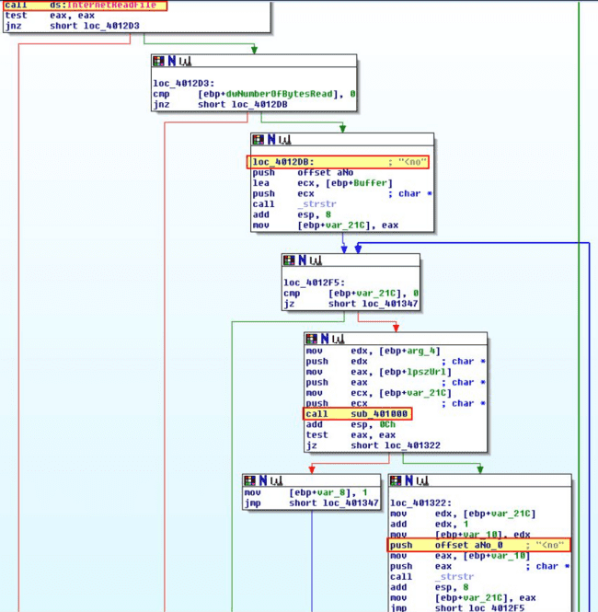

iv.When the malware receives input, what checks are performed on the input to determine whether it is a valid command? How does the attacker hide the list of commands the malware is searching for?

Ans.Based on the above analysis we know that the malware receives input from the C2 and looks for the presence of <noscript> followed by the expected domain it is fetching (e.g. http://www.practicalmalwareanalysis.com/), a command, and the number 96. If we examine sub_401684 which is passed the URL we found previously we can see that it uses ‘strtok’ to tokenise (break apart) the URL being passed to it before comparing it to see if it has the character ‘d’ passed.

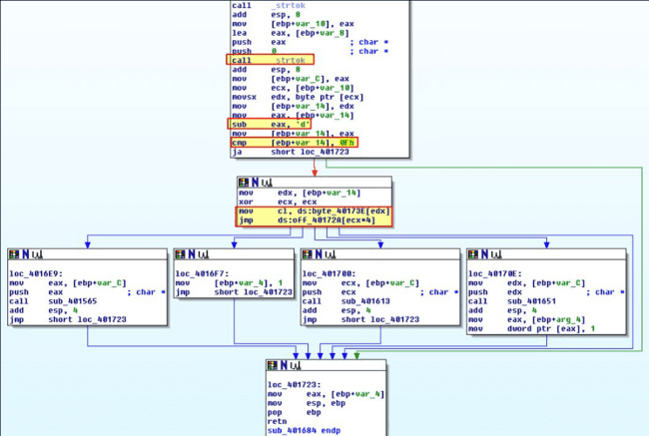

V.What type of encoding is used for command arguments? How is it different from Base64, and what advantages or disadvantages does it offer?

Ans.Examining ‘loc_40170E’ we find that it runs ‘sub_401651’ which calls what looks to be a decoding routine at ‘sub_401147’. Within this we can see what appears to be a non-standard encoding routine. We know this because it doesn’t quite follow the basis of breaking 3 bytes into 4 bytes, and instead has a call to ‘strlen’ to break this string apart for encoding, before ‘ebp+var_4’ is increasing by 1, and ‘ebp+var_8’ is increasing by 2.

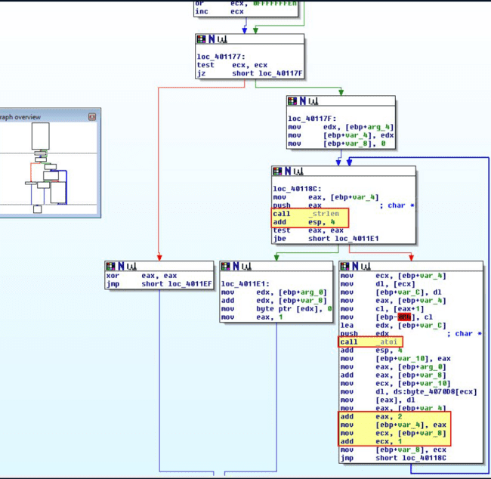

vi.What commands are available to this malware?

Ans. To determine what commands are available to is malware we need to look into the subroutines inside of ‘sub_401684’. Remembering the array we identified in question 4, the possible cases and their triggers are shown below.

* Case 0 (d): loc_4016E9
* Case 1 (n): loc_4016F7
* Case 2 (r): loc_40170E
* Case 3 (s): loc_401700
* Case 4 (other): loc_401723

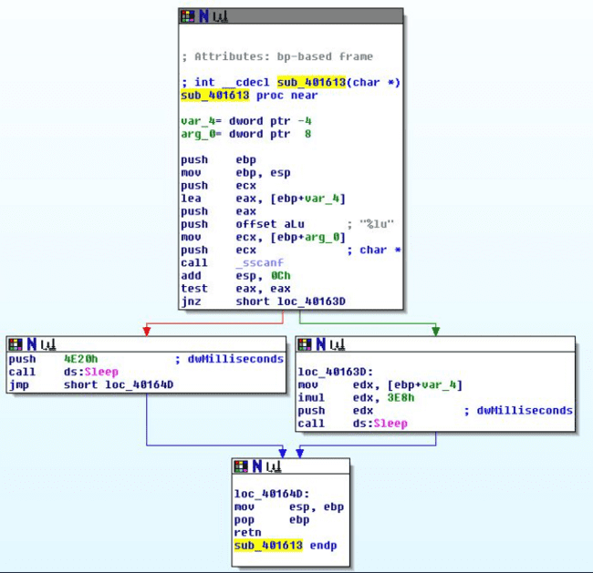

By examining sub_401651 (r) we can see that this has a call to ‘sub_401147’ to decode any provided URL, before calling ‘sub_401372’ which we identified in question 2 as being responsible for updating the C2 configuration file.

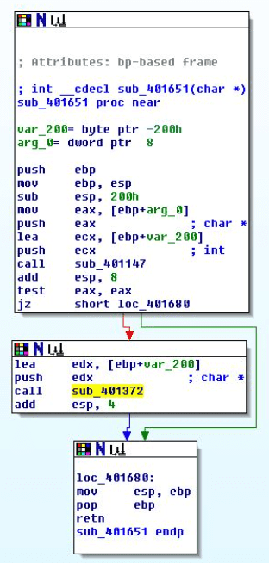

Putting this all together we know what commands are available to this malware.

vii.What is the purpose of this malware?

Based on the above commands available to this malware we can presume this is a malware dropper AKA a ‘Downloaders and Launcher’. This differs from traditional throwaway malware which may exist only to drop malware before removing itself in that it sets up persistence to allow further malware and C2 to be dropped over time.

viii.This chapter introduced the idea of targeting different areas of code with independent signatures (where possible) in order to add resiliency to network indicators. What are some distinct areas of code or configuration data that can be targeted by network signatures?

Ans.Because the malware leveraged custom, yet simple encoding mechanisms, static, yet configurable domain names, User-Agent errors, and a few other static elements such as commands being sent via the C2, we can use all of this to create specific snort rules to identify this malware. As we are focussing on network signatures, we can target the initial beacon of the malware and subsequent commands sent down via the web-based C2.

ix.What set of signatures should be used for this malware?

Ans. Expanding on the above, we can split this section into identifying the initial beacon, and then the subsequent C2 commands before testing our rules.

*Beacon:*

We gathered up the static elements of this beacon in question 1. The specific elements are highlighted below.

* Accept-Language
* UA-CPU
* User-Agent
* Accept
* Accept-Encoding

Because we can specify the C2 with autobat.exe, we can modify this to point to our own system. Given we’ve already defined ‘CYBERAIJU’ to point to one of our controlled hosts, let’s continue to use this, and create a Snort rule based on all the hardcoded elements of this beacon.

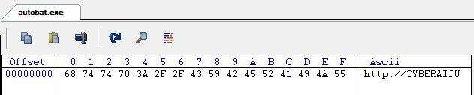

If we wanted to limit this to one hardcoded element over another it would be trivial to do; however for the purpose of thoroughly identifying every static element of this beacon for a high confidence hit, we have added all to our Snort rule.

Side Note: Given header elements stretch over many lines the hex ‘0D 0A’ needs to be used to signal a new line feed, and many other special characters will need to be converted to hex.

**d. Analyze the sample found in the file Lab15-01.exe. This is a command-line program that takes an argument and prints “Good Job!” if the argument matches a secret code.**

1. **What anti-disassembly technique is used in this binary?**

Upon opening the binary in IDA, it becomes evident that some form of anti-disassembly technique has been employed, as all data is incorrectly marked as code, and there are calls to non-existent functions.

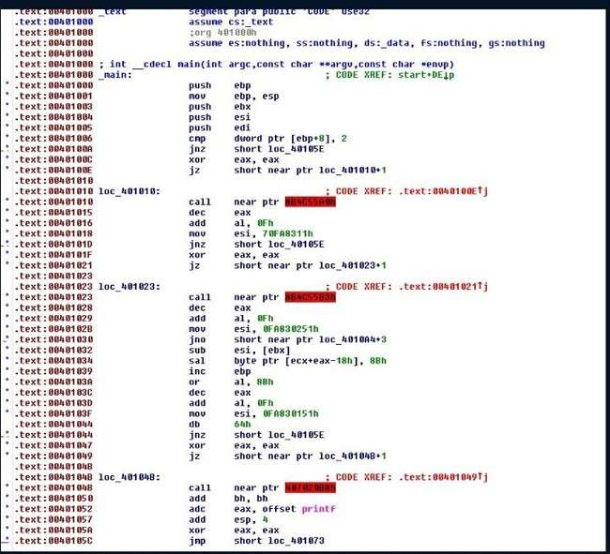

By navigating to ‘Options -> General’, we can adjust the number of opcode bytes displayed; setting this to ‘4’ in this case reveals additional details about the code's behavior.

Here, we observe four instances where an XOR operation is performed on the eax register with itself—effectively setting it to zero. This is followed by a conditional jump (jz) that checks the zero flag, which will always be set, making the condition always true. However, the disassembler initially evaluates the ‘false’ branch of this conditional jump, leading to incorrect disassembly. This use of misleading conditional branching is what causes the disassembly issues.

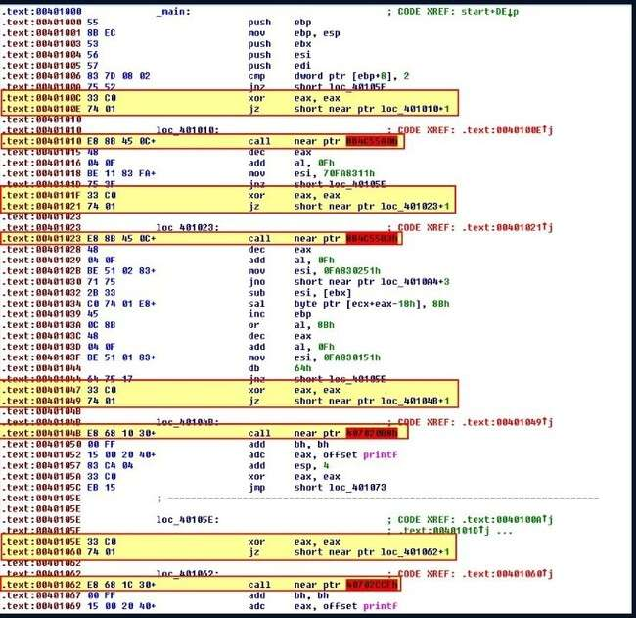

1. **What rogue opcode is the disassembly tricked into disassembling?**

The disassembly contains a rogue opcode 0xE8, which the disassembler interprets as the beginning of a 5-byte CALL instruction. As a result, it misinterprets the following bytes, effectively hiding the actual instructions that come after it. **iii. How many times is this technique used?**

To estimate how frequently this technique is used, we can quickly scan for operations that attempt to jump to a new location relative to a pointer plus an offset.

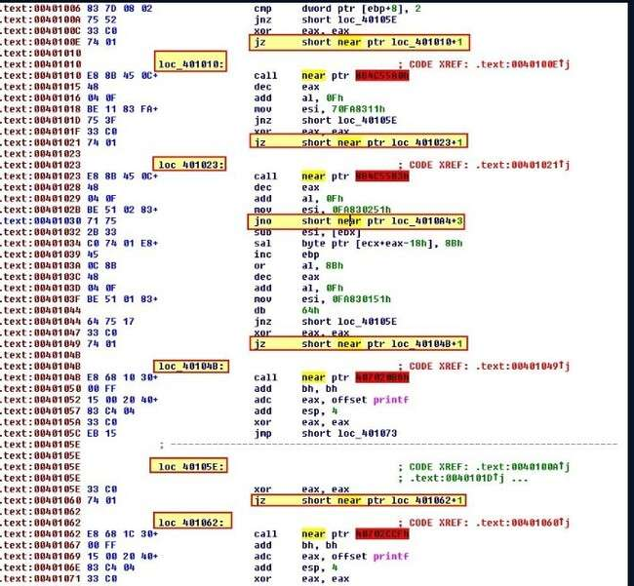

This suggests that the technique has been used five times. To verify this, we can start reconstructing the intended code. As a first step, we convert the instruction at address 00401010 into data by pressing 'D'.

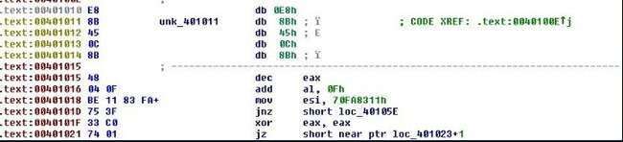

At this point, we notice that too many opcodes have been mistakenly converted to data. To correct this, we start converting everything—except the rogue 0xE8 opcode—back into code by using the ‘C’ command. Once this process is complete, it reveals the second instance of a false conditional branch.

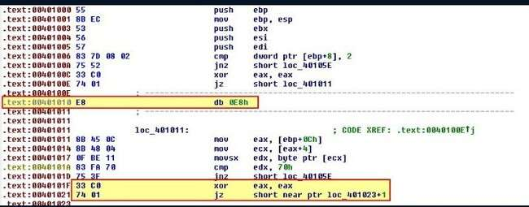

By repeating this process for each rogue instance of 0xE8, we gradually uncover previously hidden sections of the code. As a result, the disassembly starts to resemble a more accurate and coherent representation of the original program.

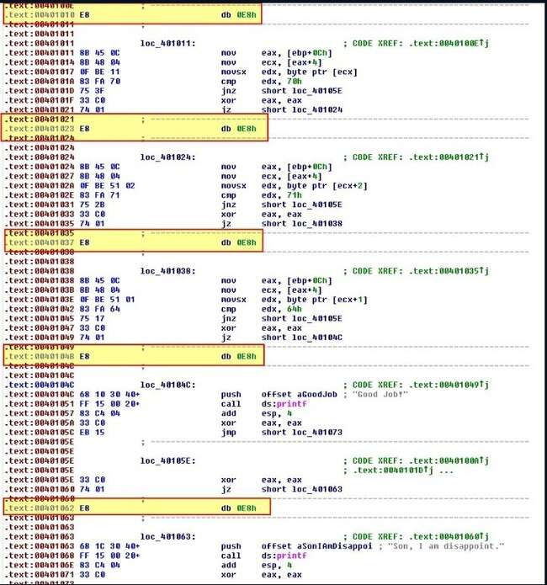

This confirms that the obfuscation technique was indeed used five times throughout the binary.

**iv. What command-line argument will cause the program to print “Good Job!”?**

By highlighting the relevant section from main to ret, we can convert it into a function in IDA by pressing ‘P’. Once defined as a function, we can now view it using IDA’s alternative graph view for better analysis and readability.

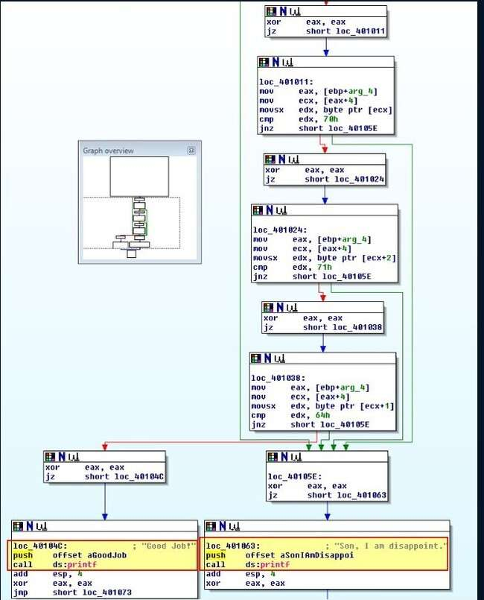

This now reveals two possible outcomes from the comparisons within the code: one path results in the message "your parent is disappoint" — a subtle reference to a 4chan meme — while the other congratulates the user for doing a good job. At this stage, it becomes straightforward to convert the hex values in the comparisons to their character constants by pressing ‘r’.

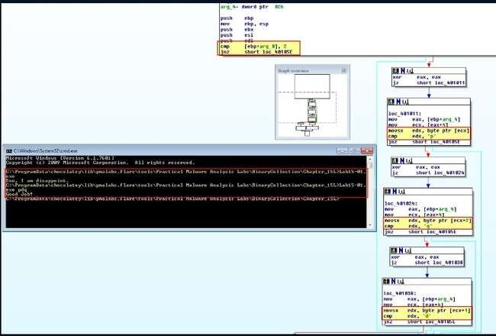

From the analysis above, we’ve determined that passing 'pdq' as an argument to the program causes all the checks to succeed, resulting in the message “Good Job!” being printed.

**e. Analyze the malware found in the file Lab15-02.exe. Correct all anti-disassembly countermeasures before analyzing the binary in order to answer the questions.**

**i. What URL is initially requested by the program?**

When opening the program in IDA and executing it, we observe that it immediately displays the message “not enough name” and then exits.

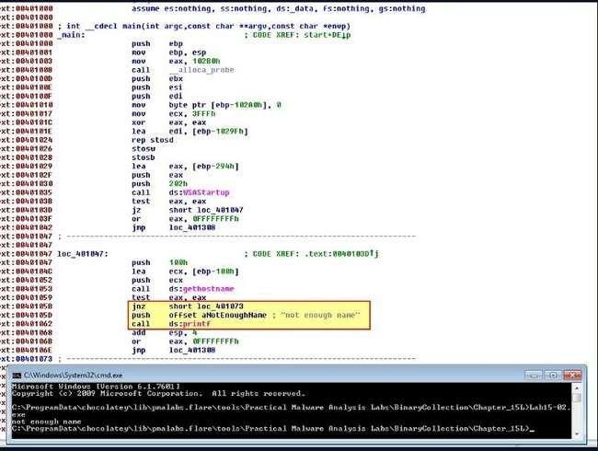

Upon examining the data in IDA, it’s clear that the disassembly is not clean—indicating the use of anti-disassembly techniques. To locate the URL initially requested by the program, we need to ensure the code is properly disassembled. We do this by scanning through the code for known antidisassembly patterns, particularly those involving E9 (JMP) or E8 (CALL) opcodes that reference invalid or suspicious function calls. This process leads us to a notable entry at address 0040115E.

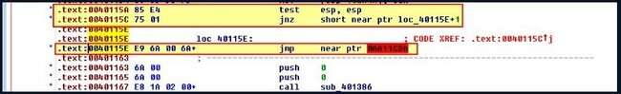

This code compares ESP to itself, which always results in a non-zero flag being set. If the flag is not zero, a jump occurs; however, the disassembler has incorrectly followed the false branch of this condition. Similar to the previous case, this false conditional branch is used as an anti-disassembly technique. To correct this, we convert the rogue opcode into data and restore the surrounding bytes back into code. Continuing our analysis, we encounter the next instance at address 004011D4, which performs a jump if the zero flag is set.

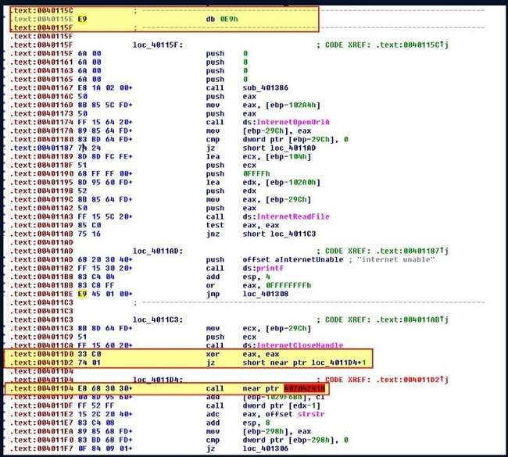

Here, the preceding operation is a XOR that will always set EAX to 0. Because of this, we apply the same approach of interpreting the following bytes as data or code as needed. Moving ahead, we come across a noteworthy entry at address 00401215.

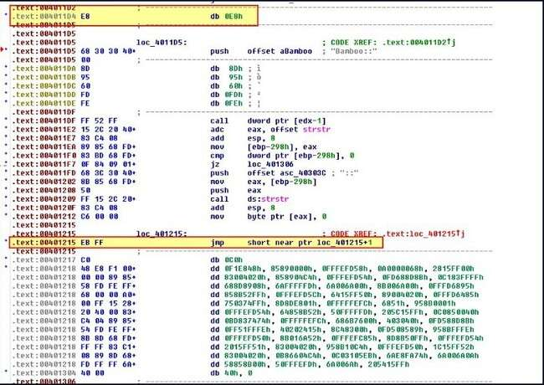

To resolve this, we first need to enable the ‘Patch’ submenu in IDA by editing the idagui.cfg file located in the cfg folder, then restart the program.

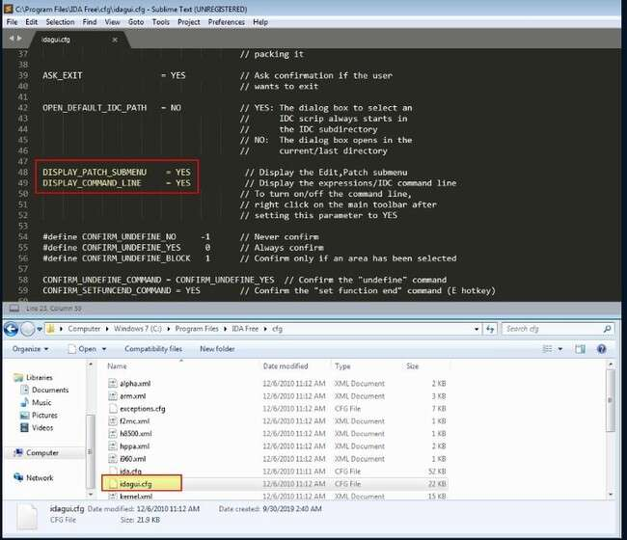

Now, beneath the rogue byte (EB), we can navigate to Edit > Patch program and change it to 90.

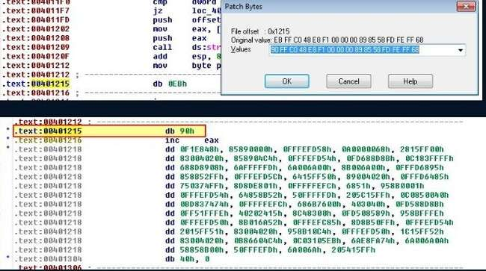

Converting this into code reveals that a different technique is being used at address 0040126D.

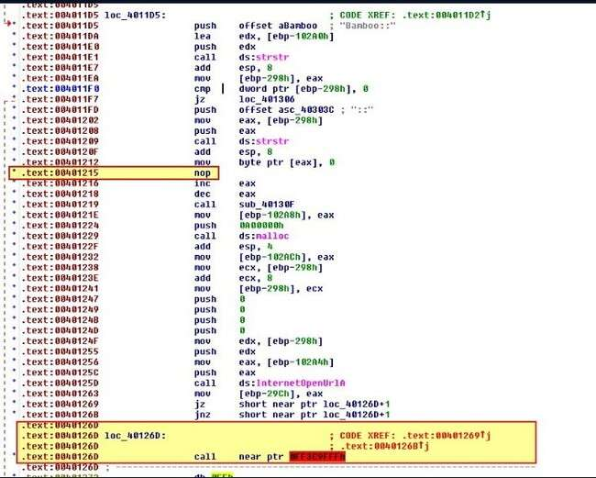

Here, the subsequent ‘jz’ and ‘jnz’ instructions both jump to the same target. Since these are two different conditionals placed consecutively, this indicates the use of another anti-disassembly technique. By treating this as data and then converting the surrounding parts back into code, we reveal more of the assembly and further proof of anti-disassembly methods at address 0040126D.

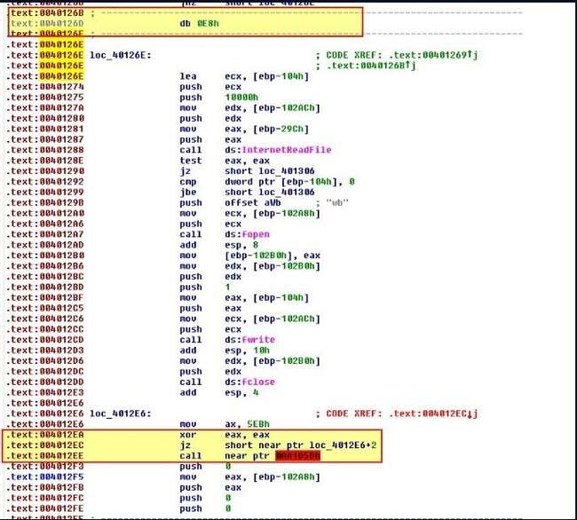

Here, we encounter a case of impossible disassembly, where the rogue opcode at 0x4012EC is used both during normal program execution and to perform an unnecessary call. By converting the surrounding areas to data and code as before, and logically following the assembly to verify its correctness, we arrive at a clearer and more accurate representation, as shown below.

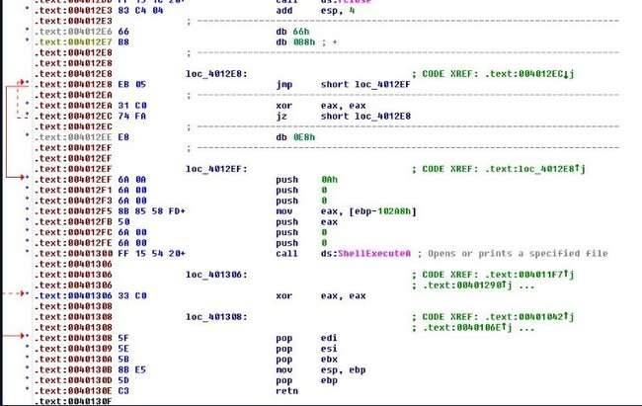

At this stage, there are no jumps to invalid addresses, and the code appears to form a valid function. To ensure proper execution, we first need to patch the rogue bytes scattered throughout— specifically, those bytes shown between lines like ‘db 0E8h’, ‘db 0E9h’, etc.—by replacing them with 0x90 (NOP) instructions so they are simply skipped over. However, to avoid errors, the bytes at 004012E6 (db 66h) and 004012E7 (db 0B8h) should **not** be patched and must remain as data since they are still in use. Once these changes are made, highlighting the area and pressing ‘P’ to convert it into a function reveals assembly that looks valid.

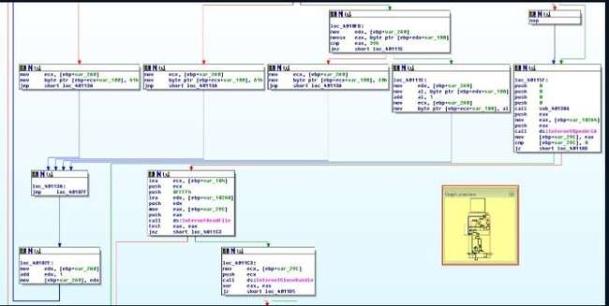

If incorrect bytes are replaced with NOPs, it can cause broken control flows—such as instructions that aren’t connected to the main code or lack cross-references—meaning you might have to revisit and fix the patching process. For now, let’s focus on the function sub_401386. Within this function, we observe what appears to be a string-building operation

. 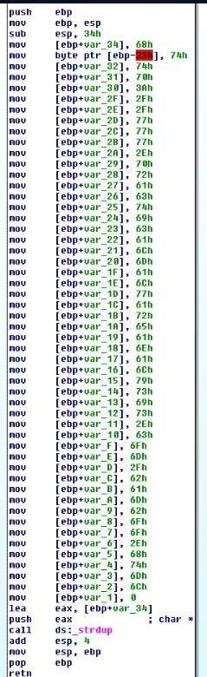

By pressing ‘R’ to convert these characters to their ASCII equivalents, we discover that they form the string:

<http://www.practicalmalwareanalysis.com/bamboo.html>

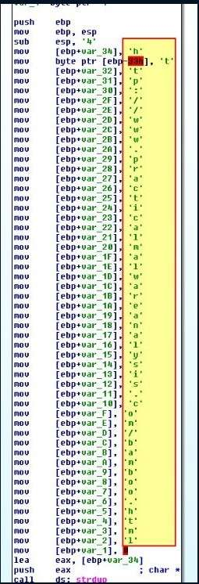

This string represents the URL initially requested by the program. We can verify this by checking the cross-references to sub_401386, which show that it’s called to set up the URL parameter passed to the InternetOpenURLA function

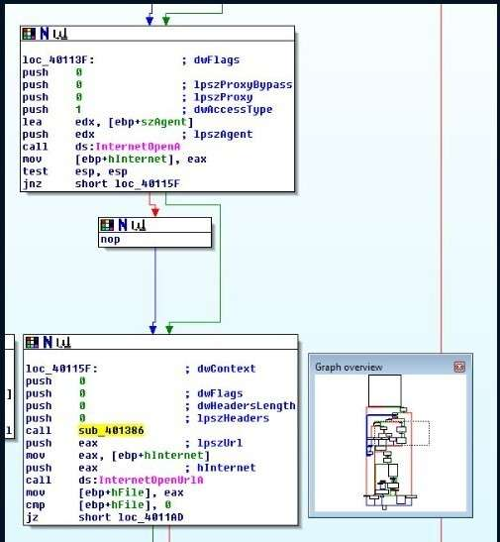

**ii. How is the User-Agent generated?**

To understand how the User-Agent is generated, we need to identify where it’s defined before the call to InternetOpenA. Looking just above that call, we can see that the hostname is assigned as the User-Agent.

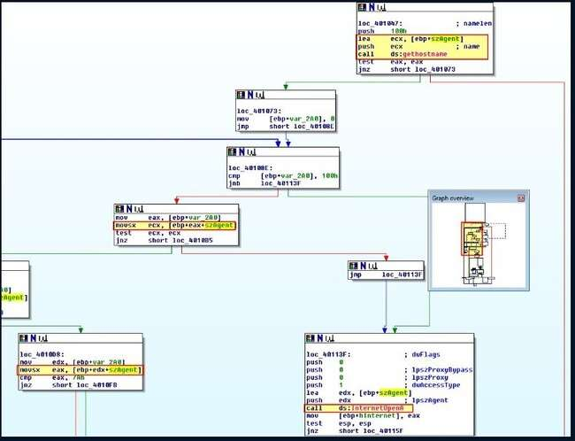

What’s interesting is that the graph overview reveals what appears to be a loop manipulating the User-Agent string. To understand how the User-Agent is generated, we need to analyze this section in detail.

Initially, [ebp+var_2A0] is set to 0 before entering the loop. The loop performs several steps:

1. It first checks if the loop counter [ebp+var_2A0] has exceeded 256. If so, it proceeds to open the URL.
2. Next, there’s a check that always causes a jump to loc_4010B5. This is residual code from the anti-disassembly measures.
3. Then, it examines the User-Agent character at position [ebp+var_2A0]:
   * If the character is 90 (ASCII ‘Z’), it resets it to ‘A’. • Otherwise, if it’s 122 (ASCII ‘z’), it resets it to ‘a’.
   * If it’s the number 9, it resets it to ‘0’.
   * If none of the above, it increments the character’s ASCII value by 1.
4. Finally, it increments [ebp+var_2A0] by 1 and repeats the loop.

Essentially, this loop performs a character rotation (ROT1) on the hostname, with boundary checks to prevent invalid ASCII characters and wrap-around logic to cycle back to the start characters once the end is reached.

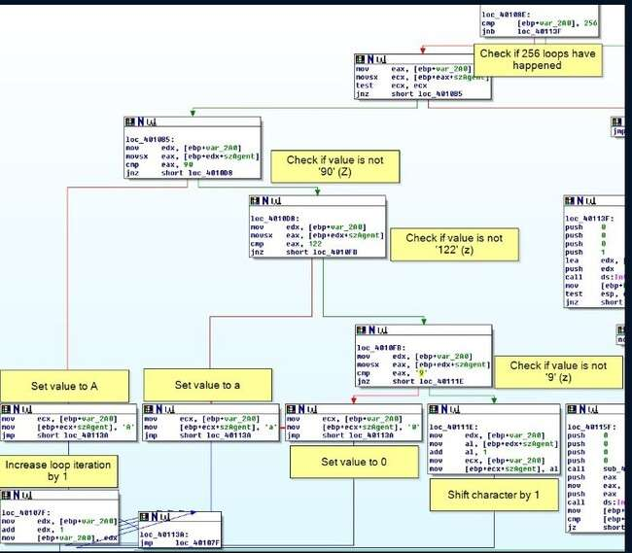

Exactly—based on this, the User-Agent is generated by taking the hostname and applying a ROT1 shift to each character, effectively incrementing every character’s ASCII value by one with wrapping rules to keep it within valid ranges. **iii. What does the program look for in the page it initially requests?**

If we look at the operations following the page read, we find that the program searches for the first occurrence of the string "Bamboo::".

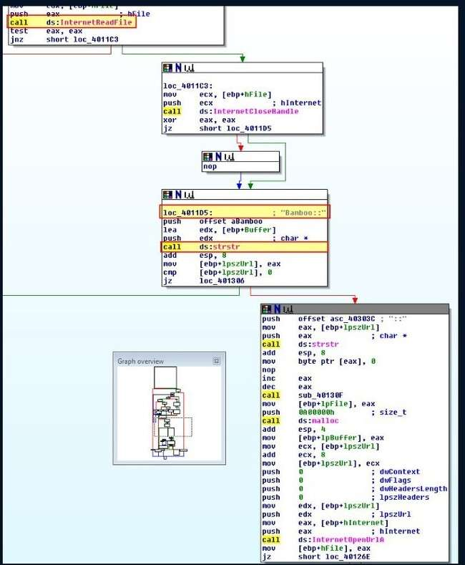

**iv. What does the program do with the information it extracts from the page?**

After locating the string “Bamboo::”, the program searches for the substring “::”. It then calls the subroutine sub_40130F before reading the bytes between “Bamboo::” and “::” into a buffer

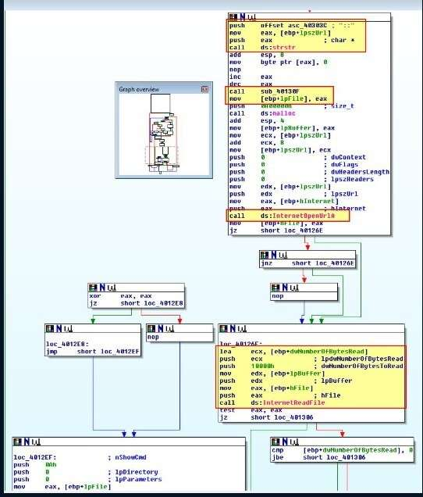

The subroutine at sub_40130F appears to perform another string-building operation, as confirmed by using ‘R’ to convert the bytes into their corresponding characters**.**

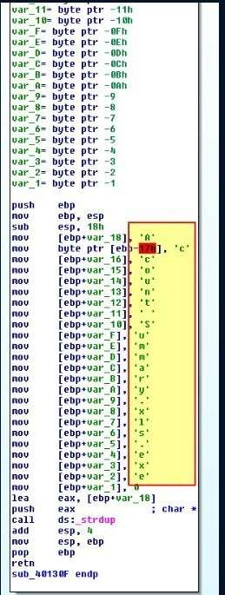

This indicates that [ebp+lpFile] is being assigned the value 'Account Summary.xls.exe'. Examining its usage further, we see that this is the filename the program will use to write the data extracted from between the strings “Bamboo::” and “::”.

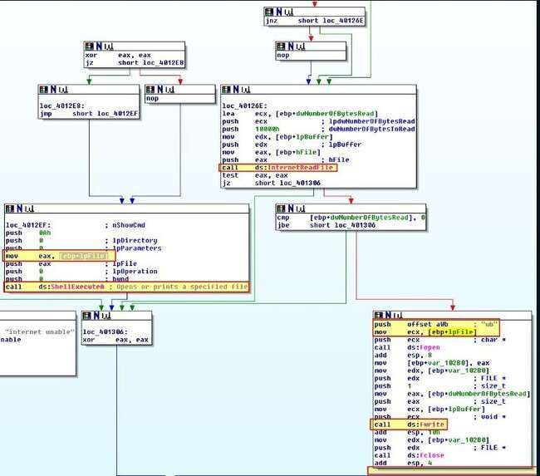

Notably, there appears to be a broken code path where nothing occurs after the file is written. On closer inspection, this is due to the impossible disassembly issue we encountered earlier in the analysis. However, we can infer that the intended behavior is to execute the file written to disk. From this, it’s clear that the program functions as a downloader and launcher—it drops a file with double extensions and then executes it.

**f. Analyze the malware found in the file Lab15-03.exe. At first glance, this binary appears to be a legitimate tool, but it actually contains more functionality than advertised.**

**i. How is the malicious code initially called?**

To understand its behavior, we can run the program using Fakenet-NG to monitor its network activity. When doing so, we observe rapid text output in the terminal—likely process lists—and, towards the end, an outbound network connection is established.

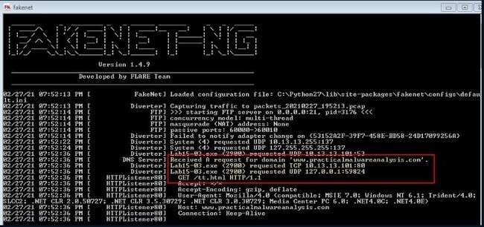

For a tool that appears to list processes, this outbound connection is suspicious. To investigate further, we load the executable into IDA. Once disassembly completes, we find that

URLDownloadToFileA is indeed imported and referenced, which aligns with what we observed during dynamic analysis. However, its usage doesn’t seem legitimate—likely due to misinterpretation by the disassembler, possibly caused by obfuscation or anti-disassembly techniques.

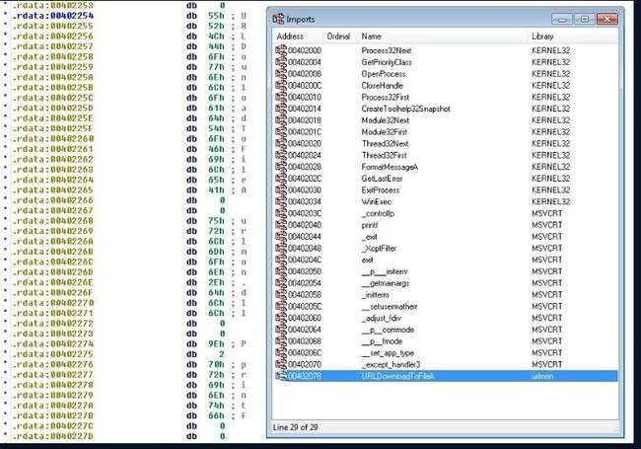

This heightens our suspicions, especially that the program may be employing anti-disassembly techniques. At the very start of the main function, we notice a modification to ebp+4, which is particularly suspicious since ebp+4 typically holds the return address. To investigate further, we can press **CTRL + K** in IDA to view the stack frame and analyze how this value is being manipulated.

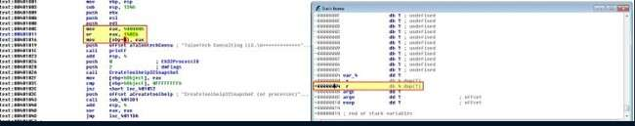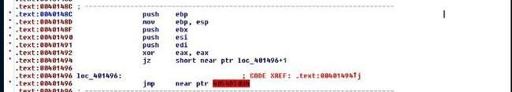

The instructions store the value 0x0040148C into ebp+4, effectively overwriting the return address. When we examine the code at 0x0040148C, we find that it hasn't been properly disassembled and contains patterns consistent with known anti-disassembly techniques. This further confirms that the program is deliberately obscuring its execution flow to evade static analysis.

By isolating the rogue byte, converting it into data, and then restoring the surrounding area back into code, we uncover a suspicious instruction that appears to perform a division by zero. This is a classic anti-disassembly technique used to confuse disassemblers and disrupt static analysis, since such instructions would cause exceptions during execution and are typically never actually reached in the real control flow. 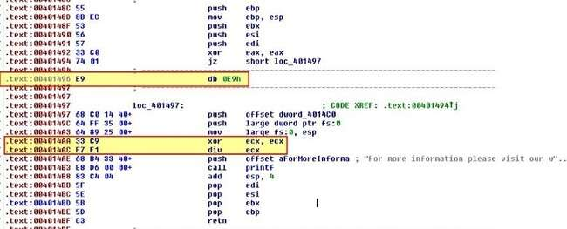

**This division-by-zero operation will trigger a runtime error, preventing any code that follows from executing—strongly**

suggesting it's a red herring, meant to mislead analysis. At this point, we can be fairly confident that this section of code is intentionally executed by overwriting the return address on the stack. This manipulation redirects control flow after the main function concludes, allowing the malware to bypass normal execution and initiate its true payload.

**ii. What does the malicious code do?**

Continuing from our previous analysis, we observe a reference to 0x004014C0 from loc_401497, but notably, there are no call instructions leading to it. This suggests that the divide-by-zero exception is likely being handled by an exception handler located at 0x004014C0. It appears that this handler was mistakenly interpreted as data by the disassembler—another result of antidisassembly techniques. This reinforces the idea that structured exception handling (SEH) is being used to redirect execution flow in a non-obvious way, further complicating static analysis.

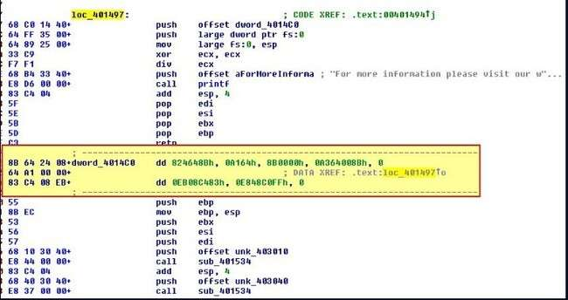

By converting the suspected handler at 0x004014C0 into code, we uncover another antidisassembly trick at address 0x004014D7. This further supports the presence of obfuscation techniques designed to mislead disassemblers and analysts, making it harder to trace the true execution path of the program.

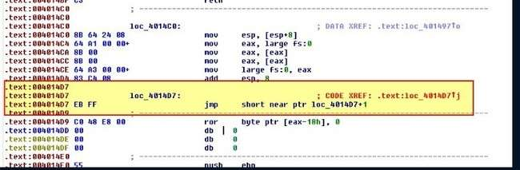

By isolating the rogue EB byte and converting it to code, we start to reveal a much clearer execution path. This section includes a call to URLDownloadToFileA, confirming the malware’s download functionality, followed by additional anti-disassembly obfuscation and finally a call to WinExec. This strongly indicates the program is designed to download a file from the internet and then execute it—typical behavior for a downloader-style malware. 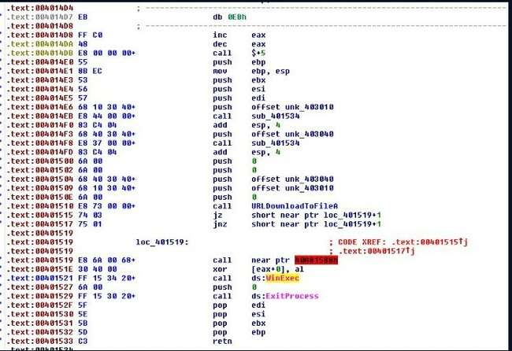

By once again isolating the rogue byte and converting the surrounding data into code, we can now see what appears to be a properly formed and coherent function. This suggests we've successfully bypassed another layer of anti-disassembly, revealing the intended control flow and behavior of the program.

**iii. What URL does the malware use?**

This question can be quickly addressed through dynamic analysis—using tools like Fakenet-NG, as demonstrated in Question 1. However, to fully understand how this functionality is constructed, we need to closely examine one of the newly revealed functions in our disassembled code. Even though the control flow graphs may still appear somewhat disorganized due to prior anti-disassembly tricks, analyzing these functions will help uncover the logic behind the program’s behavior.

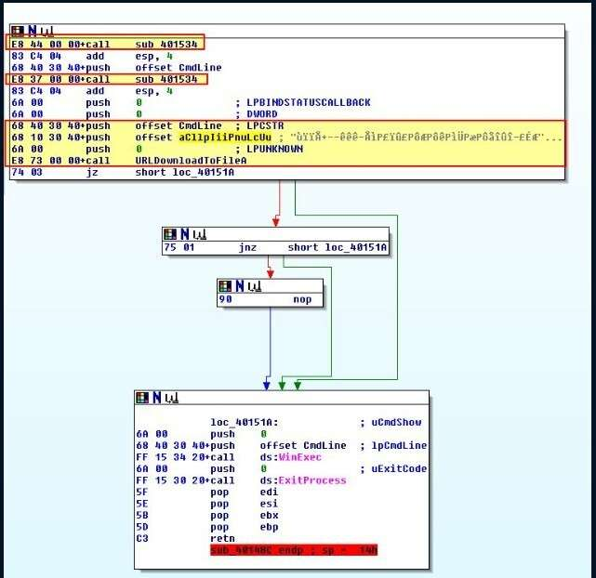

Notably, there are a couple of calls to sub_401534 right before two seemingly random strings are pushed and a call is made to URLDownloadToFileA. Upon examining sub_401534, we find that it appears to be a straightforward XOR decoding function that uses the key 0xFF.

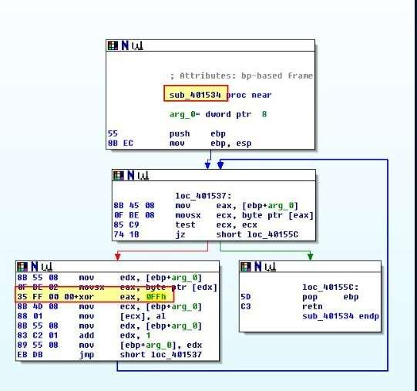

Taking the obfuscated data at byte_403010,

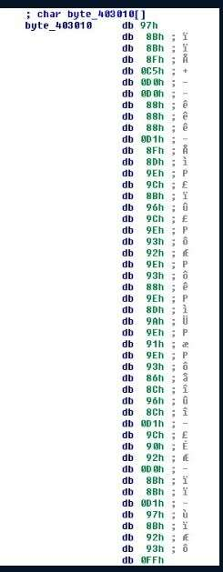

By decoding the hex values at byte_403010 and applying the XOR operation with the identified key (0xFF), we recover the original URL we identified earlier.

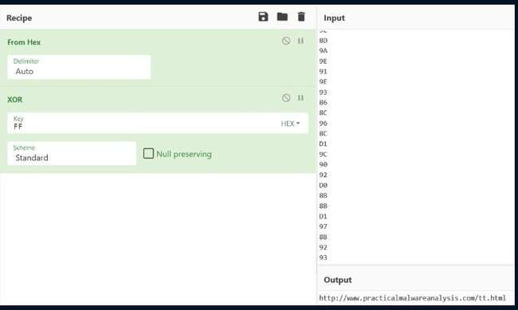

1. **What filename does the malware use?**

To find the filename used by the malware, we apply the same decode-and-XOR process to the value stored in CmdLine. This reveals the decoded filename the malware uses when writing the file to disk.

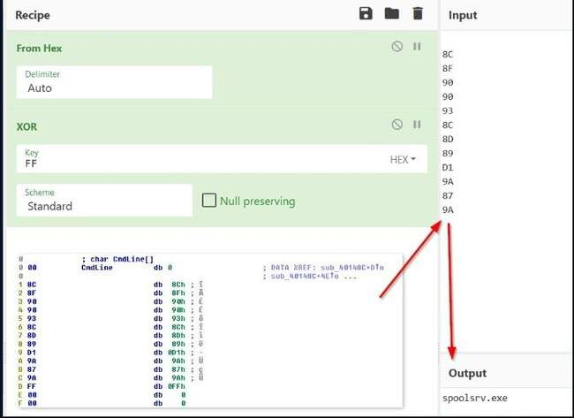

From this process, we determine that the filename used by the malware is spoolsrv.exe.